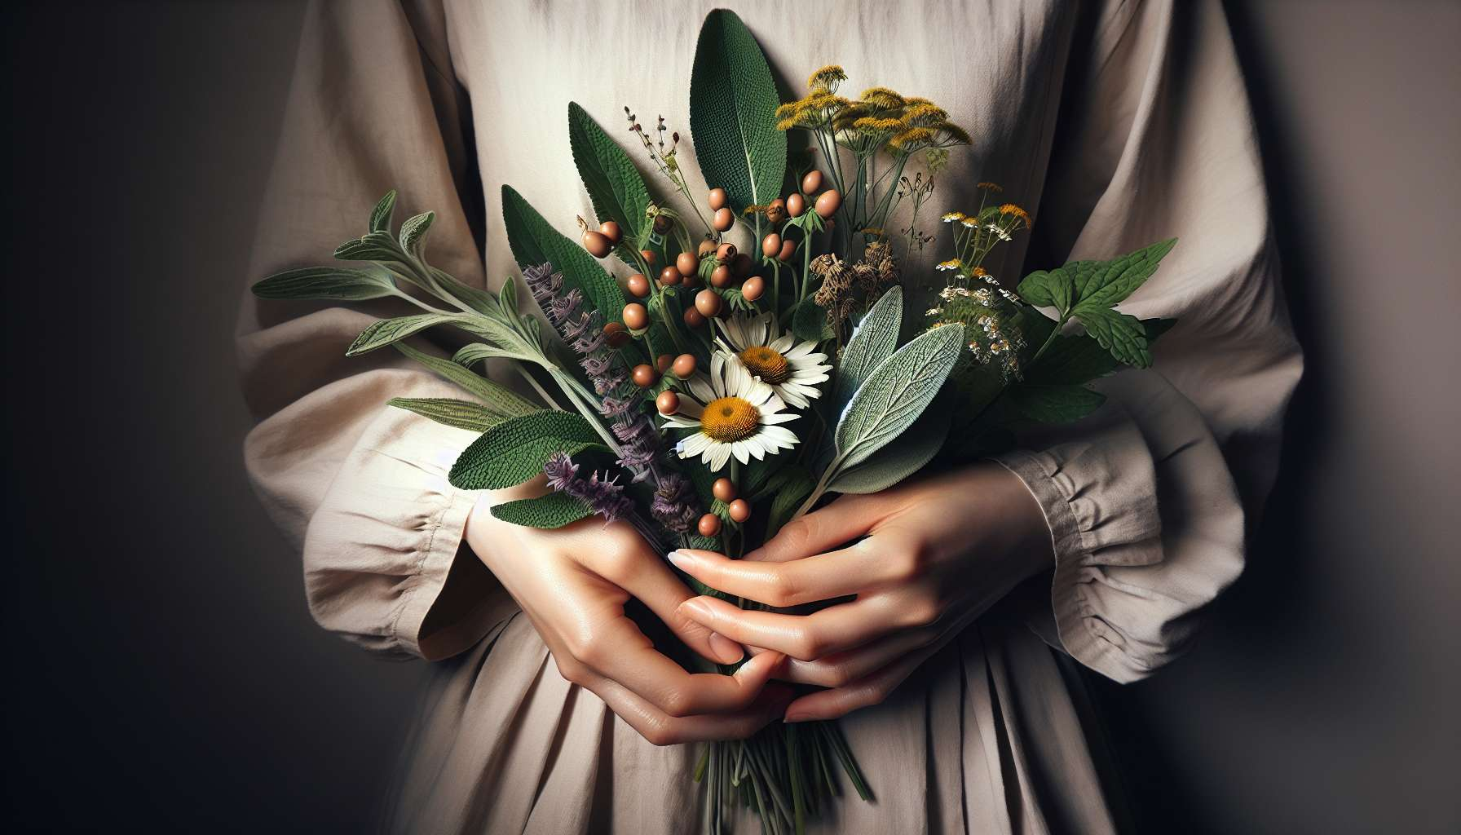

Phytotherapy, or the use of medicinal plants, is a valuable tool for supporting women's health and balance. For millennia, women have resorted to plants to alleviate gender-specific ailments, regulate their menstrual cycle, facilitate pregnancy and childbirth, and smoothly transition through the various stages of their life.  
  
Each plant has a unique energy signature and pharmacological properties that allow it to act on different systems of the body. Some plants have a particular affinity with the female hormonal system, such as lady's mantle, chaste tree, or clary sage. Others are renowned for their action on the gynecological sphere, such as feverfew, yarrow, or raspberry.  
  
It is essential to choose quality plants, harvested under optimal conditions and processed with care to preserve their active principles. Plants can be used in various galenic forms depending on individual needs and preferences: teas, mother tinctures, capsules, syrups, massage oils, etc.  
  
Here are a few examples of essential plants for women's health:  
  
- Garden sage, to regulate irregular menstrual cycles, alleviate menopause disorders, and promote fertility.  
- The chaste tree, to balance the hormonal system, reduce premenstrual symptoms, and stimulate lactation.  
- Feverfew, to soothe menstrual pains, digestive disorders, and stress.  
- Lady's mantle, to tone the uterus, regulate bleeding, and facilitate childbirth.  
- St. John's wort, to fight postpartum depression, anxiety, and sleep disorders.  
  
However, it's important to be well informed about the possible contraindications and interactions before consuming medicinal plants, especially during pregnancy and breastfeeding. It is recommended to seek the advice of a qualified herbalist or a health professional trained in phytotherapy.  
  
In addition to the internal use of medicinal plants, it is possible to use the power of plants externally, in the form of sitz baths, poultices, or massage oils. These local applications target a specific area and act directly on the tissues in question.  
  
Integrating medicinal plants into your daily lifestyle is also a way to reconnect with nature and its rhythms. Some plants like nettle, dandelion, or red clover can be consumed as food or drinks, in salads, juices, or infusions for example.  
  
Phytotherapy invites us to develop an intimate and intuitive relationship with plants, to learn to recognize them, harvest them, and transform them ourselves. This is an ancestral art passed on from woman to woman since the dawn of time and deserves to be preserved and taught to new generations.  
  
As a practitioner of Divine Feminine Healing, it is crucial to train in the use of medicinal plants to advise each woman in an enlightened and personalized way based on her constitution, her history, and her specific needs. Phytotherapy thus integrates perfectly into a holistic approach to feminine health, in synergy with other tools such as meditation, yoga, flower elixirs, or intuitive eating.  
  
Key Takeaways:   
  
- Phytotherapy uses medicinal plants to support women's health at different stages of their life (menstruation, pregnancy, menopause, etc.).  
   
- Each plant has unique properties and acts on specific systems of the female body (hormonal, gynecological, emotional).  
   
- You must choose quality plants and use them in various suitable forms (teas, tinctures, capsules, oils...).  
   
- Key plant examples: garden sage, chaste tree, feverfew, lady's mantle, St. John's wort.  
   
- Caution: Do your research on contraindications and consult a professional, especially during pregnancy/breastfeeding.  
   
- Plants can also be used externally (sitz baths, poultices) and some can be consumed in the diet.  
   
- Phytotherapy allows for reconnection with nature and the transmission of ancestral feminine knowledge.  
   
- It is a valuable tool in synergy with other holistic approaches to Divine Feminine Healing.