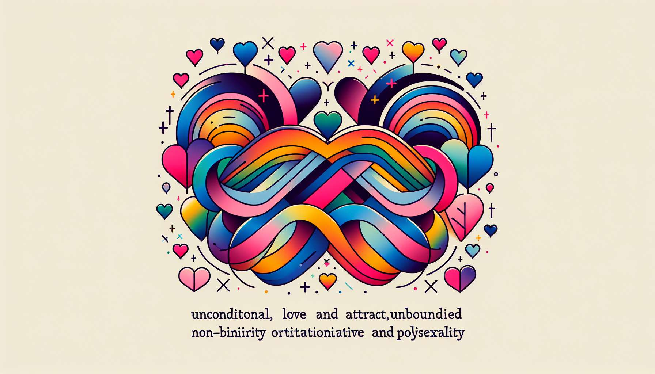

Welcome to this seventh sub-module, which will allow you to explore two sexual orientations often confused with bisexuality but which have their own specificities: pansexuality and polysexuality.  
  
Pansexuality is defined as a sexual and/or romantic attraction towards persons regardless of their gender or sex. Pansexual people may be attracted to men, women, non-binary people, transgender people, intersex people... without gender being a determining factor in their attraction. What matters are individual qualities, personality, emotional connection with the other.  
  
The term "pansexual" comes from the Greek "pan" which means "all". This does not mean that pansexual people are attracted to everyone, but rather that they have the potential to be attracted to people of all genders. Pansexuality is often described as an "hearts not parts" attraction, that is, an attraction to a person as a whole, beyond their sex or gender.  
  
Polysexuality, on the other hand, is defined as a sexual and/or romantic attraction towards several genders, but not necessarily all. For example, a polysexual person may be attracted to women and non-binary people, but not to men. Or to men and transgender people, but not to cisgender women.  
  
The prefix "poly" comes from ancient Greek and means "several" or "many". Polysexuality is therefore distinguished from pansexuality in that it involves an attraction to several genders, but not all genders. It is a more specific orientation, which recognizes attraction to a diversity of genders while still having preferences or exclusions.  
  
Pansexuality and polysexuality are often confused with bisexuality, but there are important nuances. Bisexuality is often defined as an attraction to two genders (generally men and women), while pansexuality and polysexuality open up to a plurality of genders beyond the man/woman binary. However, many bisexual people define their orientation as an attraction to their own gender and to other genders, thus including non-binary and transgender people.   
  
 Miley Cyrus is a famous figure who identifies as pansexual. In her interviews, she explains that her attraction is not limited to the male or female gender, but that she can fall in love with a person, regardless of their gender identity. She has helped popularize the term "pansexual" and make this orientation visible to the general public.  
  
The series Sense8 features a pansexual character, Lito Rodriguez, a Mexican actor who falls in love with a man and then a woman throughout the series. His attraction is not limited to a particular gender, but is focused on individuals in their singularity, beyond labels.  
  
As a coach, it is important to welcome pansexual and polysexual people you may accompany with respect and kindness. Avoid assumptions about their orientation based on the gender of their current partner. A pansexual person in a relationship with a man is not necessarily heterosexual, just as a polysexual person in a relationship with a non-binary person is not necessarily homosexual.  
  
Keep in mind that sexual orientation is an intimate and personal experience, not limited to a sexual practice or type of relationship. Your role is to provide a safe and caring space to explore these issues, without judgment or normative injunctions.  
  
By addressing pansexuality and polysexuality in your coaching practice, you will contribute to making these orientations more visible and legitimate, which are still little-known and often overlooked. You will help your clients find the words to describe their experience and accept themselves in their singularity. Because celebrating the diversity of attractions and love is working for a more inclusive world where everyone can freely and fully love.  
  
Takeaway Points:  
  
- Pansexuality is a sexual and/or romantic attraction towards persons regardless of their gender or their sex. What matters are the individual qualities and the personality.  
  
- Polysexuality is a sexual and/or romantic attraction towards several genders, but not necessarily all. It is a more specific orientation than pansexuality.  
  
- Pansexuality and polysexuality are often confused with bisexuality, but bisexuality is generally defined as an attraction to two genders.  
  
- As a coach, it's important to welcome pansexual and polysexual people with respect, without making assumptions about their orientation based on the gender of their current partner.  
  
- Sexual orientation is an intimate experience which is not limited to a practice or type of relationship. The coach's role is to provide a caring space to explore these issues without judgment.  
  
- Addressing pansexuality and polysexuality contributes to making these mostly overlooked orientations visible and legitimate, and it helps clients find the words to describe their experience and to accept themselves in their singularity.