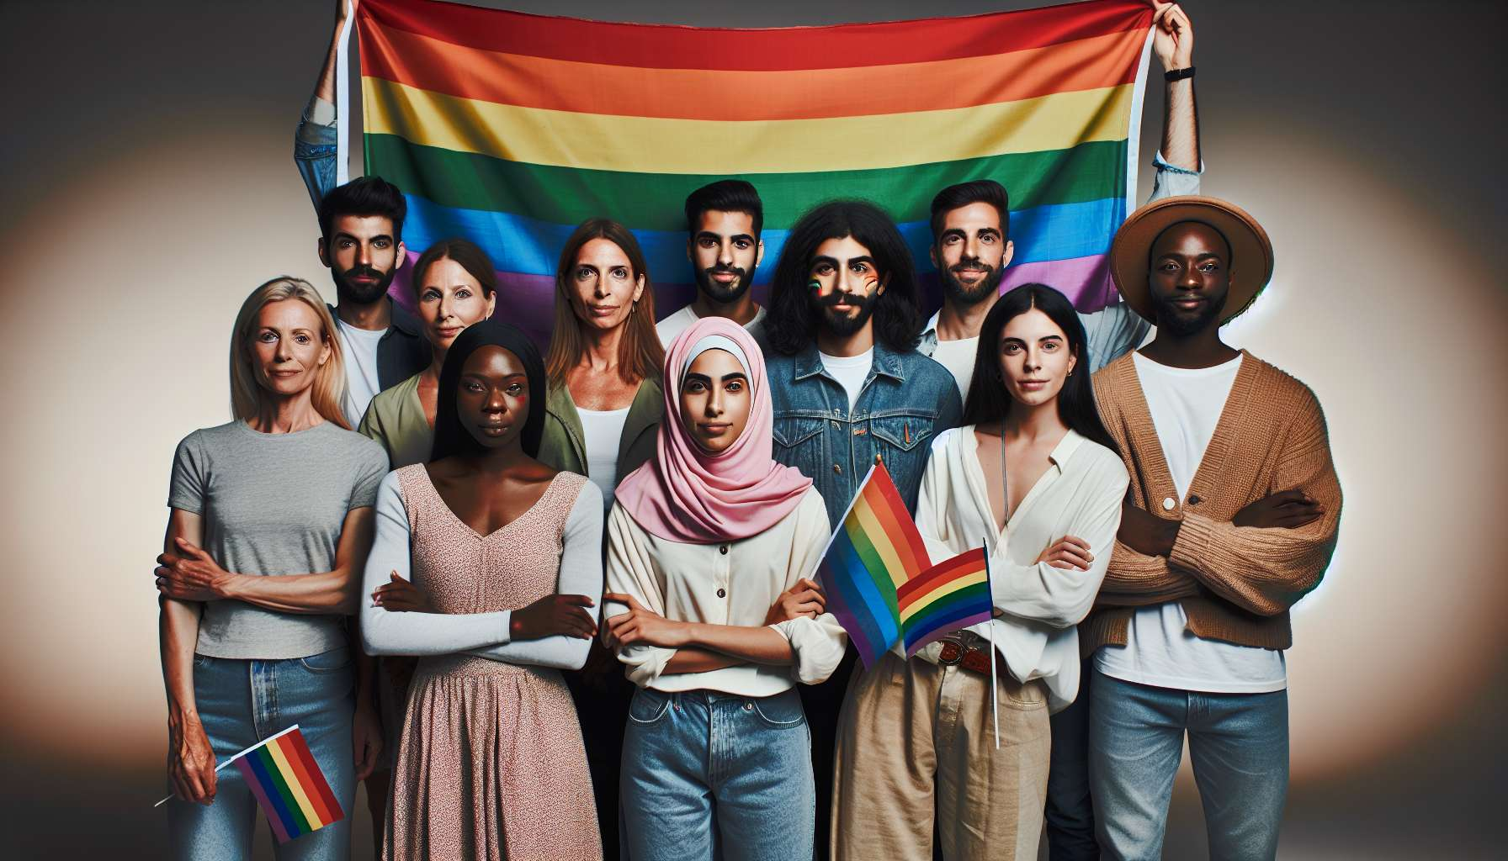
Despite considerable advancements over recent decades in the rights and visibility of LGBTQ+ individuals, there are still many challenges to overcome and battles to fight in order to achieve real equality and full emancipation. Although laws have evolved in many countries, discrimination and violence persist in reality, taking multiple and often insidious forms.
One of the major challenges is the fight against LGBTQIphobias, which manifest both in private and public spheres. According to the 2020 annual report by the association SOS Homophobia, reports of discrimination cases increased by 26% compared to the previous year, with a particularly worrisome rise in physical attacks (+22%). Trans and racially diverse LGBTQ+ individuals are particularly affected by these acts of violence. It is urgent to strengthen policies of prevention and punishment of LGBTQIphobic acts, but also to carry out education and awareness-raising work from a young age to deconstruct stereotypes and promote respect for diversity.
Another challenge is the mental and physical health of LGBTQ+ people, who bear the brunt of the effects of discrimination and stigmatization. Studies show that LGBTQ+ people are more exposed than the general population to anxiety disorders, depression, addictive behaviors, and suicidal risks. They also encounter difficulties accessing care, due to the lack of knowledge or prejudices of some health professionals. The Covid-19 crisis has exacerbated these inequalities, further isolating LGBTQ+ individuals and exposing them to family violence. It's essential to develop inclusive public health policies, taking into account the specific needs of LGBTQ+ individuals and training professionals for compassionate and non-judgmental support.
The fight against HIV/AIDS remains a current issue, despite considerable progress made in prevention and treatment. While the epidemic is now better controlled in Western countries, it continues to disproportionately affect men who have sex with men (MSM), particularly in racialized and precarious communities. The introduction of PrEP (pre-exposure prophylaxis) in 2016 marked a major advancement, by allowing HIV-negative people to protect themselves from HIV through preventive treatment. But its access is still limited and unequal. It is crucial to continue efforts of combined prevention (condom, screening, treatment as prevention, PrEP), targeting the most exposed audiences, and fight against serophobia, which continues to stigmatize HIV-positive individuals.
Another struggle concerns the rights of trans and intersex individuals, which remain largely unknown and violated. Despite progress like the depathologization of transidentity by WHO in 2019, or the possibility to change civil status without medical conditions in some countries, trans people face multiple obstacles in their transition journey and daily life. According to the 2019 FRA LGBTI II European survey, 60% of trans individuals reported having faced discrimination in the last 12 months. As for intersex individuals, they still often undergo non-consensual surgical operations in order to conform to binary gender norms. It is urgent to facilitate access to transition care for trans individuals, train health professionals on the issues of transidentity, and prohibit mutilations of intersex children in the name of respect for their bodily integrity and self-determination.
The issue of parenthood and filiation for LGBTQ+ families remains a work in progress. While many countries now authorize adoption by same-sex couples, access to assisted reproductive technology (ART) and surrogacy remains highly unequal and controversial. In France, the 2021 bioethics law opened ART to all women, but surrogacy remains forbidden. Many male couples continue to seek it abroad, in sometimes problematic legal and ethical conditions. It is necessary to rethink family law to adapt to the diversity of family configurations, ensuring the legal security and equality of all children, regardless of their mode of conception or the composition of their households.
Beyond the issue of rights, a major challenge is the visibility and representation of LGBTQ+ individuals in the public and media spaces. Despite notable progress, LGBTQ+ individuals remain underrepresented or confined to stereotyped roles in the media, culture, or politics. According to the GLAAD's Where We Are on TV report, LGBTQ+ individuals only represented 9.1% of regular characters in U.S. series for the 2020-2021 season. Some identities such as trans, non-binary, asexual, or intersex people are almost invisible. It's essential to promote a more diverse and nuanced representation of LGBTQ+ individuals in all fields, by supporting LGBTQ+ artists and creators, fighting against stereotypes, and encouraging the empowerment of communities.
Finally, a major battle is that of intersectionality and solidarity between struggles. LGBTQ+ people are not a homogeneous group, but a mosaic of identities traversed by multiple power dynamics related to race, class, gender, disability, age, etc. As philosopher Kimberlé Crenshaw, the theorist of intersectionality, points out, "identities are not layers that add up, but experiences that intersect and shape each other." A racialized trans woman does not simply experience the addition of transphobia and racism, but specific oppression that can only be understood by crossing these different axes. It is crucial for LGBTQ+ movements to consider these interconnections and to forge alliances with other social justice movements, such as feminism, anti-racism, anti-capitalism, or ecology. For the emancipation of LGBTQ+ individuals cannot be achieved without a radical transformation of society as a whole, towards greater equality, solidarity, and respect for diversity in all its forms.
Key Points:
- Despite advancements, LGBTQ+ individuals still face much discrimination and violence. It is urgent to strengthen prevention, sanction, and education policies to fight against LGBTQIphobias.
- LGBTQ+ individuals are more exposed to mental and physical health problems, exacerbated by the Covid-19 crisis. There is a need to develop inclusive health policies and train compassionate professionals.
- The fight against HIV/AIDS remains a challenge, especially for racialized and precarious MSM. It is crucial to continue efforts of combined prevention and fight against serophobia.
- The rights of trans and intersex individuals are still widely violated. Access to transition care needs to be facilitated, professionals need to be trained, and non-consensual mutilations on intersex children need to be prohibited.
- LGBTQ+ parenthood requires a rethinking of family law to ensure equality of all children, regardless of their family configuration.
- LGBTQ+ individuals remain underrepresented and stereotyped in media and culture. It is necessary to promote a more diverse representation by supporting LGBTQ+ artists.
- LGBTQ+ struggles should consider intersectionality of oppressions and develop alliances with other social justice movements for global emancipation.

