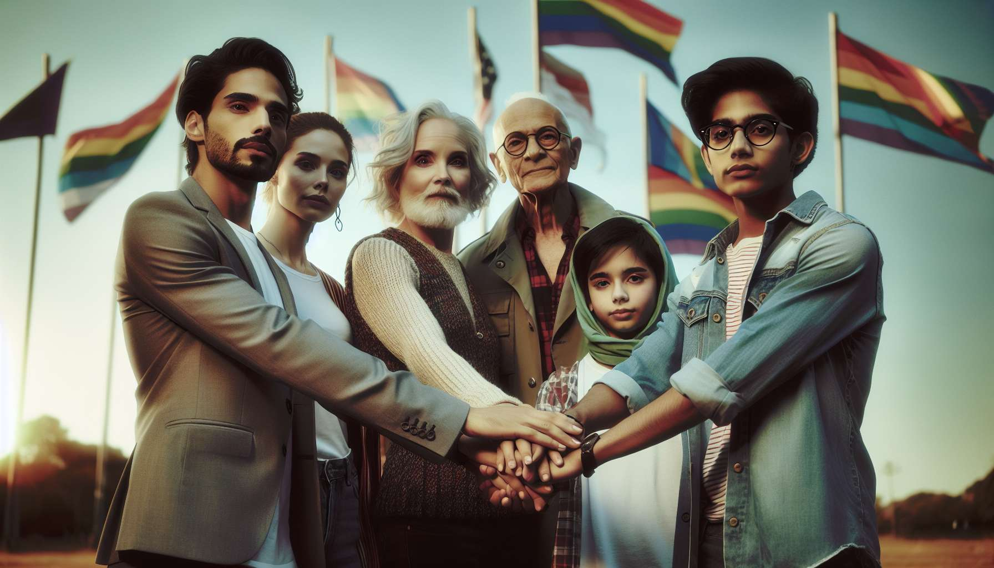

LGBTQ+ associations and communities play a crucial role in the fight for equality, visibility and the emancipation of LGBTQ+ individuals. They are key players in social and political change, acting both as spaces for sociability, solidarity and collective mobilization.  
  
Historically, LGBTQ+ associations were born out of the need to organize in the face of oppression and stigmatization. From the 1950s, groups like Arcadie in France or The Mattachine Society in the United States created spaces for meeting and mutual aid for homosexual people, at a time when homosexuality was still criminalized and pathologized.These first groups, often confidential and elitist, nevertheless laid the foundations of a sense of belonging and a collective identity.  
  
With the emergence of gay and lesbian liberation movements in the 1970s, LGBTQ+ associations became more political and radicalized. Groups like the Front Homosexuel d'Action Révolutionnaire (FHAR) in France or the Gay Liberation Front (GLF) in the United States developed a global critique of heteronormative and capitalist society, in connection with other protest movements of the time (feminism, anti-racism, anti-capitalism).Their rallying cry was "homosexual liberation," conceived as a personal and political revolution aimed at abolishing gender and sexuality norms.  
  
In the 1980s, in the face of the AIDS epidemic and the inaction of public authorities, LGBTQ+ associations played a major role in prevention, supporting patients and defending their rights. Groups like ACT UP or Aides initiated hard-hitting actions to denounce the stigmatization of HIV-positive individuals and demand appropriate public health policies. They helped break the silence around the disease and forge solidarity within LGBTQ+ communities, severely affected by the epidemic.  
  
Since the 1990s-2000s, LGBTQ+ associations have diversified and specialized, reflecting the plurality of identities and issues within communities. Associations like SOS Homophobie or Le Refuge have specialized in combating violence and discrimination, offering support, shelter and legal assistance services. Others like AIDES or Sida Info Service have developed prevention and support actions for people affected by HIV/AIDS. Associations like CONTACT or the Association of Gay and Lesbian Parents and Future Parents (APGL) have tackled issues related to homoparentality and education. This specialization reflects the ambition to meet the specific needs of the various components of the LGBTQ+ communities.  
  
But beyond their role as service providers, LGBTQ+ associations are also places of sociability and identity building. They provide meeting and expression spaces for people who are often isolated and marginalized, especially in small towns or rural areas. As sociologist Natacha Chetcuti-Osorovitz underlines, "associations are places where emotional and friendly ties are woven, where knowledge and experiences are transmitted, where solidarity and commitments are forged". They contribute to creating a sense of belonging and pride, allowing LGBTQ+ people to meet among peers and share their experiences.  
  
LGBTQ+ associations are also key players in the visibility and representation of communities in the public space. They organize events such as Pride Marches, LGBTQ+ film festivals, or commemoration days (IDAHOT, Transgender Day of Visibility, etc.). They run awareness and education campaigns for the general public, intervening in the media, schools, or corporations. They thus contribute to deconstructing stereotypes and prejudices, evolving mentalities, and promoting a culture of diversity and inclusion.  
  
Finally, LGBTQ+ associations are key players in advocacy and political lobbying. They challenge public authorities and elected officials to advance the rights of LGBTQ+ people, whether in terms of combating discrimination, access to parenthood, changes in civil status for trans people, or sexuality education. In France, the adoption of the PACS in 1999, the opening of marriage to same-sex couples in 2013, and the law on PMA for all in 2021 are all victories that owe a great deal to the mobilization of LGBTQ+ associations. They rely on their field expertise, their ability to mobilize communities, and their legitimacy with institutions.  
  
But the role of LGBTQ+ associations and communities is not limited to the political and institutional sphere. They are also spaces for experimentation and invention of new ways of life and relationships, on the fringes of dominant norms. As philosopher Paul B. Preciado emphasizes, "LGBTQ+ communities are laboratories of subjectivity production, spaces of resistance and creation where other ways of loving, desiring, making family or community are invented". Practices such as polyamory, BDSM, chemsex or co-parenting often find their origins in the margins of LGBTQ+ communities, before spreading more widely in society.  
  
However, the role of LGBTQ+ associations and communities does not go without raising debates and criticisms within them. Some activists denounce a trend towards institutionalization and depoliticization of associations, which would serve as service providers at the expense of their counter-power role. Others point to the lack of diversity and representativeness of governing bodies, often white, masculine, and from the middle and upper classes. The issue of inclusion of trans, non-binary, racialized, precarious, or disabled people remains a major challenge for many associations. Voices also rise to denounce the logics of "communitarianism" or "identity retreat" which traverse certain segments of the LGBTQ+ communities.  
  
As trans activist Karine Espineira sums up, "associations and LGBTQ+ communities are both an engine and a mirror of emancipation struggles. They reflect the diversity and complexity of our identities and experiences, with their strengths and weaknesses. They are a space of tensions and contradictions, but also of alliances and solidarities to be constantly reinvented". Faced with the challenges of globalization, neoliberalism, or the rise of far-right movements, they have a crucial role to play in defending the rights and dignity of LGBTQ+ people, by articulating specific battles and universal struggles for social justice and equality.  
  
Key points to remember:  
  
- LGBTQ+ associations were born out of the need to organize in the face of oppression and stigmatization, providing spaces for meeting, mutual aid, and the building of a collective identity.  
  
- Over the decades, they have evolved, becoming political in the 1970s, playing a key role in the face of the AIDS epidemic in the 1980s, and diversifying to meet the specific needs of different components of LGBTQ+ communities.  
  
- Beyond their role of service providers, LGBTQ+ associations are places of sociability, transmission of knowledge and experiences, and creation of emotional ties and solidarities.  
  
- They contribute to the visibility and representation of LGBTQ+ communities in public space by organizing events, running awareness campaigns, and changing mentalities.  
  
- LGBTQ+ associations are major political advocacy actors, having contributed to numerous legislative advances regarding the rights of LGBTQ+ individuals.  
  
- They are spaces for experimentation and invention of new ways of life and relationships, on the fringes of dominant norms.  
  
- However, they face internal challenges such as the trend towards institutionalization, lack of diversity and inclusion, and identity retreat dynamics.  
  
- Faced with contemporary issues, associations and LGBTQ+ communities play a crucial role in articulating specific battles with universal struggles for social justice and equality.