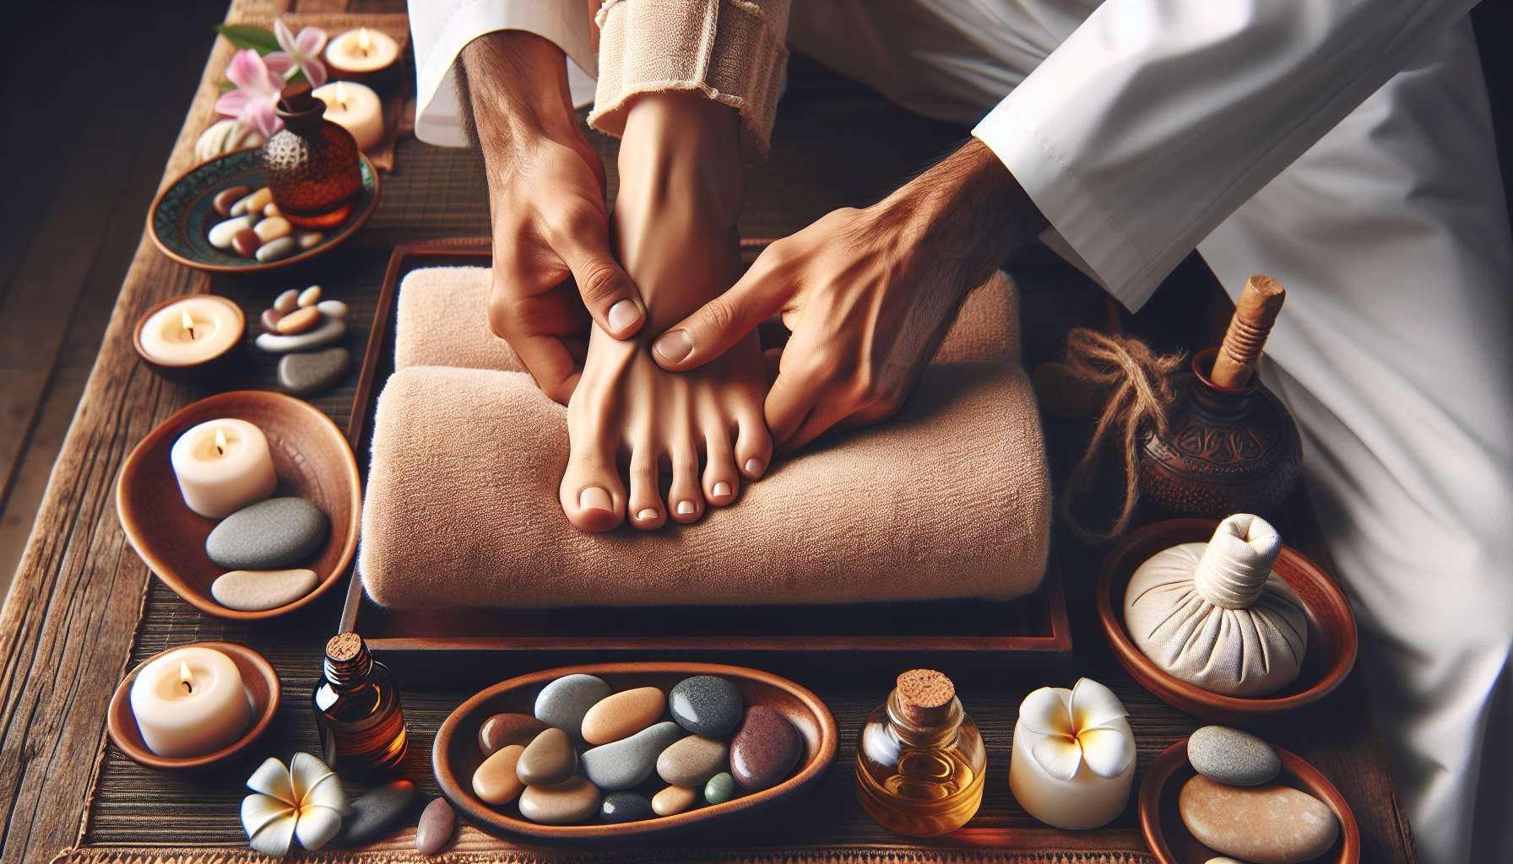

Reflexology and pressure points are ancestral manual techniques aimed at stimulating reflex areas of the body to restore energy balance and alleviate various disorders. These practices are particularly beneficial for women, allowing them to reconnect with their bodies, regulate their hormonal cycles, and enhance their overall vitality.  
  
Foot reflexology is based on the principle that every part of the body is represented on the arch of the foot. By stimulating specific points with the fingers, it is thus possible to remotely affect the organs, glands, and corresponding physiological functions. For women, reflexology is particularly indicated to alleviate menstrual disorders (painful, irregular or absent periods), menopause symptoms (hot flashes, vaginal dryness, mood swings) and hormonal imbalances (premenstrual syndrome, infertility, ovarian cysts). By working on the reflex areas of the uterus, ovaries, pituitary or thyroid, the endocrine system can be gently rebalanced and a better regulation of female cycles can be promoted.  
  
Pressure points, derived from traditional Chinese medicine, are skin points located on the body's energy meridians. By stimulating them with the fingers or specific tools (massage sticks, cups, gua sha), it is possible to unblock energy stagnations, relieve pain and promote the circulation of Qi throughout the organism. For women, certain points are particularly interesting like Ren 6 point (sea of energy) located three fingers below the navel, which regulates the functioning of the uterus and harmonizes emotions, or the Spleen 6 point (meeting of the three Yin) located above the inner malleolus, which tonifies the blood and relieves painful periods. By learning to locate and regularly massage these points, women can take their daily health into their own hands and prevent numerous imbalances.  
  
To integrate reflexology and pressure points into a practice of Divine Feminine Healing, one can propose specific protocols related to the phases of the menstrual cycle (module 2.4) or female archetypes (module 1.4). For example, during the premenstrual phase, one can massage the Liv 3 point (great hive) located between the big toe and the second toe, to soothe irritability and regulate the Liver Qi, often in excess at this time. During menstruation, one can stimulate the Bl 32 point (second sacred hole) located in the buttock fold, to relieve back pain and promote blood flow. These techniques can also be combined with suitable essential oils (module 8.2), semi-precious stones (module 8.5) or guided visualizations (module 6.4) to enhance their therapeutic effects.  
  
Here is a concrete example of a foot reflexology protocol to balance female hormones:   
1. Get comfortable, barefoot. Apply a dollop of vegetable oil (sesame, sweet almond) to the arch of your foot for easy sliding.   
2. Start by massaging the whole foot with enveloping movements to relax and stimulate circulation. Gently knead the toes, sole, and heel.  
3. Using your thumb, locate the reflex area of the ovaries, located under the inner malleolus of each foot. Apply deep sliding pressures, describing small circles, for 1 to 2 minutes on each side. Visualize a soothing light harmonizing your ovaries.  
4. Move up to the reflex zone of the uterus, located at the center of the arch of your foot. With your thumb, make "8" movements pressing deeply, for 1 to 2 minutes. Visualize a regenerating light toning your uterus.  
5. Finish by massaging the reflex area of the pituitary, located at the center of the big toe. With your index and thumb, gently pinch the toe making small circles, for 30 seconds to 1 minute. Visualize a balancing light regulating your hormonal system.  
6. Release gently and take a moment to feel the effects of the massage throughout your body. Thank yourself for this moment of kind presence to yourself.  
  
By regularly practicing reflexology and pressure points, women enhance their self-regulation and self-healing abilities. They learn to decode the messages from their bodies and provide the appropriate responses, in line with their cycles and internal seasons. In this way, they reconnect with their instinctive wisdom, awaken their intimate feminine medicine and radiate new vitality. These subtle techniques then become invaluable allies in guiding women towards more gentleness, balance and fulfillment at every stage of their life.  
  
Remember:  
  
- Foot reflexology and pressure points are manual techniques that stimulate reflex areas of the body to restore energy balance and alleviate various disorders.  
  
- These practices are particularly beneficial for women, allowing them to regulate hormonal cycles, relieve menstrual disorders and menopause symptoms, and enhance overall vitality.  
  
- Foot reflexology act on specific points of the foot arch, representing different parts of the body, organs and glands.  
  
- Pressure points, from Chinese medicine, are located on the energy meridians and can be stimulated to unblock energy stagnations and promote the circulation of Qi.  
  
- Specific protocols can be suggested in connection with the phases of the menstrual cycle or female archetypes, in combination with essential oils, semi-precious stones or guided visualizations.  
  
- An example of a foot reflexology protocol to balance female hormones is detailed, involving the massage of the reflex areas of the ovaries, uterus, and pituitary.  
  
- Regularly practicing these techniques, women enhance their self-regulation abilities, reconnect with their instinctive wisdom and awaken their intimate feminine medicine for more balance and fulfillment.