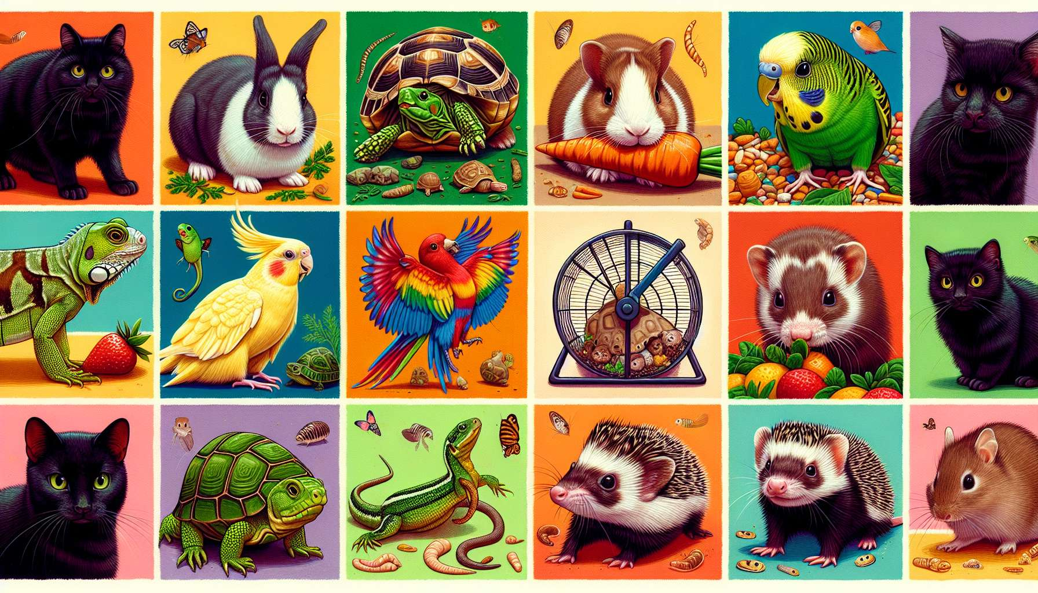
Exotic pets comprise a wide variety of non-traditional species that share our homes. Among the most popular are rodents (rabbits, guinea pigs, hamsters, gerbils, rats, mice), reptiles (turtles, lizards, snakes), birds (budgerigars, parrots, canaries, zebra finches), and certain mustelids such as ferrets. More exotic still, some choose amphibians (frogs, newts), arthropods (tarantulas, stick insects), or even small wild mammals (hedgehogs, degus, prairie dogs).
The enthusiasm for exotic pets can be explained by several factors. First of all, these animals are often easier to accommodate than dogs and cats, as they require less space and can live in a cage or terrarium. They are therefore suitable for small urban dwellings and owners with limited time to devote to walks. Furthermore, some exotic pets have a shorter lifespan than traditional pets, which can be appealing to people not wishing to commit to 15 or 20 years. Finally, exotic pets satisfy a desire for uniqueness and allow for the expression of personality through an original choice.
However, acquiring an exotic pet should not be an impulsive decision. Each species has specific needs in terms of habitat, diet, care, and behavior, which are essential to understand before getting one. For instance, a ferret requires a great deal of space for exercise and regular interaction with its owners, while a snake needs a heated terrarium and a diet composed of live or frozen prey. Consulting with a specialized veterinarian and animal protection associations is a preliminary step to ensure that the appropriate living conditions can be provided for the pet.
The relationship with an exotic pet is different from that with a dog or cat, but it is no less rich and rewarding. Some, such as rabbits or rats, are sociable and intelligent animals, capable of forming strong emotional bonds with their owner. They enjoy play sessions and moments of tenderness, and might even learn a few simple tricks. Others, like reptiles or amphibians, are more contemplative but fascinate with their beauty and singular customs. Observing a chameleon hunt insects or a gecko move along a ceiling is a unique experience that invites us to marvel at nature.
Despite the fact that most exotic pets are not as demonstrative as a dog, they do communicate with their owners through subtle signals. A rabbit grinding its teeth expresses contentment, while ears laid flat signal fear or discomfort. A parrot ruffling its feathers is seeking attention, whereas a ferret yawning denotes relaxation. Learning to decode an exotic pet's body language allows for better responsiveness to its needs and enhances bonding.
Just as with any pet, health is a major concern for owners of exotic pets. Each species is susceptible to specific diseases that need to be prevented and detected early. For instance, rabbits are highly susceptible to dental and digestive problems, while turtles can suffer from deficiencies or parasites if their diet and environment are not properly managed. Regular monitoring by a specialized vet is crucial for the well-being of these animals with such particular needs.
Regrettably, there are still many cases of abandonment and abuse of exotic pets, often due to a lack of knowledge about their needs. Some exotic species fall victim to illegal trade and extractions from their natural habitats, threatening wild populations. That is why it is essential to raise awareness about the ethical and ecological issues related to exotic pets, and to promote responsible adoption through specialized shelters rather than impulsive purchasing. Every animal deserves to live in an environment suitable for its nature, whether it is domestic or wild.
For a Grief Coach specializing in pet bereavement, assisting a grieving person following the loss of an exotic pet requires a detailed understanding of each species' specifics. The bond between an owner and their unconventional companion is often misunderstood by those around them, who may fail to grasp the intensity of the loss. However, whether it's a rat, a gecko, or a tarantula, the attachment is real, and the pain is equally valid.
By welcoming the individual's sorrow with compassion and empathy, the coach will help them express their feelings and feel validated in their experience. They may invite the person to share memories and anecdotes about their unique companion, highlighting the richness and depth of their relationship. The coach might also assist them in ritualizing their loss in a personalized way, for example by creating a small altar with photos, cherished items or natural elements that evoke the deceased pet.
The coach can also inform the person about the stages of grief and normal reactions to the loss of an exotic pet, in order to normalize their experience. They can guide the person towards specialized resources (forums, associations, readings) to find support from others who have gone through the same ordeal. If the person is considering getting a new pet, the coach can guide their reflection and help clarify their motivations, without judgment.
Lastly, the loss of an exotic pet can lead to a realization about the value of each animal life and our responsibility towards these creatures that depend on us. By assisting the person with respect and open-mindedness, the coach will invite them to draw from this unique experience to grow and add even more meaning to their commitment to the animal world. Every encounter, no matter how brief, changes us and invites us to broaden our circle of compassion.
Key points to remember:
- Exotic pets include a wide variety of non-traditional species such as rodents, reptiles, birds, mustelids, amphibians, arthropods and small wild mammals.
- The popularity of exotic pets is due to their adaptation to small dwellings, sometimes shorter life expectancy, and a desire for uniqueness.
- Each exotic pet species has unique needs in terms of habitat, diet, care, and behavior that need to be well understood before obtaining one.
- The relationship with an exotic pet is different from with a dog or cat but can be enriching and rewarding. Some are sociable and form strong emotional bonds, while others are more contemplative.
- Exotic pets communicate through subtle signals that need to be learned in order to strengthen the bond and meet their needs.
- Regular veterinary monitoring is essential because each exotic pet species is susceptible to specific diseases.
- Too many abandonments and cases of abuse still happen due to a misunderstanding of the needs of exotic pets. Responsible adoption should be prioritized.
- Assisting in the grieving process for an exotic pet requires a coach to understand the specifics of each species and the legitimacy of the bond and grief experienced.
- The coach provides empathetic emotional support, helps recall memories, assists in ritualizing loss and provides resources for support.
- The loss of an exotic pet can prompt reflection on the value of each animal life and our responsibility towards them.

