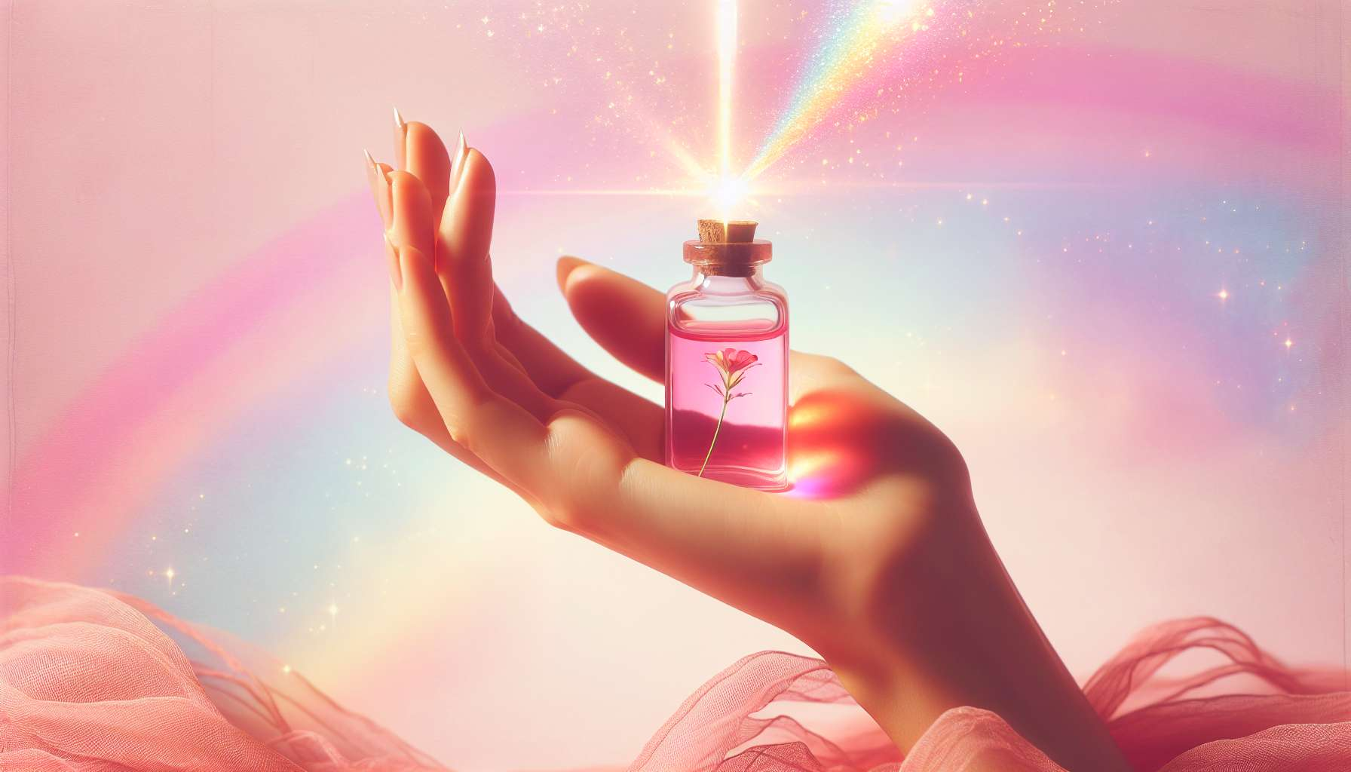

Floral elixirs are a unique form of vibrational medicine that uses the energetic essence of wild flowers to harmonize emotions, moods, and behavior patterns. Discovered in the 1930s by Dr. Edward Bach, an English doctor and homeopath, floral elixirs act as consciousness catalysts helping us to align with our true nature and express our unique potential.  
  
Each flower possesses a specific vibrational signature that resonates with a quality of the human soul. For example, the Mimulus elixir helps to overcome known fears and regain courage, while the Pine elixir soothes feelings of guilt and promotes self-compassion. There are dozens of different elixirs corresponding to as many emotional states and soul challenges.  
  
Floral elixirs are prepared by immersing freshly picked flowers in pure spring water, in the sun or moonlight depending on the flowers. The water then absorbs the vibrational imprint of the flower, which is then stabilized in organic cognac. The elixirs thus obtained are taken orally, a few drops several times a day, for a given period.  
  
Dr. Bach's system of floral elixirs includes 38 individual elixirs and an emergency elixir, the famous Rescue Remedy. Each elixir corresponds to a particular emotional state, such as fear, discouragement, loneliness, or uncertainty. The choice of elixirs is based on the person's dominant emotional state at the present time, not on their physical symptoms.  
  
Since Dr. Bach's discovery, other systems of floral elixirs have been developed, such as the California floral elixirs developed by Patricia Kaminski and Richard Katz, or the Australian floral elixirs created by Ian White. These systems use wild flowers endemic to their region and bring new vibrational nuances.  
  
Floral elixirs are valuable allies to accompany processes of internal transformation and emotional healing in women. They can be used to support different stages of female life, such as puberty, motherhood or menopause, helping to balance emotions and adjust to hormonal and psychological changes.  
  
Some elixirs are particularly suited to challenges encountered by women, like the Apple elixir that helps to reconnect with one's gentleness and sensuality, the Manzanita elixir that supports self-assertion and confidence in one's femininity, or the Mariposa Lily elixir that promotes healing of wounds related to sexuality and intimacy.  
  
Floral elixirs can be used on their own or in synergy with other tools of Divine Feminine Healing, like essential oils, medicinal plants or meditation practices. They bring a subtle and vibrational dimension that acts deeply on the energy and emotional field, supporting the global harmonization process of the being.  
  
As a practitioner, it is essential to train in the use of floral elixirs in order to advise them in a personalized and adapted way to each woman. This requires a good knowledge of the different elixirs and their indications, as well as developing one's intuition and sensitivity to perceive the deep needs of each person.  
  
Floral elixirs invite us to listen to our inner garden, to welcome our emotions with kindness and to open ourselves to the wisdom of our soul. They are a gentle, natural and respectful method of healing, embedded within a holistic and spiritual approach to feminine health. By integrating floral elixirs into her practice, the practitioner of Divine Feminine Healing has a powerful tool to guide women towards greater balance, harmony and fulfillment.  
  
Takeaways:  
  
- Floral elixirs are a form of vibrational medicine that uses the energetic essence of wild flowers to harmonize emotions and moods.  
  
- Discovered by Dr. Edward Bach in the 1930s, floral elixirs act as consciousness catalysts to express our unique potential.  
  
- Each flower has a specific vibrational signature that resonates with an aspect of the human soul.  
  
- Floral elixirs are prepared by immersing fresh flowers in pure spring water, imbued with their vibrational footprint, then stabilized in organic cognac.  
  
- Dr. Bach's system of floral elixirs consists of 38 individual elixirs and an emergency elixir, Rescue Remedy. Other systems have been developed since, such as Californian and Australian floral elixirs.  
  
- Floral elixirs are valuable allies for assisting the processes of internal transformation and emotional healing in women, supporting the various stages of female life.  
  
- Certain elixirs are specifically suited to challenges faced by women, like Apple, Manzanita or Mariposa Lily.  
  
- Floral elixirs can be used alone or in combination with other tools of Divine Feminine Healing.  
  
- Practitioners must train in the use of floral elixirs to give personalized advice, developing their intuition and sensitivity.  
  
- Floral elixirs fit within a holistic and spiritual approach to feminine health, inviting self-listening and openness to soul wisdom.