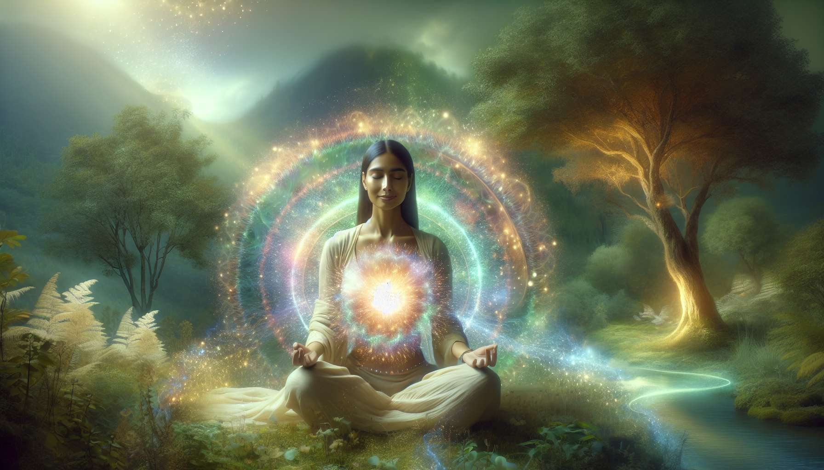

Emotional healing meditations are powerful practices for welcoming, soothing, and transforming our inner wounds. They invite us to create a space of compassionate presence towards ourselves, to listen to and honor our painful emotions, often repressed or ignored. By cultivating this quality of unconditional acceptance, we learn to connect with our vulnerability gently and compassionately, and to gradually release traumatic memories crystallized in our bodies and psyche.  
  
A classic emotional healing meditation involves focusing attention on a difficult emotion that inhabits us, such as sadness, anger or fear. Rather than trying to flee or control it, we fully welcome it into our consciousness, with deep breathing and an open attitude. We can visualize this emotion as a ball of colored energy in our body, and surround it with gentle and soothing light. We can also give it a voice, listen to it reveal its deep message, the unsatisfied need it seeks to express.  
  
By acknowledging and validating our emotion, we allow it to naturally unravel, to transform into more fluid and bright energy. We realize that it is not our enemy, but a precious part of ourselves striving to be heard and integrated. Through practice, we develop a healthier and more mature relationship with our emotions, based on listening and respect rather than judgment and control.  
  
Emotional healing meditations can also target specific wounds related to our personal history, such as abandonment, abuse or unresolved grief. We can visualize our wounded inner child, reach out to them with love, hold them in our arms and offer them the comforting words they need. We can also imagine going back in time to relive a traumatic scene, bringing ourselves the support and protection we needed at that moment.  
  
By reconnecting with our inner child and healing our past wounds, we release a huge life energy that was previously blocked in our unconscious. We reconcile with abandoned parts of ourselves, restore our sense of integrity and inner coherence. We transform our painful relational patterns into a renewed ability to love and trust.  
  
For women in particular, emotional healing meditations are essential to free themselves from conditioning and wounds related to patriarchy. By exploring and healing the shame, guilt or fear deeply rooted in the collective feminine unconscious, we reconnect to our innate dignity and freedom. We learn to assert ourselves, to set our boundaries and to honor our unique truth, beyond social and family injunctions.  
  
Personally, I have experienced the transformative power of these meditations in my own journey of rape healing. For years, I carried this wound as a shameful secret, which cut me off from my vital energy and sabotaged my relationships. Thanks to a diligent meditation practice, by visualizing my wounded self and surrounding it with a loving presence, I gradually transformed this traumatic memory into a force of resilience and compassion. I learned to forgive myself, trust myself again, and open up to love and intimacy.  
  
I encourage my students to create their own healing meditations, drawing inspiration from their inner wisdom and imagery that soothes them. One of them used to visualize a purifying star shower cleansing her wounds, another imagined plunging into a sacred lake with regenerative virtues after laying her burdens on the shore. The essential is to cultivate an inner space of gentleness and unconditional welcome, allowing us to connect with ourselves and others from our healed heart.  
  
Through regular practice, emotional healing meditations help us develop our emotional and relational intelligence. We learn to welcome our entire emotional spectrum with equanimity, to express our feelings authentically and to handle conflicts constructively. We become more conscious, responsible and free beings in our interactions, capable of creating nourishing and fulfilling relationships.  
  
By healing our emotional wounds, we also develop our ability to experience and radiate positive emotions, such as joy, gratitude, peace and unconditional love. We discover within us an inexhaustible source of wellbeing and fulfillment, independent of external circumstances. We become solar and inspiring beings, naturally uplifting the vibration of those around us.  
  
For women, healing emotional wounds is a crucial step in reclaiming their creative power and freedom of being. By freeing ourselves from memories of submission, fear, and powerlessness, we reconnect with our overflowing life and love power. We embody a fulfilled and luminous femininity, contributing to the healing and harmonization of the world through our radiant presence. We participate in the birth of a new earth, where the feminine and masculine honor and celebrate each other in sacred partnership.  
  
Takeaways:  
  
- Emotional healing meditations enable us to welcome and soothe our inner wounds with kindness and compassion.  
  
- They involve focusing on a difficult emotion, fully welcoming it, visualizing it and surrounding it with soothing energy.  
  
- By acknowledging and validating the emotion, we allow it to transform. We develop a healthier relationship with our emotions.  
  
- These meditations can target specific wounds related to our history. We can visualize our wounded inner child and provide them with comfort and support.  
  
- For women, they are essential for freeing themselves from patriarchal conditioning and wounds. We reconnect to our dignity and freedom.  
  
- The author has experienced their transformative power in her rape healing journey, by transmuting the traumatic memory into a force of resilience and compassion.  
  
- Regular practice develops emotional and relational intelligence. We learn to welcome our emotions and create fulfilling relationships.  
  
- By healing, we develop the ability to experience positive emotions and radiate joy and love.  
  
- For women, it is crucial to reclaim their creative power and freedom of being, embodying fulfilled femininity that contributes to the world's harmonization.