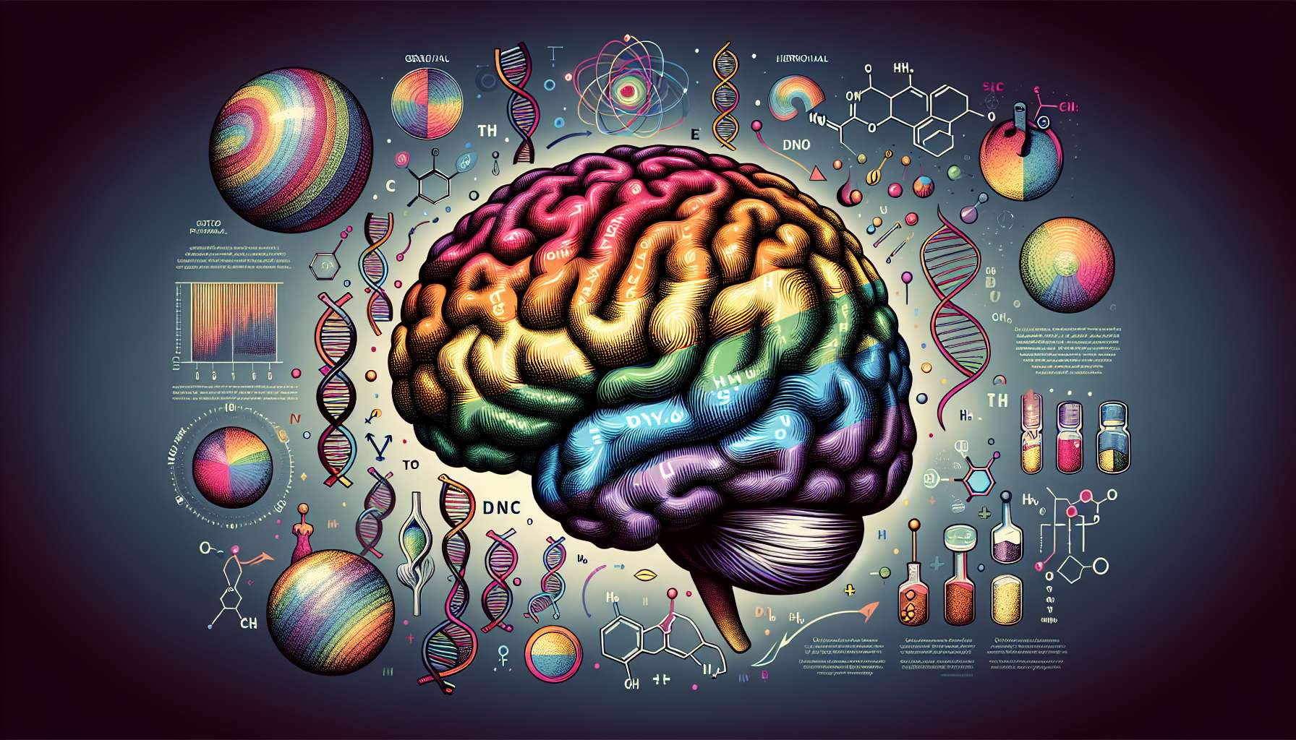

Neuroscience and biology provide complementary insights to understand the biological foundations of sexual orientation and gender identity. They investigate the genetic, hormonal and neurological factors that underlie the diversity of sexual and gender expressions. While acknowledging the role of biological influences, these approaches do not consider them as absolute determinants and emphasize the complex interaction between biology and environment in the development of identities.  
  
Studies in behavioral genetics, conducted on twins, have highlighted a hereditary component of sexual orientation. They show that monozygotic twins (genetically identical) are more likely to have the same sexual orientation than dizygotic twins. However, the concordance is not 100%, suggesting that genes are not the only factor at play. Variations on certain genes, such as the Xq28 gene, have been associated with male homosexuality, without being predictive. These data indicate a complex and multifactorial genetic influence, interacting with the environment.  
  
Prenatal hormonal factors also appear to play a role in the development of sexual orientation and gender identity. Exposure to different levels of testosterone and estrogen in utero may influence sexual differentiation of the brain. Studies on women with congenital adrenal hyperplasia, exposed to high levels of androgens during gestation, show a higher probability of homosexual or bisexual orientation. Similarly, differences in the index-to-ring finger ratio (2D:4D), a marker of prenatal androgen exposure, have been observed in homosexual and transgender individuals. These data suggest a role for prenatal hormones in sexual orientation and gender identity, without unequivocally determining them.  
  
For example, in a 2019 study, researchers analyzed the genome of nearly half a million people and identified five genetic markers significantly associated with sexual orientation. However, these variants only explained 8 to 25% of the heritability of sexual orientation, highlighting the influence of other factors, including environmental ones.  
  
Neuroscience has also explored the neuronal correlates of sexual orientation and gender identity. Brain imaging studies have highlighted structural and functional differences between the brains of heterosexual and homosexual individuals, particularly in regions involved in the processing of sexual and emotional stimuli. In transgender individuals, brain activation patterns closer to their felt gender than their assigned sex have been observed. These data suggest a neuronal signature of sexual orientation and gender identity, without making them fixed neurobiological categories.  
  
Thus, a 2008 study showed that homosexual men had similar amygdala responses to heterosexual women when exposed to androgenic pheromones, while homosexual women had responses similar to heterosexual men. These results suggest a sex-atypical brain organization in homosexual individuals, possibly related to prenatal hormonal influences.  
  
It is important to emphasize that these neurobiological differences are neither binary nor deterministic. There is a large interindividual variability and many overlaps between groups. Biological influences interact complexly with the social and cultural environment to shape sexual identities and behaviors. Neuroscientific and biological approaches must therefore be articulated with social sciences to develop an integrative understanding of sexual and gender diversity.  
  
For example, epigenetics studies how the environment can modify gene expression, without changing the DNA sequence. Factors such as stress, nutrition or social experiences can influence the "activation" of certain genes. Thus, monozygotic twins may display epigenetic differences contributing to their differences in sexual orientation, despite identical genetic heritage. These epigenetic mechanisms illustrate the complex interaction between biological and environmental factors in the development of sexual orientation.  
  
Finally, it is crucial to remember that neuroscientific and biological research on sexual orientation and gender identity raises ethical and political issues. Historically, biologizing discourses have sometimes been used to pathologize and discriminate against LGBTQ+ individuals, presenting them as "abnormal" or "against nature". It is therefore essential to adopt a critical and reflexive approach, questioning the normative presuppositions underlying this research and being careful not to reduce identities to biological variables. Neuroscience and biology data must be used cautiously, from a depathologizing and non-essentialist perspective, to better understand and accept sexual and gender diversity.  
  
In summary, neuroscience and biology provide interesting insights into the biological foundations of sexual orientation and gender identity. They highlight the influence of genetic, hormonal and neural factors, while emphasizing their complex interaction with the environment. These approaches must be articulated with social sciences to develop a non-reductionist, integrative understanding of LGBTQ+ identities. Their inclusion in support for LGBTQ+ individuals can help deconstruct essentialist prejudices and value sexual and gender diversity as a natural expression of human variability. However, they must be used with caution and critical thinking, ensuring not to reduce identities to biological determinants, and always respecting the self-determination of the individuals concerned.  
  
Key points:  
  
1. Neuroscience and biology explore the biological foundations of sexual orientation and gender identity, studying the genetic, hormonal, and neurological factors that underpin the diversity of sexual and gender expressions.  
  
2. Behavioral genetic studies suggest a hereditary component of sexual orientation but it is not deterministic. Genes interact complexly with the environment.  
  
3. Prenatal exposure to different levels of sex hormones (testosterone, estrogens) can influence sexual differentiation of the brain and play a role in the development of sexual orientation and gender identity.  
  
4. Structural and functional differences have been observed in the brains of homosexual and transgender individuals, particularly in regions involved in the processing of sexual and emotional stimuli. However, these differences are not binary or deterministic.  
  
5. Biological influences interact complexly with the social and cultural environment to shape identities and sexual behaviors. Epigenetics illustrates how the environment can modify gene expression.  
  
6. Neuroscientific and biological research on sexual orientation and gender identity raises ethical and political issues. It is crucial to adopt a critical and reflexive approach, avoiding reducing identities to biological variables and pathologizing LGBTQ+ individuals.  
  
7. Neuroscientific and biological approaches should be combined with social sciences to develop an integrative and non-reductionist understanding of sexual and gender diversity, serving better acceptance and respect for the self-determination of those concerned.