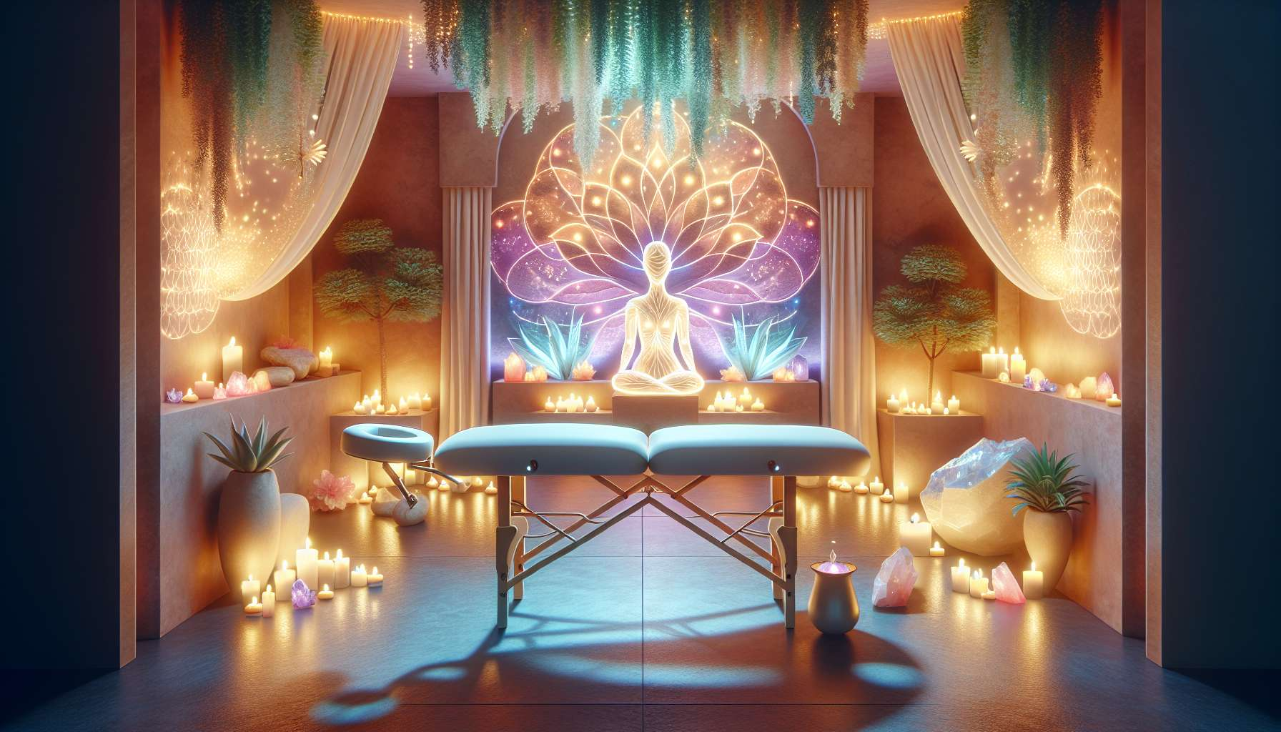

The preparation of space and oneself is a crucial step in creating an environment conducive to healing and letting go. As a Divine Feminine Healing practitioner, it is essential to pay particular attention to creating a warm, welcoming, and secure atmosphere for your clients.  
  
Start by choosing a space dedicated to your practice, ideally a quiet and private room where you will not be disturbed. Make sure to keep this space clean, tidy, and airy. You can add a personal touch with elements that promote relaxation and harmony, such as green plants, natural candles, stones or crystals. The use of soft, soothing colors can also contribute to creating a relaxing mood, as we saw in the module on chromotherapy.  
  
Carefully prepare the material you will need for the session: essential oils, floral elixirs, soft music, blankets, pillows, etc. Check that everything is in order and within reach before your client arrives. For example, you could create a small altar with symbolic objects that inspire you and connect you to sacred feminine energy.  
  
Before each session, take the time to center yourself and connect with yourself. Practice a few minutes of conscious breathing, meditation, or yoga to ground yourself in the present moment and make yourself available. Remember the importance of inner balance in order to offer quality space to the other.  
  
You may also perform a space purification ritual, using, for example, white sage, incense, or a singing bowl. The intention is to clarify the room's energy and create a bubble outside of time and space conducive to therapeutic work.  
  
Do not forget that your presence is the most valuable tool. Beyond the material preparation, it is your being and presence quality that will make the difference. Hence, cultivate an inner posture of calm, centering, kindness, and openness. Your client should feel upon her arrival that she is welcomed in a safe and containing space, conducive to letting go and connecting with oneself.  
  
Finally, remember to respect hygiene rules and current health protocols. Air out the room between each client, disinfect surfaces and equipment, wash your hands. These simple gestures contribute to creating a climate of trust and security, essential to the therapeutic process.  
  
In summary, the preparation of space and oneself is a sacred act that lays the foundations of the therapeutic relationship. By creating a warm, harmonious, and safe atmosphere, you offer your clients a haven conducive to inner exploration, emotional healing, and reconnection with their feminine essence.  
  
Key takeaways:  
  
- Choose a dedicated, quiet, and private space for your practice, and keep it clean, tidy, and airy.  
   
- Create a relaxing mood with elements such as plants, candles, stones, soft, and comforting colors.  
   
- Carefully prepare the necessary material before each session.  
   
- Center and connect with yourself before each session, perhaps with conscious breathing, meditation, or yoga.  
   
- Carry out a space purification ritual to clarify the energy of the room.  
   
- Cultivate an inner posture of calm, centering, kindness, and openness, as the practitioner's presence is the most precious tool.  
   
- Respect hygiene rules and health protocols to create a climate of trust and security.  
   
- The preparation of space and oneself lays the foundations of the therapeutic relationship by offering clients an environment conducive to inner exploration, emotional healing, and reconnection with their feminine essence.