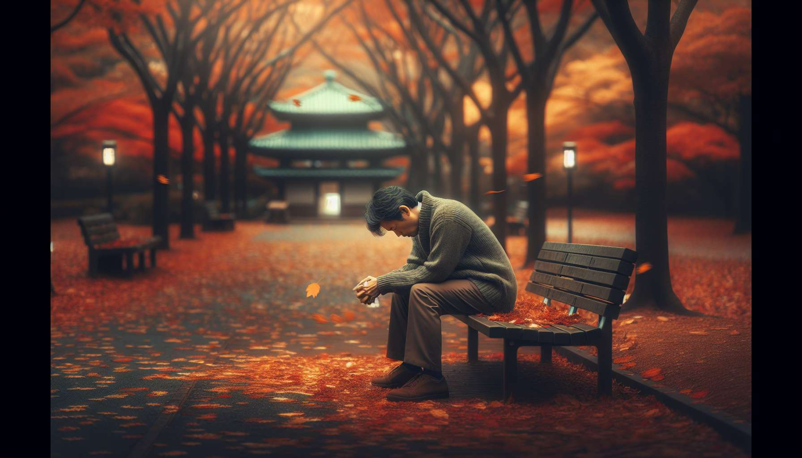

The place of bereavement in our contemporary Western societies is paradoxical. On one hand, death has never been so present in the media, in series, in video games. Images of disasters, attacks, wars reach us directly and continuously. Death is overexposed, trivialized, sometimes sensationalized. But on the other hand, bereavement remains a taboo subject, relegated to the private sphere, almost shameful. We value performance, success, control. Suffering and vulnerability are perceived as weaknesses to hide.  
  
This privatization of grief is a relatively recent phenomenon in history. Until the beginning of the 20th century, bereavement was a social event, framed by collective rituals and strict dress codes. Black was worn for a certain period, condolence visits were codified. Bereavement was visible, recognized and shared by the community. With the secularization and individualization of our societies, bereavement has become a private matter. Funeral rites have been standardized, shortened. We favor cremation over burial, civil ceremonies over religious services.   
  
This evolution is part of a more global approach to death in our modern societies. With the progress of medicine and the extension of life expectancy, death has gradually been pushed back, hidden, medicalized. We die mainly in hospital, away from our loved ones. The dead body is taken care of by professionals, hidden from sight. This distancing from death strengthens the feeling of strangeness and anxiety in the face of it. We are no longer familiar with its rituals, its stages. We no longer know how to behave in the presence of a bereaved person, what to say to them.   
  
When Marie's colleague lost his wife, he only took two days off for the funeral. Back in the office, he acted as if nothing had happened, joking with clients. But in private, he was collapsing, unable to cope with the pain he could not share with anyone. He internalized the social injunction to silence and resilience.  
  
This injunction to resilience is another characteristic of our contemporary relationship to bereavement. Under the influence of positive psychology, we value rebounding, rapid reconstruction. We expect bereaved people to quickly regain functionality, productivity. Bereavement leave is often minimal, a few days at most. We no longer have time to stop, to withdraw to live our grief. This pressure to be resilient can induce feelings of guilt in those unable to "get over their loss" according to the implicit timeline.  
  
Yet, many psychologists emphasize the importance of respecting the time of grief, which cannot be decreed. Each bereavement is unique and takes the time it needs. Trying to rush or deny it only delays the process. It is essential to be able to articulate one's grief, to find spaces to express and share it. This is the whole point of bereavement support groups that are developing, making up for the lack of informal social support.  
  
Sophie took more than a year to realize that her husband had died. She kept talking to him, setting his plate, waiting for him to return. Her environment was worried about this apparent denial. By joining a support group for widows, Sophie was able to express her sorrow and doubts without being judged. She realized that her path was unique and that she had the right to take the time she needed.  
  
Another significant evolution in the place of bereavement in our societies is the emergence of new practices related to digital technology. With social networks, bereavement takes on an unprecedented virtual dimension. We announce the death of a loved one on Facebook, we receive condolences by text message. Deceased people's pages become virtual memorials where messages, photos are left. Some even go so far as to create chatbots imitating the deceased to continue interacting with them.  
  
These practices question the boundary between private and public, real and virtual. They offer new spaces for expression and sharing of grief, especially for younger generations. But they also raise ethical questions about respect for privacy, management of digital data after death. They can also give the illusion of a presence that impedes necessary detachment.   
  
Since her daughter's death, Nadia spends hours on her Facebook profile. She looks at her photos, re-reads her posts, writes her messages. Sometimes, she feels like her daughter is going to answer. Her therapist invites her to reflect on the meaning of these virtual interactions. Is it a way to cultivate her memory or an avoidance of the reality of her absence?  
  
Finally, the place of bereavement in our societies raises questions about the social recognition of certain losses. All bereavements are not equal in the face of social conventions. Some remain taboo, unrecognized, causing discomfort. This is the case with perinatal losses (miscarriages, deaths in utero, deaths at birth) which are still too often minimized. This is also the case with deaths by suicide, drug overdose, AIDS which remain stigmatized. Or pet bereavements, considered as "non-losses".  
  
This implicit ranking of bereavements can generate significant suffering among the bereaved concerned. Deprived of social support, rituals, legitimacy in their grief, they feel misunderstood, alone, sometimes even ashamed. Recognizing the diversity of bereavement experiences and embracing all losses without judgment is a major challenge for a more inclusive and empathetic society.  
  
When Leah's dog died, she took a week off. Her colleagues laughed, not understanding why one can be devastated by the loss of "just an animal". Leah felt very alone in her grief. By joining a forum for people bereaved by their pet, she found support and realized her grief was legitimate.  
  
In summary, the place of bereavement in our contemporary societies is in full evolution. Between overexposure to death and denial of bereavement, between privatization and virtualization of rituals, between the demand for resilience and the need for recognition, bereaved people navigate a choppy sea of paradoxes and contradictory injunctions. Reintegrating bereavement as a natural and universal experience, giving it a place in the social space, respecting its diverse expressions, these are challenges for a more humane and compassionate society in the face of suffering.  
  
Key takeaway points:  
  
- The place of bereavement in our contemporary Western societies is paradoxical: death is overexposed in the media but bereavement remains a taboo subject, relegated to the private sphere.  
  
- Bereavement has moved from a social event framed by collective rituals to a private affair, with the secularization and individualization of our societies.  
  
- Death is increasingly pushed back, hidden and medicalized, enhancing the feeling of estrangement and anxiety towards it.  
  
- There exists a social injunction to resilience and rapid recovery after bereavement, sometimes generating a sense of guilt in the bereaved.  
  
- It is important to respect the unique timing of each bereavement and to find spaces to express and share grief.  
  
- Digital technology is introducing new bereavement practices (announcements on social networks, virtual memorials) that question the boundary between private and public, real and virtual.  
  
- Some bereavements remain taboo and not socially recognized (perinatal losses, stigmatized deaths, pet bereavements), adding to the sorrow of the bereaved concerned.  
  
- Recognizing the diversity of bereavement experiences and reintegrating bereavement as a natural experience in the social space are challenges for a society that aims to be more compassionate towards suffering.