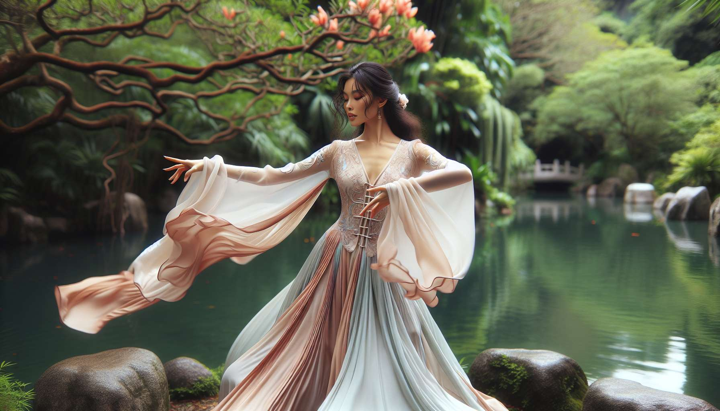

Qi Gong and Tai Chi are two thousand-year-old Chinese energetic arts that aim to cultivate and harmoniously circulate vital energy (Qi) within the body. These practices are particularly beneficial for women, allowing them to strengthen their overall health, balance their emotions, and reconnect with their deep feminine essence.  
  
The Qi Gong relies on the slow and mindful execution of fluid movements, combined with deep breathing and mental focus. Sequences are often inspired by natural elements (such as water, wind, fire) or the animal kingdom (crane, tiger, dragon...). Through regular Qi Gong practice, women learn to relax their bodies, soothe their minds, and release energy blockages. Some specific movements help to tone the reproductive organs, stimulate blood circulation in the pelvis, and alleviate menstrual cycle-related disorders. Qi Gong is also very effective in reducing stress, anxiety, and sleep disorders, by regulating the nervous system.  
  
The Tai Chi, often described as a "moving meditation", is a sequence of martial postures performed slowly, gracefully, and precisely. This art promotes grounding, balance, and coordination. For women, Tai Chi develops inner strength, self-confidence, and assertiveness. The practice emphasizes the alternation between Yin (receptivity, gentleness, inwardness) and Yang (action, firmness, outwardness), thus reflecting the subtle dance of feminine and masculine polarities within each. Tai Chi is also recognized for its benefits on bone density, joint flexibility, and postural balance, essential aspects for women's health, particularly post-menopause.  
  
To integrate Qi Gong and Tai Chi in a Divine Feminine Healing practice, you might propose specific movements related to the phases of the menstrual cycle (module 2.4) or feminine archetypes (module 1.4). Thus, you can teach the sequence of the "Six Healing Sounds" in Qi Gong to harmonize the organs and emotions, or the "13 Movement Tai Chi" form which evokes the grace and fluidity of feminine energy. These arts can also be combined with guided visualizations of the elements (module 6.6) or meditations on goddesses (module 4.5) to enhance their therapeutic power.  
  
Here is a concrete example of a Qi Gong sequence for women, called "Goddess Spirals":  
1. Standing, feet rooted in the ground, visualize a golden thread connecting you to the sky. Breathe deeply into your belly, imagining a golden light filling your pelvis.  
2. Begin to draw spirals in front of your body with your hands, palms facing down. Inhale as you raise your arms and exhale as you lower them, in a continuous, fluid movement.  
3. Visualize swirling the creative energy in your pelvis, awakening your feminine power. Feel the warmth and vitality spreading through your entire body.  
4. Vary the size and orientation of the spirals, always synchronizing the movement with your breath. Let your pelvis softly undulate, as if rocked by a peaceful swell.  
5. To finish, gather the energy between your palms and lay it on your lower abdomen. Take a moment to feel the awakening of your feminine energy and send yourself a message of love and gratitude.  
  
By regularly practicing Qi Gong and Tai Chi, women reconnect with their bodies, their emotions, and their natural cycles. They cultivate flexibility, fluidity, and inner harmony, essential qualities to fully unfold their feminine potential and thrive in their lives. These ancestral arts are priceless tools for accompanying women on their path to healing and personal transformation.  
  
Key Takeaways:  
  
- Qi Gong and Tai Chi are two Chinese energetic arts that aim to cultivate and harmoniously circulate vital energy (Qi) within the body. They are particularly beneficial for women's overall health.  
- Qi Gong uses fluid movements, deep breathing, and mental focus to relax the body, soothe the mind, and release energy blockages. It can alleviate menstrual cycle-related disorders and reduce stress and anxiety.  
- Tai Chi is a "moving meditation" that promotes grounding, balance, and coordination. It allows women to develop their inner strength and confidence and reflects the dance of feminine and masculine polarities. It also benefits bone density and flexibility.  
- To integrate Qi Gong and Tai Chi into a Divine Feminine Healing practice, one can propose movements related to the menstrual cycle or feminine archetypes and combine them with visualizations and meditations.  
- One example of a Qi Gong sequence for women is "Goddess Spirals", which awakens the creative energy of the pelvis through fluid, spiraled movements synchronized with breath.  
- By regularly practicing these arts, women reconnect with their bodies, their emotions, and cultivate the flexibility, fluidity, and inner harmony essential to their fulfillment.