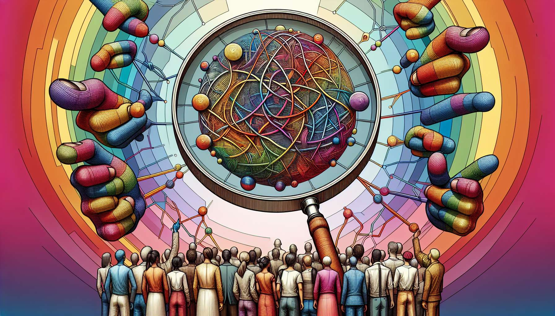

Epistemology is a branch of philosophy that questions the conditions for the production and validity of knowledge. When applied to the field of gender and sexuality, it provokes critical reflection on how knowledge about these subjects is constructed, legitimized, and disseminated. It questions the normative assumptions underlying scientific, medical, legal, or activist discourses about gender and sexuality.  
  
A central issue is that of the naturalization of gender and sexuality categories. Numerous discourses tend to present these categories as natural, universal, and ahistorical realities. Feminist and queer epistemology challenges this naturalization, showing how gender and sexuality categories are social and historical constructions, which vary according to cultural contexts and times. They denounce essentialism, which consists of reducing identities to fixed and immutable properties, inscribed in biology or the psyche.  
  
For example, medical discourses have long presented homosexuality as a mental illness, relying on psychoanalytic or behaviorist theories. It was not until 1973 when homosexuality was removed from the Diagnostic and Statistical Manual of Mental Disorders (DSM) in the United States, under pressure from gay and lesbian activist movements. This example shows how psychiatric categories are social constructions, reflecting the norms and power relations of a period.  
  
Another issue at stake is that of the objectivity and neutrality of knowledge about gender and sexuality. Dominant epistemology, inherited from positivism, postulates a clear separation between the knowing subject and the object of knowledge. It values an ideal of objectivity and axiological neutrality, where the researcher is seen as an impartial observer, detached from his object. Feminist epistemology challenges this ideal, showing that all knowledge is situated, that is, it is produced from a particular social and political position. It encourages acknowledging the subjective and embodied dimension of knowledge, as well as the power relations that traverse it.  
  
Thus, feminist studies have shown how medical research on women's bodies and sexuality has long been biased by sexist and androcentric assumptions. Clinical trials often excluded women, considering the male body as the norm. The specific symptoms of cardiovascular diseases in women were little studied, leading to diagnostic errors. These biases reflect the dominant position of men in the medical institution and society in general.  
  
Gender and sexuality epistemology also questions the conditions for the legitimization and circulation of knowledge. It shows how some discourses acquire the status of truth, while others are disqualified or marginalized. It analyzes the power relations between the different actors who produce and disseminate knowledge about gender and sexuality: researchers, doctors, lawyers, journalists, activists... It highlights the importance of social movements and subaltern countercultures in the production of alternative knowledge and challenging dominant discourses.  
  
For example, the knowledge of trans people has long been marginalized and disqualified by medical and psychiatric discourses. Trans experiences and identities were reduced to pathological categories, such as "transsexualism" or "gender identity disorder". Trans people had to conform to strict and stereotypical medical protocols to access transition. It is only recently, under the impetus of trans movements, that alternative knowledge has emerged, valuing the self-determination of trans individuals and the depathologization of identities.  
  
Lastly, gender and sexuality epistemology invites reflection on the social and political uses of knowledge. It shows how scientific knowledge can be used to legitimize or challenge power relations, to pathologize or emancipate social groups. It underscores the ethical and political responsibility of knowledge producers, encouraged to question the effects of their discourses on the populations concerned.  
  
Thus, feminist and queer theories have been used by LGBTQ+ movements to deconstruct pathologizing discourses about non-conforming sexualities and gender identities. They have helped develop counter-discourses asserting the legitimacy and pride of LGBTQ+ identities. In turn, activist knowledge has enriched academic reflection by encouraging it to shift from dominant categories and include the voices of those concerned.  
  
In summary, the epistemology of knowledge about gender and sexuality encourages critical vigilance about the conditions for the production, legitimacy, and use of this knowledge. It urges professionals supporting LGBTQ+ people to question their own assumptions, diversify their sources of knowledge and value the experiential knowledge of the people concerned. Adopting a reflective and critical stance towards knowledge is essential for developing ethical and emancipatory support practices that serve the self-determination and well-being of LGBTQ+ individuals.  
  
Key takeaways:  
  
- Gender and sexuality epistemology critically examines the production and validity of knowledge in these fields.  
  
- It calls into question the naturalization of gender and sexuality categories, showing that these are social and historical constructs.  
  
- The objectivity and neutrality of knowledge are questioned: all knowledge is situated and reflects power relations.  
  
- Conditions for the legitimization and circulation of knowledge are analyzed, showing how certain discourses dominate while others are marginalized.  
  
- Social movements and activist knowledge play a pivotal role in producing counter-discourses and alternative knowledge.  
  
- Epistemology invites reflection on the social and political uses of gender and sex knowledge, and the responsibility of knowledge producers.  
  
- Adopting a reflective and critical stance toward knowledge is paramount for professionals assisting LGBTQ+ individuals, in order to cultivate ethical and emancipatory practices.