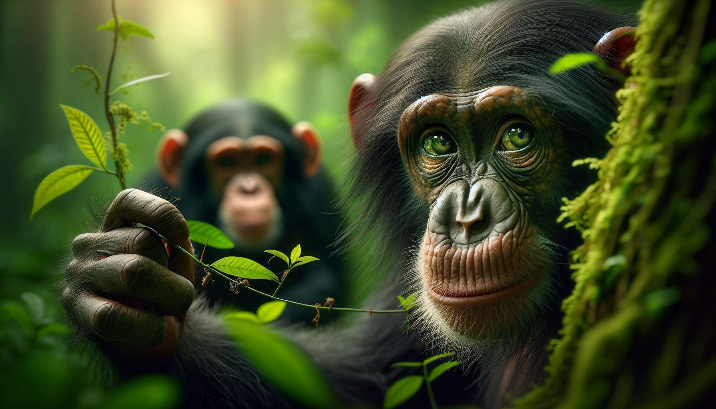

Ethology is the science that studies the behavior of animals in their natural environment. It is interested in the interactions between the animal and its environment, as well as the biological and psychological mechanisms that underlie these behaviors. Modern ethology was founded in the 1930s by biologists Konrad Lorenz, Nikolaas Tinbergen, and Karl von Frisch, who received the Nobel Prize in 1973 for their pioneering work in this field.  
  
Ethologists observe animals in their natural habitat and describe their behaviors in an objective and systematic way. They seek to understand how these behaviors have evolved throughout the history of the species and what are their adaptive functions. For example, the study of hunting behavior in lions has shown that cooperation between group members increases the chances of success, which has favored the evolution of this social behavior.  
  
A key concept in ethology is that of instinct, which refers to an innate, hereditary behavior specific to a species. Fixed action patterns, like the dance of bees or the mating display of certain birds, are typical examples. These instinctive behaviors are triggered by specific signal-stimuli and occur in a stereotyped manner.  
  
However, modern ethology also acknowledges the importance of learning and behavioral flexibility. Many behaviors result from a complex interaction between genetic predispositions and experiences lived by the individual. Thus, in chimpanzees, imitation learning plays a crucial role in the transmission of tool use techniques within the group.  
  
Animal communication is another fascinating study area for ethologists. Animals use a wide variety of visual, acoustic, olfactory, and tactile signals to exchange information and coordinate their social interactions. Understanding animal communication systems has important applications, notably for the welfare of pets and farm animals.  
  
The observation methods used in ethology are varied and adapted to the characteristics of each species. They include direct observation in the field, often using binoculars or cameras, but also controlled experiments to test specific hypotheses. Ethologists also use modern techniques like radio-tracking or acoustic analysis to study behaviors difficult to observe directly.  
  
In conclusion, ethology offers an exciting perspective on animal life and helps us better understand our own behaviors as an animal species. It has important practical applications in diverse fields such as wildlife conservation, farming, veterinary medicine, or comparative psychology. For Grief Coaches specializing in animal bereavement, a basic knowledge of ethology is essential to understand the deep nature of the bond that connects humans to their animal companions.  
  
Key takeaways:  
  
- Ethology is the science that studies animal behavior in their natural environment, focusing on the interactions between the animal and its environment, as well as the underlying biological and psychological mechanisms.  
  
- The pioneers of modern ethology are Konrad Lorenz, Nikolaas Tinbergen, and Karl von Frisch, who received the Nobel Prize in 1973 for their work.  
  
- Ethologists seek to understand the evolution and adaptive functions of animal behaviors by observing them in an objective and systematic manner.  
  
- Instinct is a key concept in ethology, referring to an innate, hereditary behavior specific to a species, triggered by specific signal-stimuli.  
  
- Modern ethology also recognizes the importance of learning and behavioral flexibility, resulting from an interaction between genetic predispositions and lived experiences.  
  
- Animal communication, using visual, acoustic, olfactory, and tactile signals, is an important field of study in ethology.  
  
- The observation methods in ethology are diverse and adapted to each species, ranging from direct observation in the field to the use of modern techniques like radio-tracking.  
  
- Ethology has practical applications in various fields, such as wildlife conservation, farming, veterinary medicine, and comparative psychology.  
  
- For Grief Coaches specializing in animal bereavement, a basic understanding of ethology is essential for understanding the deep bond between humans and their animal companions.