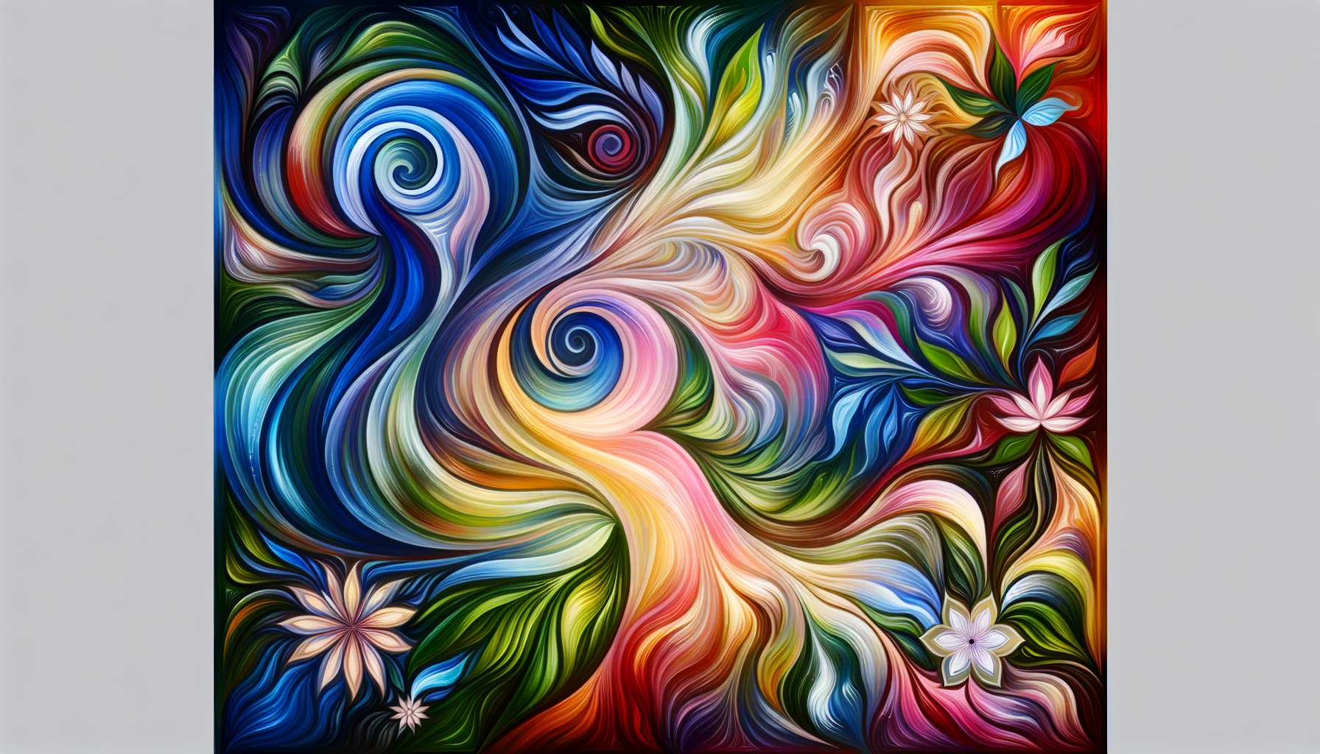

Chromotherapy is a therapeutic approach that uses the vibrational and energetic properties of colors to rebalance the body and mind. Each color has a unique frequency that resonates with different aspects of our being, and can be used to support physical, emotional, and spiritual healing processes.  
  
Colors are omnipresent in our environment and have a profound impact on our well-being, often unbeknownst to us. Chromotherapy invites us to become aware of this influence and to use colors intentionally to create harmonious and therapeutic living spaces.   
  
In chromotherapy, it is considered that each color is connected to a part of the body, an organ function, and a specific emotional state. For example, red is associated with vitality, grounding, and blood circulation, while blue is linked to soothing, communication and the respiratory system.  
  
Here is an overview of the main colors used in chromotherapy and their indications:  
  
- Red: stimulates vital energy, warms the body, boosts blood circulation. Indicated for fatigue, anemia, low blood pressure.  
   
- Orange: promotes zest for life, relieves emotional tension, stimulates creativity. Indicated for mild depression, digestive disorders, creative blockages.  
   
- Yellow: clarifies the mind, strengthens the nervous system, stimulates concentration. Indicated for mental confusion, weak memory, constipation.  
   
- Green: balances emotions, regenerates tissues, soothes the nervous system. Indicated for nervousness, irritability, chronic fatigue.  
   
- Blue: soothes the mind, promotes communication, relieves inflammation. Indicated for insomnia, sore throats, fever.  
   
- Indigo: develops intuition, calms the mind, purifies the blood. Indicated for stress, skin disorders, migraines.  
   
- Purple: raises spiritual consciousness, stimulates the immune system, relieves pain. Indicated for autoimmune diseases, nervous disorders, bereavement.  
  
For women in particular, certain colors can be precious allies to accompany the different phases of their life cycle. For example, red and orange are energizing colors that can be used to support vitality during menstruation or to stimulate libido. Green and blue are soothing colors that can help regulate emotions during the premenstrual phase or gracefully navigate through menopause.  
  
There are many ways to integrate colors into daily life and in Divine Feminine Healing practice. For example, one can dress in specific colors according to their needs, decorate their interior with harmonious shades, surround themselves with meaningful colored objects or visualize colors in meditation.  
  
In session, the practitioner can use tools such as colored fabrics, chromotherapy lamps, or color elixirs to bathe the client in an atmosphere conducive to relaxation and healing. She can also guide visualizations where colors are imagined radiating and rebalancing different parts of the body and different energy centers.  
  
Chromotherapy can be combined with other approaches such as flower elixirs, aromatherapy, or lithotherapy to create powerful vibrational synergies. For example, one can use a blue-colored flower elixir like agrimony to soothe the mind, in synergy with soothing chamomile essential oil and a lapis lazuli stone to stimulate self-expression.  
  
Beyond their therapeutic properties, colors also have a deep symbolic and spiritual dimension. In many traditions, they are associated with qualities of the soul, virtues, or stages of consciousness evolution.  
  
As a Divine Feminine Healing practitioner, it is essential to familiarize oneself with the language of colors and develop sensitivity to their subtle nuances. This requires refining one's inner vision, listening to intuition, and connecting with the wisdom of the heart. Because beyond theoretical knowledge, it is by cultivating an intimate and living relationship with colors that one can truly perceive their messages and magic.  
  
Integrating chromotherapy into practice offers women a gentle, poetic, and intuitive healing path that invites them to connect with the beauty of the world and the light of their being. It offers them vibrant, colorful keys to traverse their shadows, unfold their gifts, and radiate their unique essence. It also accompanies them in a process of heart-opening and awakening to joy, in resonance with the rainbow of life.  
  
Chromotherapy is a subtle art that requires presence, listening, and intuition. It invites us to marvel at the infinite palette of colors, to savor their nuances, and to receive their teachings. It teaches us to see life as a perpetual work of art in creation, where each color has its place and beauty.  
  
As Divine Feminine Healing practitioners, may we be messengers of light and color, to re-enchant the world and celebrate life in all its nuances. May we convey to the women we accompany the confidence in their own inner palette, and the audacity to unfold their unique colors with authenticity and freedom. Because it is by daring to fully radiate our colors that we become co-creators of a more beautiful, vibrant and brighter world.  
  
Key Takeaways:  
  
- Chromotherapy uses the vibrational and energetic properties of colors to rebalance the body and mind. Each color has a unique frequency that resonates with different aspects of our being.  
  
- Colors have a profound impact on our well-being. Chromotherapy invites us to become aware of this and to use them intentionally to create harmonious and therapeutic living spaces.  
  
- Each color is linked to a part of the body, an organ function, and a specific emotional state. For example, red is associated with vitality and blood circulation, while blue is linked to soothing and the respiratory system.  
  
- For women, certain colors can be valuable allies to accompany the different phases of their life cycle, such as red and orange to support vitality during menstruation, or green and blue to help regulate emotions during the premenstrual phase.  
  
- There are many ways to integrate colors into daily life and in Divine Feminine Healing practice, like dressing in specific colors, decorating with harmonious shades, or visualizing colors in meditation.  
  
- Chromotherapy can be combined with other approaches such as flower elixirs, aromatherapy, or lithotherapy to create powerful vibrational synergies.  
  
- As a Divine Feminine Healing practitioner, it is essential to familiarize oneself with the language of colors, develop sensitivity to their nuances, and cultivate an intimate and living relationship with them.  
  
- Integrating chromotherapy into practice offers women a gentle, poetic, and intuitive healing path that invites them to connect with the beauty of the world and the light of their being.