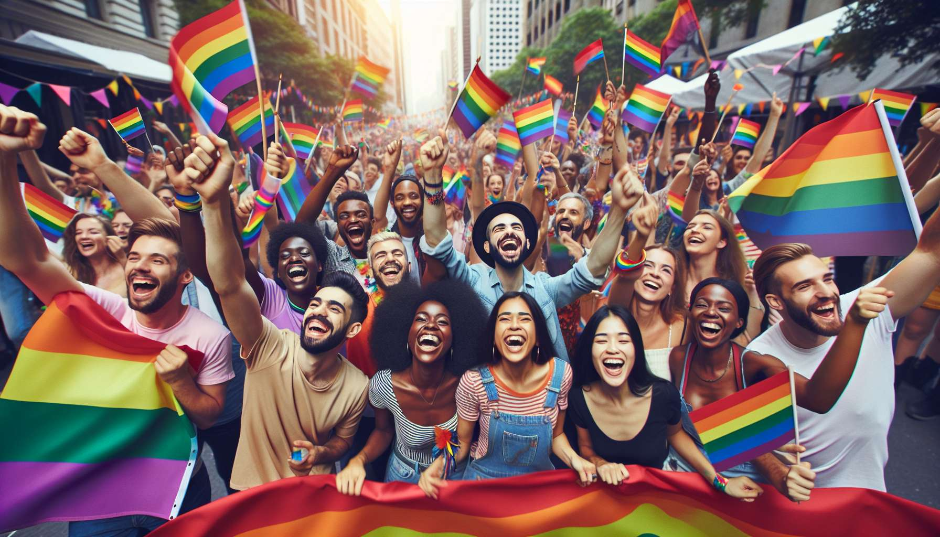

Visibility days are key moments for LGBTQ+ communities around the world. They allow for the celebration of the diversity of identities and gender expressions, raise public awareness about the fight against discrimination, and strengthen solidarity within the communities.  
  
Among these days, the most emblematic is undoubtedly the International Day Against Homophobia, Transphobia, and Biphobia (IDAHOT), which is held every year on May 17. This date was chosen in reference to May 17, 1990, the day when the World Health Organization removed homosexuality from the list of mental illnesses. Launched in 2004 by the IDAHO committee (International Day Against Homophobia), this day is now celebrated in over 130 countries through cultural events, debates, gatherings. Each year, a theme is highlighted: in 2021, it was "Together: Resist, Support, Heal!" in reference to the Covid-19 pandemic and its impact on LGBTQ+ individuals. IDAHOT is an opportunity for many institutions and companies to show their support for the LGBTQ+ cause, for example by flying the rainbow flag. It is also a time for awareness in schools and universities.  
  
Another important day is the Transgender Day of Visibility (TDoV), which is held every year on March 31. Created in 2009 by American activist Rachel Crandall, this day aims to celebrate transgender people and raise public awareness of the discrimination they face. It is an opportunity to highlight historical or contemporary figures in trans activism, such as Marsha P. Johnson or Laverne Cox, but also to give a voice to ordinary trans people to share their experiences and aspirations. Many events are organized on this occasion, such as film screenings, exhibits, round tables. On social media, trans people and their allies share messages of pride and support with the hashtag TransDayOfVisibility.  
  
Pride Marches, also known as Gay Pride or LGBT Pride, are another high point of LGBTQ+ visibility. They are held every year around June, in reference to the Stonewall riots of June 1969 that marked the birth of the modern gay liberation movement. The first march took place in 1970 in New York, at the call of the Gay Liberation Front and Gay Activists Alliance. Since then, the movement has spread to many countries around the world. In France, the first march took place in 1977 at the call of the Gay Liberation Group (GLH). Today, Pride Marches are organized in many French cities, attracting hundreds of thousands of participants. These marches are both a time of celebration, with colorful floats and artistic performances, and a time of political demand, with slogans and speeches advocating for equal rights. They give positive visibility to LGBTQ+ communities and help create a sense of belonging and solidarity. They are also an opportunity to build alliances with other social movements, such as feminism or anti-racism.  
  
These visibility days are part of a long history of LGBTQ+ activism. They echo other moments of collective mobilization, such as the Day of Silence launched in 1996 in American universities to protest against the silence imposed on LGBTQ+ people, or the "National Coming Out Day" launched in 1988 to encourage LGBTQ+ people to publicly affirm their identity. They testify to the creativity and resilience of LGBTQ+ communities to exist in public space despite oppressions.  
  
However, these visibility days also face criticism and debates within LGBTQ+ movements. Some activists denounce the increasing depoliticization and commercialization of Pride Marches, with floats sponsored by major companies accused of "pinkwashing," i.e., instrumentalizing the LGBTQ+ cause for marketing purposes without truly committing to equality. Others point out the lack of inclusiveness and representation in these events, still very focused on cisgender white gay men and not open enough to LGBTQ+ people of color, trans, non-binary, disabled, or precarious. The issue of police presence in Pride Marches is also a topic of debate, with some activists refusing to march alongside an institution perceived as LGBTphobic and racist.  
  
As sociologist Salima Amari points out, "visibility is not an end in itself, it is a means of social transformation". Beyond identity affirmation, the challenge is to turn these days into levers for social and political change, by combining celebration and demand, pride and indignation, joy and resistance. It is about reclaiming public space to make it a place of contestation of norms, but also a place of invention of new ways of life and relationships. In this sense, visibility days are both a legacy to honor and a horizon to incessantly reinvent, in order to advance equality and emancipation for all.  
  
Key Points:  
  
- LGBTQ+ visibility days, such as IDAHOT (May 17), Transgender Day of Visibility (March 31), and Pride Marches (June), allow for the celebration of diverse identities, raising public awareness, and strengthening solidarity.  
  
- These days are part of a long history of LGBTQ+ activism and echo other moments of collective mobilization. They demonstrate the creativity and resilience of LGBTQ+ communities to exist in public space despite oppressions.  
  
- Pride Marches are both a time of celebration and political advocacy. They provide positive visibility to LGBTQ+ communities and create a sense of belonging and solidarity, as well as build alliances with other social movements.  
  
- However, these days face criticism and debates within LGBTQ+ movements, particularly on depoliticization, commercialization, lack of inclusivity and representation, as well as the presence of law enforcement.  
  
- Beyond identity affirmation, the challenge is to turn these days into levers for social and political change, combining celebration and demand, pride and indignation, joy and resistance, to advance equality and emancipation for all.