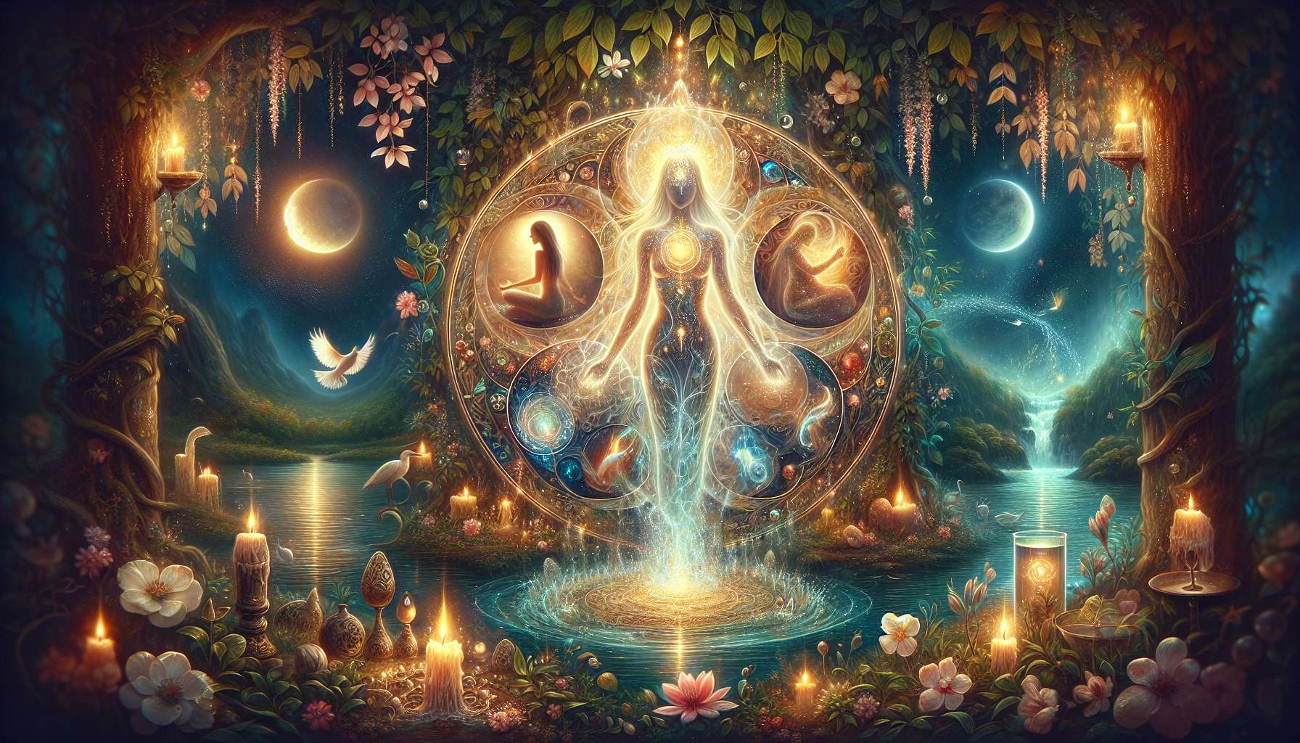

The Wicca is a modern spiritual tradition that draws its roots from pre-Christian pagan cults of Western Europe. It honors the divine feminine principle, embodied by the Goddess, in harmony with the masculine principle, represented by the Horned God. Wicca places a central focus on the cycles of nature and rituals that celebrate feminine energies, thus offering a path of awakening and healing particularly suited to women.  
  
At the heart of Wiccan practice is the worship of the Triple Goddess, who embodies the three aspects of the sacred femininity: the Maiden, symbol of purity, innocence, and renewal; the Mother, source of life, fertility, and creation; and the Crone, holder of knowledge, wisdom, and mysteries. Each aspect is associated with a phase of the moon and a moment in the life cycle of women, inviting them to honor and integrate these energies into their own existence.  
  
Rituals are at the heart of Wiccan practice and allow connection to the subtle energies of nature and the cosmos. The Sabbats, which celebrate the key points of the wheel of the year, are special moments to honor feminine energies and connect with the cycles of the Earth. Hence, Imbolc (February 1) celebrates purification and renewal, Beltane (May 1) honors fertility and sacred sensuality, Lammas (August 1) marks the time of harvest and abundance, and Samhain (October 31) invites exploring the mysteries of death and rebirth.  
  
Esbats, rituals that follow the phases of the moon, are opportunities to honor the Goddess and work with the lunar energies. The new moon is conducive to introspection, shaping intentions and planting metaphorical seeds. The full moon is a moment of celebration, gratitude, and release of stagnant energies. Each phase is an invitation to synchronize oneself with natural rhythms and cultivate an intimate relationship with the creative forces of the universe.  
  
Wiccan rituals call upon various sacred tools to channel and direct subtle energies. The altar, the sacred space where the symbols of the Goddess and God are laid out, is the vibratory heart of the practice. Candles, representing the element fire, are used to invoke light, passion, and transformation. Crystals, precious allies of the earth, amplify energies and promote healing. Herbs and essential oils, gifts from the plant kingdom, purify the space and elevate vibrations. Each tool becomes a support for awakening and honoring the sacred feminine within oneself.  
  
Wicca also invites the cultivation of a deep relationship with the elements - earth, air, fire, water - and to honor them as manifestations of the Goddess. Specific rituals allow for connection to each element and balancing their energies within oneself. Thus, an earth ritual may include a seated meditation in contact with the ground, an offering of seeds or crystals, and a dance to ground the energies of stability and abundance. A water ritual may take place near a river or ocean, with libations and songs to purify emotions and promote inner fluidity.  
  
Beyond collective rituals, Wicca encourages a personal and intimate practice with the sacred feminine. Guided meditations, creative visualizations, and shamanic journeys are all tools to explore the different facets of the Goddess within oneself and receive her teachings. Working with archetypes, such as the Priestess, the Healer, the Witch, or the Enchantress, allows awakening of internal resources and unfolding one's full potential as a woman.  
  
Wicca thus offers a path of emancipation and healing for women, inviting them to reconnect with their sacred essence and creative power. By honoring the cycles of life and cultivating an intimate relationship with the forces of nature, they can transform the wounds of patriarchy and re-enchant their existence. They become agents of change, working for the advent of a world where the sacred feminine is honored and celebrated in all its beauty and power.  
  
Integrating the teachings of Wicca into our Divine Feminine Healing practice allows us to offer women a sacred space to reconnect with their deep essence and deploy their inner magic. By creating speaking circles, rites of passage, and healing ceremonies, we participate in the resurgence of the sacred feminine and the transmission of ancestral wisdom. May we all awaken to our priestess nature and embody the Goddess in each of our actions, for our greatest good and that of Mother Earth.  
  
Takeaways:  
  
1. Wicca is a modern spiritual tradition that honors the divine feminine principle, the Goddess, in harmony with the masculine principle, the Horned God.  
  
2. The worship of the Triple Goddess is central, embodying the three aspects of sacred femininity: the Maiden, the Mother, and the Crone.  
  
3. Rituals, like Sabbats and Esbats, allow for connection with the subtle energies of nature and the cosmos, celebrating the key points in the wheel of the year and phases of the moon.  
  
4. Sacred tools, like the altar, candles, crystals, and herbs, are utilized to channel and direct subtle energies during rituals.  
  
5. Wicca invites one to develop a profound relationship with the elements (earth, air, fire, water) and to honor them as manifestations of the Goddess.  
  
6. Personal practice, through meditations, visualizations, and shamanic journeys, allows for exploring the different facets of the Goddess within oneself and receiving her teachings.  
  
7. Working with feminine archetypes aids in awakening internal resources and unfolding one's full womanly potential.  
  
8. Wicca offers a path to emancipation and healing for women, inviting them to reconnect with their sacred essence and creative power.  
  
9. Integrating the teachings of Wicca into the practice of Divine Feminine Healing provides the creation of sacred spaces for women's reconnection to their deep essence and transmission of ancestral wisdom.