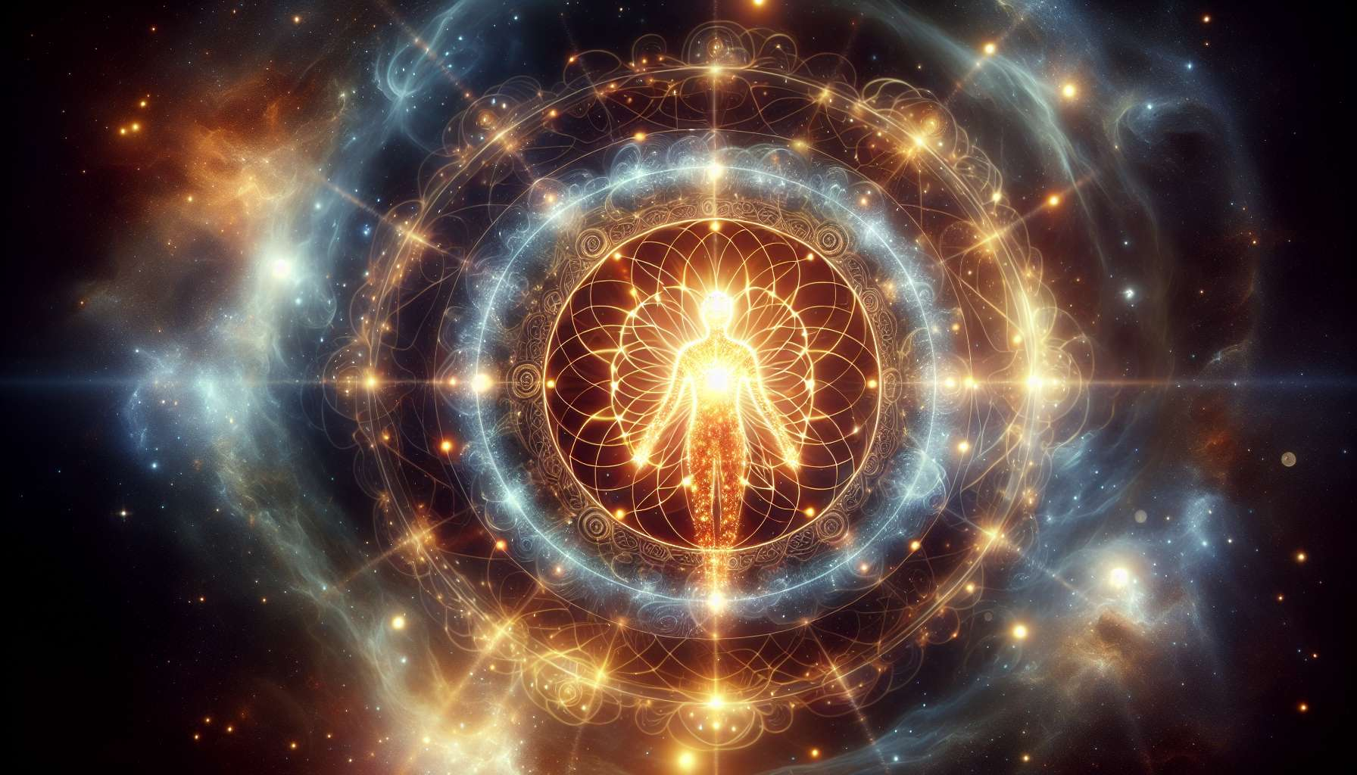

Bodies of light and bodies of wisdom represent the most subtle and highest dimensions of our being. They are the manifestation of our divine nature and our unlimited potential. Unlike the physical, etheric, astral and mental bodies which are still subject to the laws of duality and separation, the bodies of light and wisdom vibrate at a much higher frequency and are in direct resonance with the Universal Source.  
  
The concept of the body of light has its origin in many spiritual traditions, such as Tibetan Buddhism, Taoism, or Kabbalah. It is often associated with the idea of a "resurrection body" or "ascension body", that is, a subtle vehicle that allows consciousness to transcend the limits of matter and access higher dimensions of reality. In the yogic tradition, we talk about a "diamond body" or "vajra deha", an indestructible and luminous body that is the support of awakening.  
  
The body of light is considered as the vehicle of the soul, the sacred temple in which our divine spark resides. It is made up of a subtle and luminous matter, vibrating with love and wisdom. When it is fully activated and deployed, it radiates an indescribable clarity and beauty, similar to an inner sun. It is through the body of light that we can experience the highest states of consciousness, such as mystic ecstasy, fusion with the divine or realization of our Buddha nature.  
  
The body of wisdom, for its part, is the direct emanation of our higher Self, of our essential nature beyond the ego and conditioning. It is the receptacle of our innate wisdom, of our intuitive knowledge of the laws of the universe. When we are aligned with our body of wisdom, we have access to infallible inner guidance, a spiritual compass that shows us the right and luminous path. It is at this level that the archetypes, the matrices of perfection that guide our evolution and realization, are located.  
  
The bodies of light and wisdom are not separated from the other subtle bodies, but are the culmination and quintessence of them. They naturally unfold when the lower bodies have been purified, balanced, and harmonized. This is why the work of the Spiritual Healing Coach first consists in helping the person to clean and align their different bodies, in order to create the optimal conditions for the emergence of the higher bodies.  
  
For example, a person who has worked on healing their emotional wounds and transforming their limiting mental patterns will naturally have access to higher levels of consciousness. By purifying their astral and mental body, they allow the light of their soul to spread more freely throughout their being. Similarly, an individual who has developed their energy sensitivity and mastery of subtle channels will be better able to capture the vibratory frequencies of the bodies of light and wisdom.  
  
The deployment of the higher bodies is a gradual and natural process, which resonates with the person's spiritual journey. It cannot be forced or rushed, but unfolds according to the unique rhythm of each soul. The coach's role is to accompany this process with patience, kindness, and discernment, proposing practices adapted to support the awakening of the bodies of light and wisdom.  
  
Among these practices, we can mention meditation, contemplation, heart prayer or activation of higher centers like the heart chakra or crown chakra. Working with spiritual guides, angels, and ascended masters is also a powerful catalyst for awakening higher bodies. By invoking these presences of light and merging with their essence, we can accelerate our own vibratory transmutation.  
  
For example, the practice of the inner smile meditation, which consists of spreading the light of the smile in every cell of the body, is an excellent way to awaken the body of light. Likewise, contemplating divine virtues and qualities, such as compassion, peace or joy, activates the codes of wisdom contained in our spiritual DNA.  
  
It is important to understand that the awakening of the bodies of light and wisdom is not an end in itself, but a stage on the path to ultimate realization. Even when we have access to these higher dimensions of our being, we continue to deepen our union with the divine, to refine our service to humanity and the planet. The higher bodies are valuable tools for accomplishing our soul's mission and participating in the elevation of collective consciousness.  
  
As a Spiritual Healing Coach, it is essential to cultivate your own connection with your bodies of light and wisdom, in order to radiate this vibration to your clients. The more we are anchored in our own inner light, the more we can inspire and guide others towards their own awakening. By embodying soul qualities and living according to the principles of universal wisdom, we become beacons on the path of healing and realization.  
  
In summary, the bodies of light and wisdom are the most sacred and luminous dimensions of our being. They are the promise of our unlimited potential, our connection to the divine Source. By working to purify and align our different subtle bodies, we create the optimal conditions for the emergence of these higher bodies. The Spiritual Healing Coach's mission is to accompany this awakening process with grace, wisdom, and humility, offering adapted practices and embodying the virtues of the soul himself. It is a demanding but infinitely rewarding path, enabling us to realize our essential nature and contribute to the advent of a new world, bathed in light and love.  
  
Here is a synthesis of the key points to remember from this text on the bodies of light and wisdom:  
  
Key points:  
  
- Bodies of light and wisdom are the most subtle and elevated dimensions of our being, vibrating in resonance with the Universal Source.  
  
- The body of light is the vehicle of the soul, composed of a subtle and luminous matter. Fully activated, it allows experience of higher consciousness states.  
  
- The body of wisdom is the emanation of the Higher Self and the receptacle of our innate wisdom. Aligned with it, one accesses accurate inner guidance.  
  
- Higher bodies naturally emerge when the lower bodies (physical, etheric, astral, mental) are purified and harmonized.  
  
- The deployment of bodies of light and wisdom is a gradual process following the unique rhythm of each soul. The spiritual coach accompanies it with patience and discernment.  
  
- Practices such as meditation, contemplation, activation of higher chakras and invocation of spiritual guides support the awakening of higher bodies.  
  
- The awakening of the bodies of light and wisdom enables one to fulfill their soul's mission and contribute to the elevation of collective consciousness.  
  
- The coach must cultivate his own connection to his higher bodies to inspire his clients. By embodying the virtues of the soul, he becomes a beacon on the path of realization.