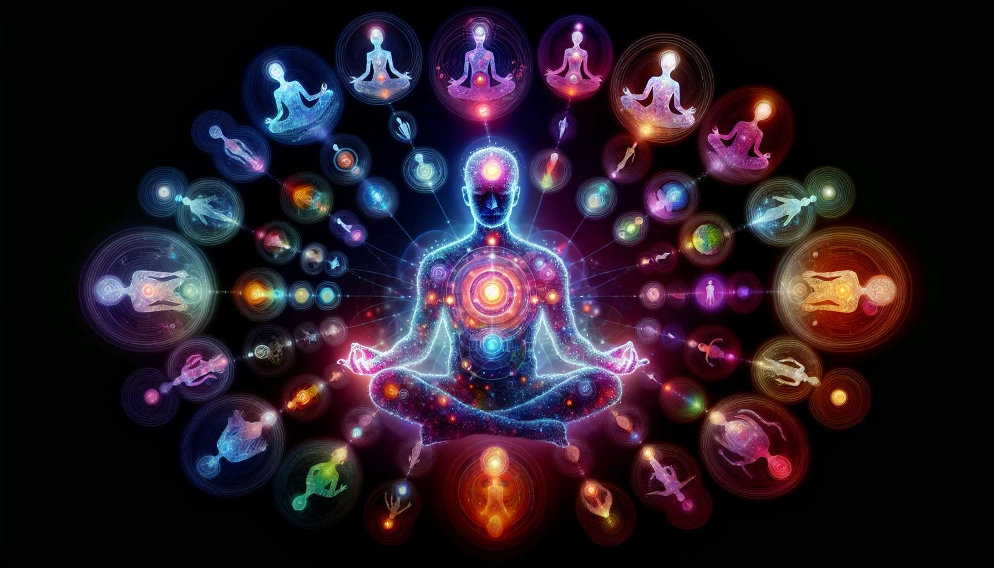

Inner dialogue and communication with parts of oneself are essential practices for any spiritual healing practitioner. They allow us to explore our inner world, to better understand ourselves, and to resolve psychological conflicts that can hinder the healing process.  
  
The concept of "parts of oneself" refers to the different facets of our personality, often born from our personal history and significant experiences. These parts can be wounded, angry, fearful, or wise and loving. Each one has their own needs, beliefs and emotions, which can sometimes contradict each other.  
  
Inner dialogue involves communicating with these different parts, listening to them with kindness and accepting them in their entirety. The aim is to create a safe space within oneself where each part can freely express itself, without judgement or censorship. It is a form of active meditation where one listens to one's feelings and deep intuitions.  
  
To initiate an inner dialogue, one can start by putting oneself in a state of relaxation and receptivity, using breathing or visualization techniques. One can then mentally address a part of oneself that manifests itself, for example an intense emotion or an uncomfortable bodily sensation. You can ask it questions such as: "What do you want to tell me?", "What do you need?", "What is your function in my life?".  
  
It is important to welcome with openness and compassion everything that emerges, even if it can be destabilizing or painful. Each part has a reason to exist and a wisdom to impart, even those that initially seem negative or destructive. By listening to them with respect and recognizing their legitimacy, one can gradually soothe and integrate them harmoniously.  
  
A powerful technique for deepening inner dialogue is "Voice Dialogue", developed by psychologists Hal and Sidra Stone. It involves physically embodying different parts of oneself, changing position, posture and voice to bring them to life. For example, you can sit on a chair to represent your "inner critic" part, then on another to embody your "vulnerable child". By dialoguing in this concrete way, one can shed light on the unconscious dynamics that drive us and find new ways to harmonize them.  
  
Through practice, one can also learn to identify and dialogue with more archetypal parts of oneself, such as one's "inner sage", "courageous warrior" or "passionate lover". These symbolic figures can become invaluable allies on the path to healing and self-realization.  
  
As a practitioner, you can guide your clients in exploring their inner dialogue by offering targeted exercises and accompanying them with kind listening. For example, you can suggest they keep a dialogue journal, where they record exchanges with their different parts, or create collages visually representing these facets of themselves. You can also invite them to role-play, where you embody some of their parts to facilitate communication.  
  
Inner dialogue is an exciting journey into the heart of oneself, which allows us to reconcile all dimensions of our being and to develop a genuine intimacy with ourselves. By lovingly and discerningly embracing our different parts, we can gradually integrate them into a coherent and harmonious whole, and achieve greater inner freedom.  
  
Remember that this process requires patience, gentleness, and humility. It is normal to encounter resistance or fears along the way, as some parts of us have been long suppressed or ignored. Welcome them with even more compassion, reminding yourself that they only seek to be heard and loved.  
  
By engaging in this practice yourself and sharing it with your clients, you are helping to create more peace and understanding in the world. Because it is by learning to dialogue with our own parts of shadow and light that we develop the ability to welcome those of others with more openness and tolerance. So, open the doors of your heart wide and let the shimmering symphony of your deep self emerge!  
  
Key points:  
  
- Inner dialogue allows us to explore our inner world, better understand ourselves, and resolve psychological conflicts that hinder healing.  
  
- The "parts of oneself" are the different facets of our personality, with their own needs, beliefs, and emotions. They can be wounded, angry, scared, or wise and loving.  
  
- Inner dialogue creates a safe space where each part can express themselves freely, without judgement. It is a form of active meditation attuned to our feelings.  
  
- To have a dialogue, one can address a part that manifests itself through an emotion or sensation and kindly inquire about its needs and function.  
  
- Each part has a purpose and wisdom to impart. By attentively listening to them, we can soothe and harmoniously integrate them.  
  
- "Voice Dialogue" involves physically embodying different parts to reveal unconscious dynamics and find how to harmonize them.  
  
- We can also dialogue with archetypal parts (inner sage, warrior, lover) that become allies.  
  
- The practitioner can guide this process through exercises (dialogue journal, collages, role-playing) and empathetic listening.  
  
- This inner journey allows us to reconcile all dimensions of our being for more freedom and peace, by patiently welcoming resistance along the way.