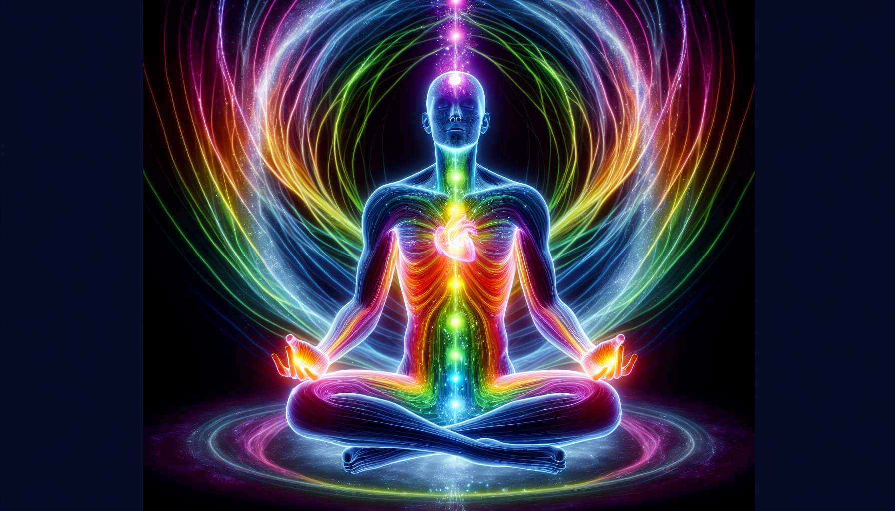

Healing through colors and chromotherapy is an ancestral practice that uses the vibratory properties of the different colors of the light spectrum to rebalance and harmonize the different planes of the being. Each color has a unique frequency that resonates with our cells, our organs and our energy fields, stimulating vital functions, unblocking emotional stagnations and restoring overall harmony.  
  
The seven main colors used in chromotherapy are those of the rainbow: red, orange, yellow, green, blue, indigo and violet. Each is associated with specific qualities and preferentially acts on certain aspects of ourselves. Thus, red stimulates vitality and self-confidence, orange promotes creativity and joy of life, yellow clarifies thought and boosts memory, green soothes the nervous system and opens the heart, blue calms the mind and facilitates communication, indigo develops intuition and imagination, and violet elevates spiritual consciousness and promotes transmutation.  
  
Dinshah Ghadiali, an Indian doctor and scientist, was a pioneer of modern chromotherapy. His research has shown that exposure to specific light frequencies can have powerful therapeutic effects on a wide range of physical and psycho-emotional disorders. He developed a system of "color baths" using colored filters on incandescent lamps, allowing the body or certain areas to be bathed in a color chosen for its virtues. His work has paved the way for numerous clinical applications of chromotherapy.  
  
There are multiple ways to integrate colors into a healing process. We can use colored clothing or fabrics, surround ourselves with objects in chosen shades, consume foods rich in certain pigments, or even mentally visualize colors in meditation. A particularly powerful technique is to combine visualization with breathing: we imagine the desired color bathing the area to be treated with each inhalation, and a complementary color dissolving blockages with each exhalation.  
  
Chromotherapy is closely related to the system of chakras, these subtle energy centers located along the spine. Each chakra vibrates at a specific color frequency, and imbalances often manifest as a change in this color. Thus, a weakened root chakra will tend to shift towards dull brown rather than bright red, while an overactive solar chakra will appear in a blazing yellow. By using the appropriate colors, through projection or visualization, we can gently rebalance each chakra and bring it to radiate in its optimal shade.  
  
Theo Gimbel, an acupuncturist and researcher in chromotherapy, has developed an approach linking colors to the meridians of Chinese medicine. According to him, each meridian is associated with a color that stimulates its energy when it is deficient, and soothes it when it is excessive. For example, the Liver meridian, related to the management of anger and frustration, will benefit from green in case of stagnation and red in case of exhaustion. By judiciously combining colors and acupuncture points, we can restore a harmonious flow of Qi throughout the body.  
  
Beyond vision, chromotherapy can also use sound and elixirs. Each color indeed has a musical note that corresponds to it, and some therapists use colored sound sequences to harmonize the subtle bodies. Similarly, we can imbue water or oils with the vibration of a color, by direct exposure or mental impregnation, to create elixirs with regenerative properties. The essential thing is to reconnect to the vibratory essence of colors and consciously integrate it into our practice.  
  
As a Spiritual Healing Coach, integrating chromotherapy into your practice will enable you to provide your clients with gentle yet powerful vibrational support. By guiding them in the exploration and use of colors, you will help them deeply rebalance their energy system and express their unique potential. Color is a wonderful catalyst for unlocking cellular memories, harmonizing emotions and elevating consciousness.  
  
Johann Wolfgang von Goethe, poet and scientist, asserted that "colors are the sufferings and joys of light". Chromotherapy invites us to embrace these plays of shadow and clarity at the heart of ourselves, to radiate the light of our essential being. Like a prism refracting the solar spectrum, each color therapy session reconnects us to our rainbow nature, the vibrant expression of the One Life dancing within us.  
  
Key takeaways:  
  
- Chromotherapy uses the vibratory properties of the 7 colors of the rainbow to rebalance the being on all its planes.  
  
- Each color has a unique frequency that resonates with our cells, organs, and energy fields. Red stimulates vitality, orange creativity, yellow thinking, green soothes, blue calms the mind, indigo develops intuition, and violet elevates consciousness.  
  
- Dinshah Ghadiali was a pioneer, demonstrating the therapeutic effects of exposure to specific light frequencies. He developed "color baths".  
  
- Colors can be integrated through clothing, diet, visualization coupled with breathing.  
  
- Colors are related to chakras. Rebalancing a chakra involves bringing it to radiate in its optimal shade.  
  
- Theo Gimbel associates colors with the meridians of acupuncture. Each color can stimulate or soothe the energy of a meridian.  
  
- Beyond vision, sound (musical notes) and elixirs (water/oils imbued) also use the vibrations of colors.  
  
- Integrating chromotherapy provides powerful vibrational support for unlocking memories, harmonizing emotions, and elevating consciousness.  
  
- As Goethe put it, colors are "the sufferings and joys of light". Chromotherapy invites us to radiate our inner light.