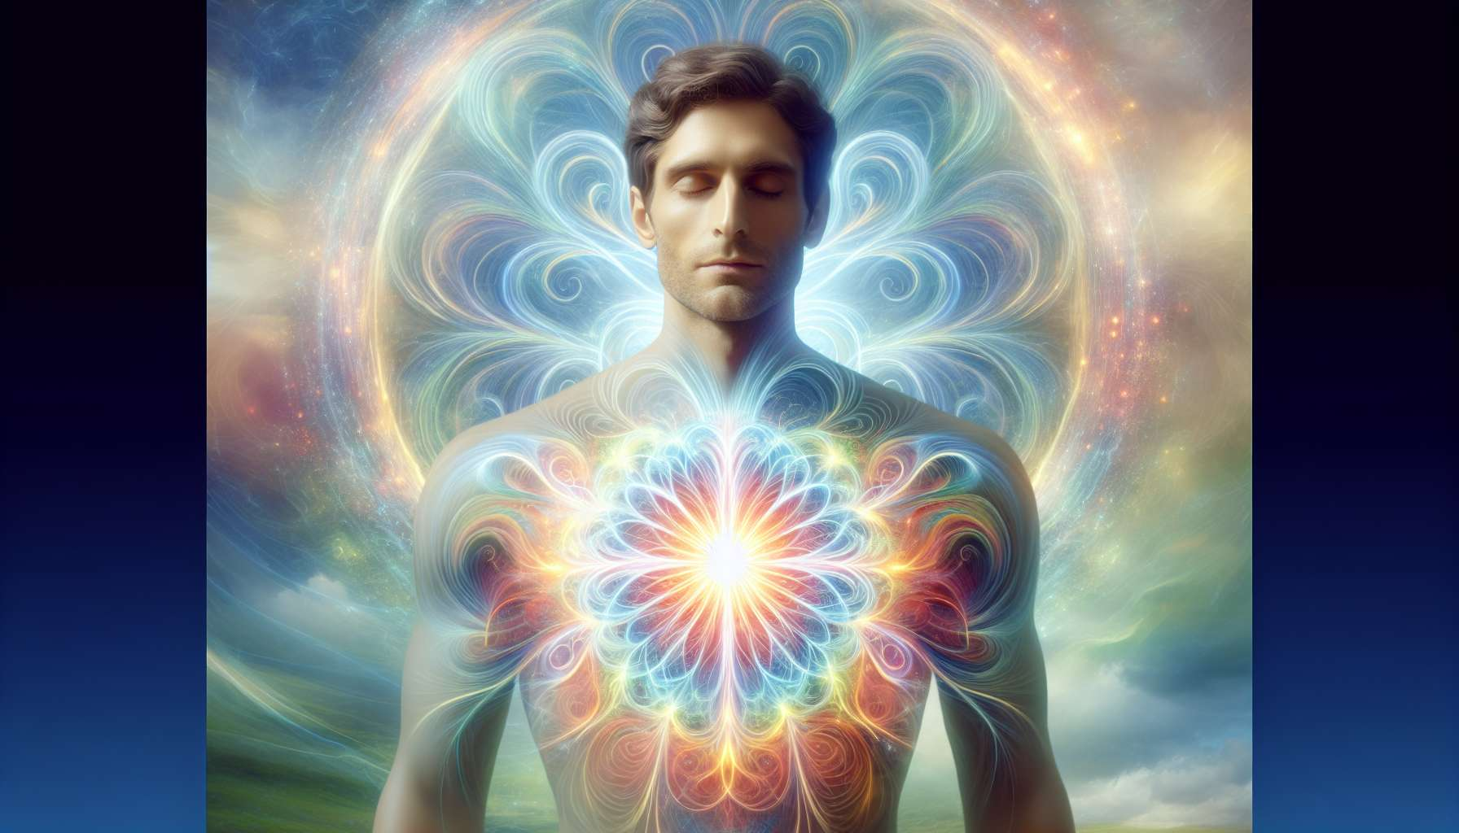

Thoughts and emotions have a considerable impact on our energy and our vibratory field. They are like frequencies that we constantly emit and which not only influence our own energetic balance, but also that of our environment and the people around us. Understanding this intimate link between our inner world and our energy radiation is essential for the Spiritual Healing Coach, as it allows them to act at the root of imbalances and promote a profound and lasting transformation in their clients.  
  
Each thought we formulate, every emotion we experience generates a specific form of energy that vibrates at a certain frequency. Positive, inspiring and kind thoughts create bright and elevated thought-forms, which nourish our energy field and strengthen our connection to our divine essence. Conversely, negative, critical or limiting thoughts give birth to dark and dense thought-forms, which weigh down our aura and disconnect us from our true nature.  
  
Similarly, harmonious emotions like joy, gratitude or compassion radiate a sweet and comforting energy, which soothes and regenerates our entire being. They create a coherent and balanced vibratory field, promoting the fluid circulation of vital energy in all our subtle bodies. On the contrary, discordant emotions like anger, fear or sadness emanate a chaotic and disturbed energy, which creates blockages and stagnations in our energy system.  
  
For example, a person who constantly dwells on anxious thoughts and allows themselves to be overwhelmed by panic emotions will literally permeate their energy field with these fear vibrations. This can manifest as a dark and unsettled aura, imbalanced chakras, congested meridians, or even a weakening of the etheric body. Ultimately, if nothing is done to transmute these heavy energies, they can even end up crystallizing in the physical body in the form of tension, pain or illness.  
  
Conversely, a person who deliberately cultivates thoughts of love and peace and who is grounded in emotions of serenity will radiate pure and beneficial light. Their energy field will be vast, luminous and harmonious, attracting positive circumstances and encounters to them. This person will naturally become a healing agent for their surroundings, as their mere presence will be enough to elevate vibrations and inspire the best in others.  
  
As Spiritual Healing Coaches, our role is to help our clients become aware of the energetic impact of their thoughts and emotions, and to learn to manage them consciously and responsibly. This involves deep work on limiting beliefs, repetitive mental patterns and repressed emotional memories that are the source of these heavy energies.   
  
For example, we may use techniques such as EFT (Emotional Freedom Technique) or PSYCH-K to release emotional blockages and reprogram negative thoughts. We may also suggest practices such as meditation, visualization or heart coherence to help the person cultivate positive inner states and strengthen their energy field.   
  
It is important to understand that we are the creators of our energetic reality. Every choice we make at the level of our thoughts and emotions shapes our personal vibration and draws to us experiences in resonance. Thus, by learning to consciously choose elevated thoughts and harmonious emotions, we become the architects of our destiny and the co-creators of a better world.  
  
A beautiful illustration of this principle is the story of Louise Hay, a pioneer in the field of positive thinking and self-healing. Diagnosed with cancer, she undertook a profound inner transformation, focusing on affirmations of love and forgiveness towards herself and others. By radically changing her thought patterns and aligning with emotions of peace and gratitude, she was able to completely heal from her disease and inspire millions of people around the world.  
  
In summary, our inner world and our energy radiation are closely connected. The thoughts and emotions we hold have a direct impact on the quality of our vibratory field and our capacity to embody our highest potential. As Spiritual Healing Coaches, our mission is to guide our clients in this realization and provide them with the tools to master their energy. For it is by deliberately choosing to emit frequencies of love, joy and peace that we can create miracles in our lives and contribute to the elevation of collective consciousness.  
  
Points to take away:   
  
- Thoughts and emotions have a considerable impact on our energy and vibratory field. They affect our energy balance and that of our surroundings.  
  
- Positive thoughts and harmonious emotions create high vibrations that strengthen our connection to our divine essence and promote a balanced energy field. Conversely, negative thoughts and discordant emotions generate dense energies that disrupt our energy system.  
  
- Anxious thoughts and fear emotions can permeate the energy field, leading to chakra imbalance, meridian congestion and a weakening of the etheric body, potentially even manifesting physically.  
  
- Cultivating thoughts of love and emotions of serenity allows for positive energy radiation, attracting beneficial circumstances and encounters.  
  
- The role of the Spiritual Healing Coach is to help clients become aware of the energetic impact of their thoughts and emotions, and manage them consciously and mindfully. This involves work on limiting beliefs, repetitive mental patterns and repressed emotional memories.  
  
- Techniques such as EFT, PSYCH-K, meditation, visualization and heart coherence can be used to release emotional blockages, reprogram thoughts and cultivate positive inner states.  
  
- We are the creators of our energy reality. By consciously choosing elevated thoughts and harmonious emotions, we shape our personal vibration and attract resonating experiences.   
  
- Louise Hay's story illustrates the power of inner transformation through work on thoughts and emotions, enabling her to heal from cancer and inspire many people.