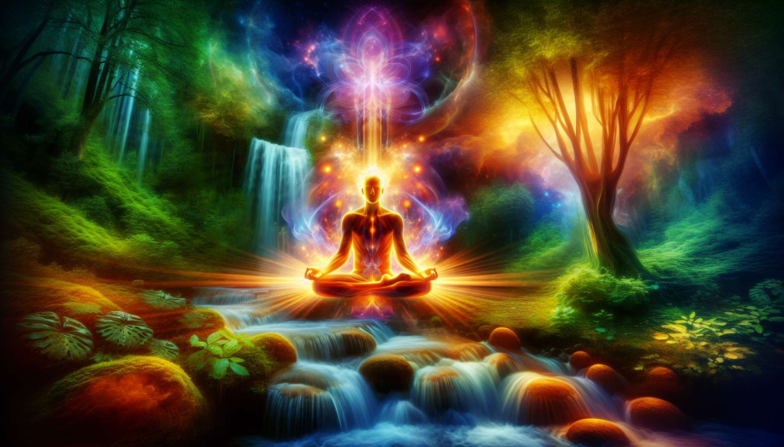
Guided meditation and creative visualization are powerful tools to facilitate inner healing and personal growth. They enable the calming of the mind, reconnecting with one's deep essence, and accessing expanded consciousness states conducive to transformation.
Guided meditation involves using voice and words to guide a person into a state of deep relaxation and inner focus. The practitioner invites the meditator to focus on their breath, body sensations, and suggested mental images. By allowing oneself to be guided by the practitioner's voice, the meditator can let go of their usual thoughts and open up to new perspectives.
A guided meditation session generally starts with a progressive relaxation phase, where the person is invited to relax each part of their body, from the feet to the head. Suggestions such as "Feel your legs getting heavier and completely relaxing" or "Imagine a wave of beneficial warmth running down your back and dissolving all tensions" can be used. This step allows for the release of physical blockages and prepares for deeper work.
Then, the practitioner guides the meditator through different visualizations depending on the intention of the session. This could involve imagining a place of rejuvenation, dialoguing with a benevolent inner figure, transmuting a difficult emotion into light, or connecting to a universal energy source. The possibilities are endless and can be tailored to the specific needs of each person.
Creative visualization, on the other hand, is a technique that uses the power of imagination to influence inner and outer reality. It is based on the principle that clear, emotionally charged mental images have a direct impact on our subconscious and our energy field. By repeatedly and intensely visualizing a goal or desired state of being, favorable conditions for its manifestation are created.
For effective visualization, it is important to engage all your senses and to make the experience as vivid and detailed as possible. For example, if the goal is to overcome an addiction, one can imagine throwing a pack of cigarettes into a trash can, feeling the lightness and pride that result from it, hearing the encouragement of loved ones, etc. The more embodied the visualization, the greater its impact on the psyche.
It is also essential to associate positive emotions and powerful affirmations with visualization. For example, you can internally repeat phrases such as "I am at peace with myself" or "I love and accept myself completely" while feeling the joy and gratitude that accompany them. This helps anchor new thought patterns and beliefs conducive to flourishing.
As a spiritual healing practitioner, you can create your own guided meditations and visualizations based on the themes that you hold dear. Give free rein to your creativity and intuition in designing unique and meaningful inner journeys. You can draw inspiration from your own healing experiences, wisdom archetypes, natural elements, or sacred symbols from various traditions.
Feel free to record your meditations to listen to them again and share them with your clients. You can also use them as a support during your workshops or individual treatments. The more you practice and guide these tools, the more you will gain in ease and depth in your accompaniment.
Guided meditation and creative visualization are invitations to explore one's inner world, to reconnect with one's true nature, and to activate one's unlimited potential. As a practitioner, you have the privilege of guiding your clients in these sacred spaces of transformation and self-disclosure. Make each inner journey a unique work of art, imbued with beauty, kindness, and unconditional love.
Key Points to remember:
- Guided meditation and creative visualization are powerful tools for inner healing and personal growth. They help calm the mind, reconnect with one's deep essence, and access expanded states of consciousness.
- Guided meditation uses voice and words to guide the meditator into a state of deep relaxation and inner focus. It usually includes a phase of progressive relaxation followed by visualizations tailored to the intention of the session.
- Creative visualization uses the power of imagination to influence inner and outer reality. By repeatedly and intensely visualizing a goal or desired state of being, one creates favorable conditions for its manifestation.
- For effective visualization, it is important to engage all your senses, associate positive emotions, and powerful affirmations.
- As a practitioner, you can create your own guided meditations and visualizations, drawing inspiration from your experiences, wisdom archetypes, natural elements, or sacred symbols. Give free rein to your creativity and intuition.
- Feel free to record your meditations to listen to them again, share them with your clients, and use them as support during your workshops or individual treatments.
- Guided meditation and creative visualization are invitations to explore one's inner world, reconnect with one's true nature, and activate one's unlimited potential. As a practitioner, you have the privilege of guiding your clients in these sacred spaces of transformation and self-disclosure.

