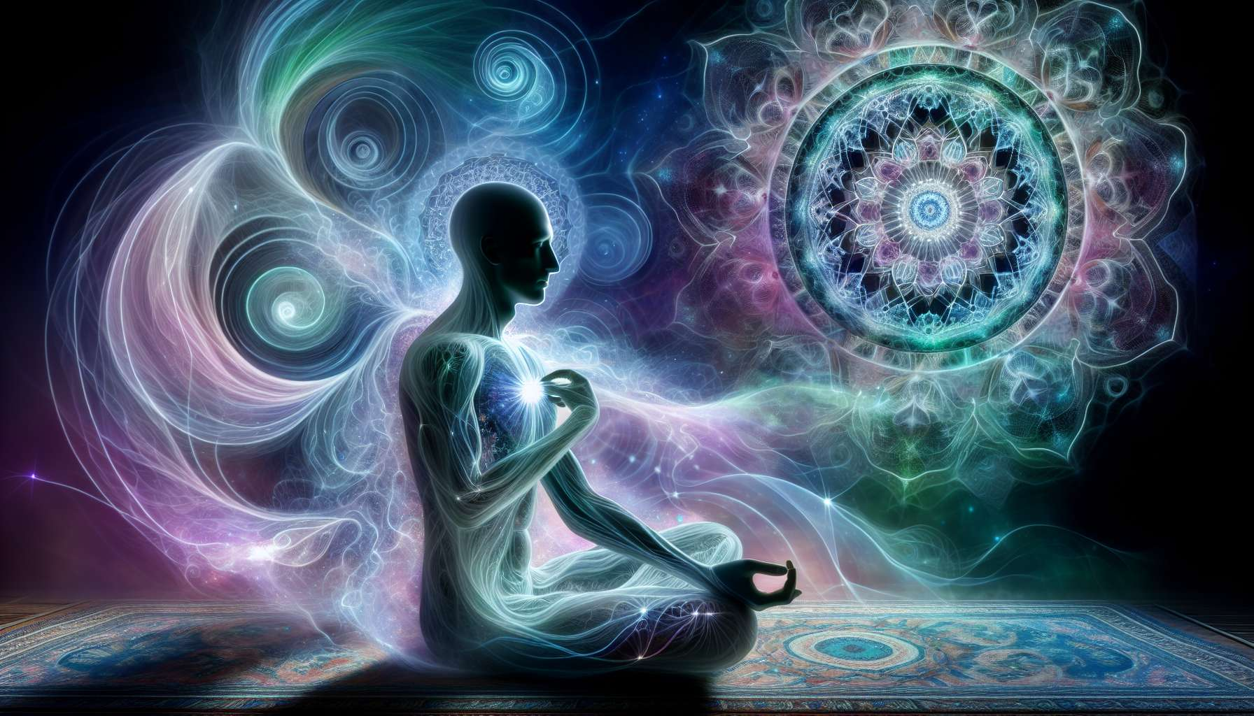

Spiritual healing is a holistic approach that aims to restore harmony and balance at the physical, emotional, mental, and spiritual levels. It is based on the fundamental principle that every human being possesses an innate capacity for self-healing and transformation.  
  
Unlike conventional medicine, which mainly focuses on treating symptoms, spiritual healing is interested in the deep causes of imbalance. It views illness or discomfort as mere external manifestations of a dysfunction at a more subtle level of being.  
  
According to this approach, we are much more than our physical body. We are made up of different subtle bodies (etheric, astral, mental, causal) that interact and influence each other. A blockage or disturbance in one of these bodies can affect the others and eventually manifest on the physical plane.  
  
Spiritual healing therefore aims to restore the harmonious flow of life energy throughout these subtle bodies. It relies on the idea that when we connect to our deep essence and align with our spiritual nature, our body can mobilize its internal resources for self-regulation and regeneration.  
  
One of the key principles is the recognition of the uniqueness of each individual. Each person is unique, with their own history, beliefs, patterns of operation. Spiritual healing does not offer a universal recipe but seeks to adapt to the rhythm and specific needs of each person.  
  
Intention is another fundamental principle. The quality of presence and attention that the therapist or coach will bring during the process is essential. Beyond the techniques used, it's the strength of his or her intention that creates a conducive space for healing and transformation.  
  
Spiritual healing uses a variety of tools such as energy healing, meditation, visualization, rituals, etc. But more than the tools themselves, the quality of consciousness and openness of the heart matters. The therapist acts as a catalyst, a facilitator who helps the person mobilize their own internal resources.  
  
A final important principle is individual responsibility. Spiritual healing believes that we are the creators of our reality and that we have the power to transform our lives. The therapist is not there to "save" or "heal" the other, but to accompany them in their own process of evolution and autonomy.  
  
As Carl Jung said, "He who looks outside dreams, he who looks inside awakes." Spiritual healing invites us to this inner journey, to meet ourselves, to awaken our limitless potential for healing and realization.  
  
Key points to remember:  
  
- Spiritual healing is a holistic approach aimed at restoring balance at all levels of being (physical, emotional, mental, spiritual).  
  
- It relies on each individual's innate self-healing capacity.  
  
- Disease is seen as a manifestation of an imbalance in the subtle bodies.  
  
- The goal is to restore a harmonious flow of vital energy.  
  
- Each person is unique, and the guidance adapts to their specific needs.  
  
- The intention and quality of presence of the therapist are essential.  
  
- Many tools are used (energy healing, meditation, visualization, rituals), but the quality of consciousness is the key.  
  
- Individual responsibility is central: everyone has the power to transform their lives.  
  
- Spiritual healing is an inward journey to awaken our healing and realization potential.