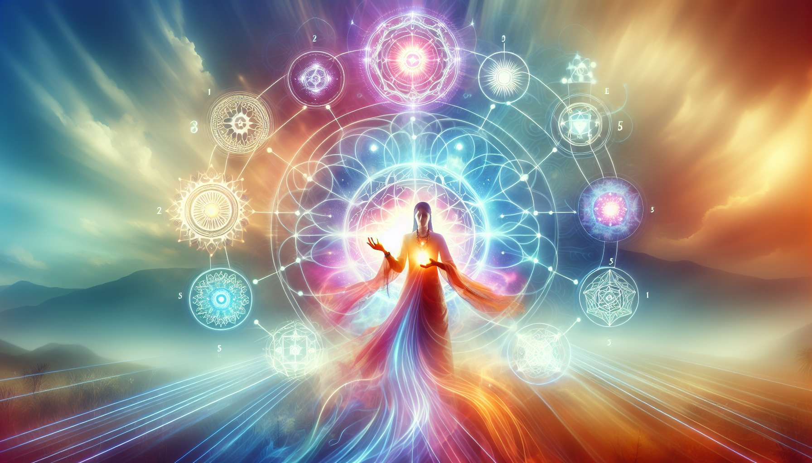

The integration of various energy healing techniques into coaching practice is a subtle art requiring creativity, intuition, and experience. It's not just about juxtaposing tools, but combining them in a synergistic manner to create a personalized approach tailored to the unique needs of every client.  
  
The first step is to master each technique separately, understanding its principles, protocols, and specific areas of application. This requires in-depth learning and regular practice to develop one's energy sensitivity and the ability to channel various healing frequencies. It is essential to respect the integrity of each approach and avoid distorting them by inappropriately mixing them.  
  
Once this solid foundation is obtained, the coach can start experimenting with combinations according to the issues encountered. For example, for a client suffering from chronic pain related to an old trauma, Reiki can be used to soothe physical pain, Quantum Touch to release emotional memory, and chromotherapy to rebalance disrupted energy fields. The art is in discerning which technique is most appropriate at which moment, guided by one's therapeutic intuition.  
  
Donna Eden, a pioneer in energy medicine, speaks of the importance of respecting the wisdom of the body and following its cues. Occasionally, during a session, the coach might feel an urge to use one technique over another, even if it wasn't initially planned. By listening to these subtle signals and trusting the process, the most potent combinations spontaneously emerge.  
  
Another key aspect is integrating energy techniques into the overall coaching process. It's not just about adding occasional "treatments," but using them as levers to support the client's overall transformation. For example, a Reconnection session could be used to overcome a major obstacle and open up new perspectives, while regular Magnified Healing practice helps to durably anchor changes and enhance connection to internal guidance.  
  
Richard Bartlett, creator of Matrix Energetics, emphasizes maintaining a state of wonder and non-attachment in practice. Rather than trying to control everything, the coach is invited to co-create with the unified field and open up to the infinite possibilities of healing. Letting go of rigid protocols and cultivating a playful presence allows the intelligence of Life to freely express through us, leading to astounding synchronicities and miraculous healings.  
  
Integrating energy techniques also requires cultivating essential qualities such as compassion, humility, transparency, and alignment. The coach must be clear about their intention to serve the client's greatest good without trying to impress or prove anything. They should be honest about their skills' limits, know when to refer to other professionals if needed, and always aim to empower the client in their healing journey.  
  
Barbara Ann Brennan, a former NASA physicist turned healer, talks about the importance of regularly self-treating to become a clear and potent channel. By applying energy techniques on themselves, the coach develops their sensitivity, clarifies their own energy fields, and deeply embodies healing frequencies. It's by radiating their own light that they naturally inspire their clients to reconnect with theirs.  
  
Finally, integrating energy techniques into coaching requires flexibility and creativity. Since every client is unique, there is no miracle recipe or universal protocol. It's by exploring different combinations, daring to think outside the box, and constantly refining their perception that the coach develops their unique style and mark. The key is always to keep in mind the central objective: awakening the infinitely healing potential within us all.  
  
Key takeaways:  
  
- Integrating energy techniques into coaching requires creativity, intuition, and experience to create a synergistic and personalized approach.  
  
- Understanding each technique separately and respecting their integrity is crucial before combining them appropriately according to the client's needs.  
  
- The coach should be guided by their therapeutic intuition and the body's wisdom in choosing the most appropriate techniques at each moment.  
  
- Energy techniques should be integrated into the overall coaching process to support the client's deep transformation, not just as occasional "treatments."  
  
- Maintaining a state of wonder, non-attachment, and co-creation with the unified field can lead to surprising healings.  
  
- The coach must cultivate essential qualities such as compassion, humility, transparency, and alignment, with clear intentions to serve the client.  
  
- Regularly practicing energy techniques on oneself allows the coach to develop their sensitivity and embody healing frequencies.  
  
- Due to each client's uniqueness, integrating energy techniques requires flexibility, creativity, and constant exploration to develop one's style.