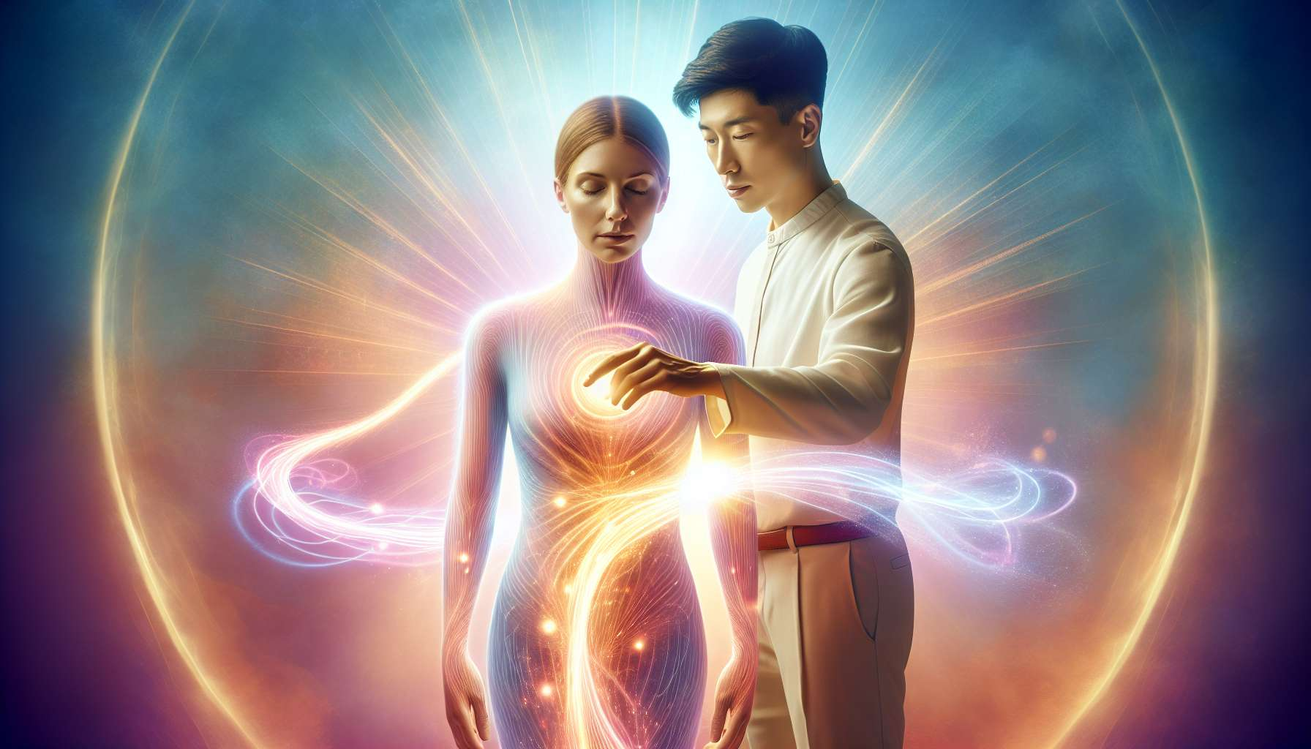

Quantum Touch is an energy healing technique developed by Richard Gordon in the 1970s. Based on the principles of quantum physics, this approach posits that everything is energy and that our body is a vibratory field that can be influenced by consciousness and intention. The goal of Quantum Touch is to elevate the vibratory frequency of the practitioner to resonate with that of the recipient, thereby promoting self-healing.  
  
One of the key principles of Quantum Touch is that the body has an innate intelligence that knows how to heal itself. When provided with the necessary energy, at the right frequency, it can effect extraordinary transformations. Richard Gordon thus recounts the case of a woman suffering from severe scoliosis who, after a Quantum Touch session, saw her spine spontaneously straighten, to the amazement of her doctor.  
  
The basic technique of Quantum Touch relies on a specific breathwork, deep and rhythmic, which allows the accumulation of energy in the hara (energy center located below the navel). This abdominal breathing, combined with an aligned and relaxed body posture, allows the practitioner to enter a meditative state conducive to channeling universal energy.  
  
Once this energy is accumulated, the practitioner directs it towards the area to be treated by visualizing a beam of light coming out of their hands. They can hold their hands at a distance or in contact with the body, focusing on the sensation of heat and tingling that emanates. The key is to maintain a pure healing intention, without attachment to the outcome, allowing the body's intelligence to do its work.  
  
Richard Gordon emphasizes the importance of kinesthetic awareness in the practice of Quantum Touch. Instead of following a mechanical protocol, the practitioner is invited to develop their sensitivity to perceive subtle energy changes in the recipient's body. This allows them to adjust the power and direction of the energy beam in real time, according to the specific needs of each area.  
  
Another powerful tool of Quantum Touch is the technique of love and gratitude. By connecting to an intense feeling of unconditional love and gratitude, the practitioner can significantly amplify the flow of energy passing through them. Richard Gordon recommends thinking about a person or situation that naturally evokes these positive emotions, and allow them to imbue their being during the session.  
  
Quantum Touch can be used to relieve pain, speed up the healing of injuries, strengthen the immune system or even harmonize emotions and thoughts. Its applications are broad and complementary to other care approaches, whether conventional or alternative. Many health professionals, such as nurses, physiotherapists, and dentists, now incorporate Quantum Touch into their practice.  
  
As a Spiritual Healing Coach, Quantum Touch is a valuable tool to guide your clients towards overall well-being. By transmitting this high-frequency energy, you will help them to dissolve physical and emotional blockages, to regain their vitality and to activate their self-healing potential. Combined with coaching and personal development techniques, Quantum Touch offers a powerful integrative approach for profound transformation.  
  
Deepak Chopra, renowned physician and spiritualist, sees Quantum Touch as a perfect illustration of the link between science and spirituality. According to him, this technique shows that we are not separate beings, but interconnected energy fields capable of influencing each other through the power of our intention and compassion. By learning to master our own energy field, we become active agents in our healing and evolution.  
  
Key points to remember:  
  
1. Quantum Touch is an energy healing technique based on the principles of quantum physics, developed by Richard Gordon in the 1970s.  
  
2. This approach postulates that everything is energy and that our body is a vibratory field that can be influenced by consciousness and intention.  
  
3. The goal of Quantum Touch is to elevate the vibratory frequency of the practitioner to resonate with that of the recipient, promoting self-healing.  
  
4. The basic technique involves a specific, deep and rhythmic breathwork, combined with an aligned and relaxed posture, allowing the practitioner to channel universal energy.  
  
5. The practitioner directs the accumulated energy towards the area to be treated by visualizing a light beam coming out of their hands, while maintaining a pure healing intention.  
  
6. Kinesthetic awareness is crucial to perceive energy changes in the recipient's body and adjust the energy beam accordingly.  
  
7. The technique of love and gratitude amplifies the energy flow by connecting to intense positive emotions.  
  
8. Quantum Touch can relieve pain, accelerate healing, strengthen the immune system and harmonize emotions and thoughts.  
  
9. This technique complements other care approaches and is increasingly integrated by health professionals.  
  
10. According to Deepak Chopra, Quantum Touch illustrates the link between science and spirituality, showing that we are interconnected energy fields capable of influencing each other through intention and compassion.