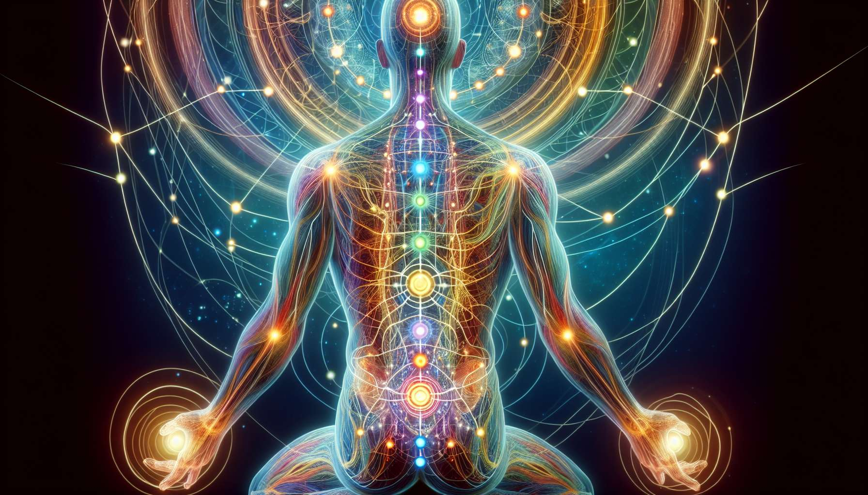

Meridians are energy channels that run through the body, connecting the various organs and tissues together. According to traditional Chinese medicine, they form a complex network allowing the harmonious circulation of Qi, the vital energy. There are twelve main meridians, each associated with a specific organ and physiological and psycho-emotional function.  
  
Along these meridians are acupuncture points, sort of "gates" that allow access to the energy system. These points are generally located in anatomical depressions or at the junction of muscles and tendons. When stimulated by needles, heat, or pressure, these points have the ability to rebalance the circulation of Qi in the corresponding meridians and restore harmony in the associated organs and functions.  
  
Each meridian has a well-defined trajectory, which begins and ends at key points called "well points" and "source points". For example, the Lung meridian starts under the collarbone, descends along the arm to the thumb, while the Kidney meridian starts under the foot, ascends along the leg to the chest. Knowing the course of the meridians allows the precise location of acupuncture points and understanding their interconnections.  
  
Acupuncture points have specific functions and precise therapeutic indications. Thus, the point "Liver 3", located on the top of the foot between the first and second metatarsal, is renowned for calming the mind, soothing anger, and promoting the free circulation of Qi throughout the body. The point "Stomach 36", located below the knee, is considered a general tonification point, strengthening the vital energy and stimulating immunity.  
  
Some acupuncture points also have a diagnostic function. For example, the point "Lung 9", located on the wrist, is often sensitive to palpation in case of respiratory problems or accumulated sadness. Similarly, the point "Heart 7", located at the wrist level, can be painful in case of anxiety disorders or palpitations.  
  
In the practice of the Spiritual Healing Coach, knowledge of meridians and acupuncture points allows refining the energy diagnosis and proposing targeted care protocols. For example, if a client suffers from chronic digestive disorders, the coach can work on the Stomach and Spleen meridians, stimulating specific points like "Stomach 36" or "Spleen 6" to rebalance the digestive functions.   
  
Likewise, for a person suffering from insomnia and mental ruminations, the coach can focus on the Heart and Master-Heart meridians, using points like "Heart 7" or "Master-Heart 6" to soothe the mind and promote quality sleep.  
  
It is important to note that meridians and acupuncture points are not isolated, but work in synergy with other energy systems of the body, such as chakras and the aura. Thus, an imbalance of the root chakra may manifest with increased sensitivity of kidney meridian points, while a blockage of the throat chakra may disrupt the circulation of Qi in the lung meridian.  
  
The Spiritual Healing Coach, therefore, uses his global knowledge of the subtle anatomy to establish links between different levels and propose an integrative and personalized approach. For example, he may combine a chakra balancing session with stimulation of corresponding acupuncture points, while working on associated thought patterns and emotions.  
  
The goal is to restore the harmonious circulation of vital energy throughout the body, acting on both meridians, chakras, and subtle bodies. This holistic approach seeks to treat the person as a whole, promoting a return to balance and lasting well-being at the physical, emotional, mental and spiritual levels.  
  
  
Key points to remember:  
  
- Meridians are energy channels connecting organs and tissues, allowing the circulation of Qi according to traditional Chinese medicine.  
  
- There are twelve main meridians, each associated with an organ and specific physiological and psycho-emotional functions.   
  
- Acupuncture points, located along the meridians, allow access to the energy system and rebalance the circulation of Qi when stimulated.  
  
- Each meridian has a defined course, starting and ending at key points called "well points" and "source points".  
  
- Acupuncture points have specific functions and precise therapeutic indications, as well as a role in energy diagnosis.  
  
- The Spiritual Healing Coach uses knowledge of meridians and acupuncture points to establish targeted and personalized care protocols.  
  
- Meridians and acupuncture points work in synergy with other energy systems like chakras and the aura.  
  
- The holistic approach of the Spiritual Healing Coach aims to restore the harmonious circulation of vital energy by acting on different levels of being to promote lasting well-being.