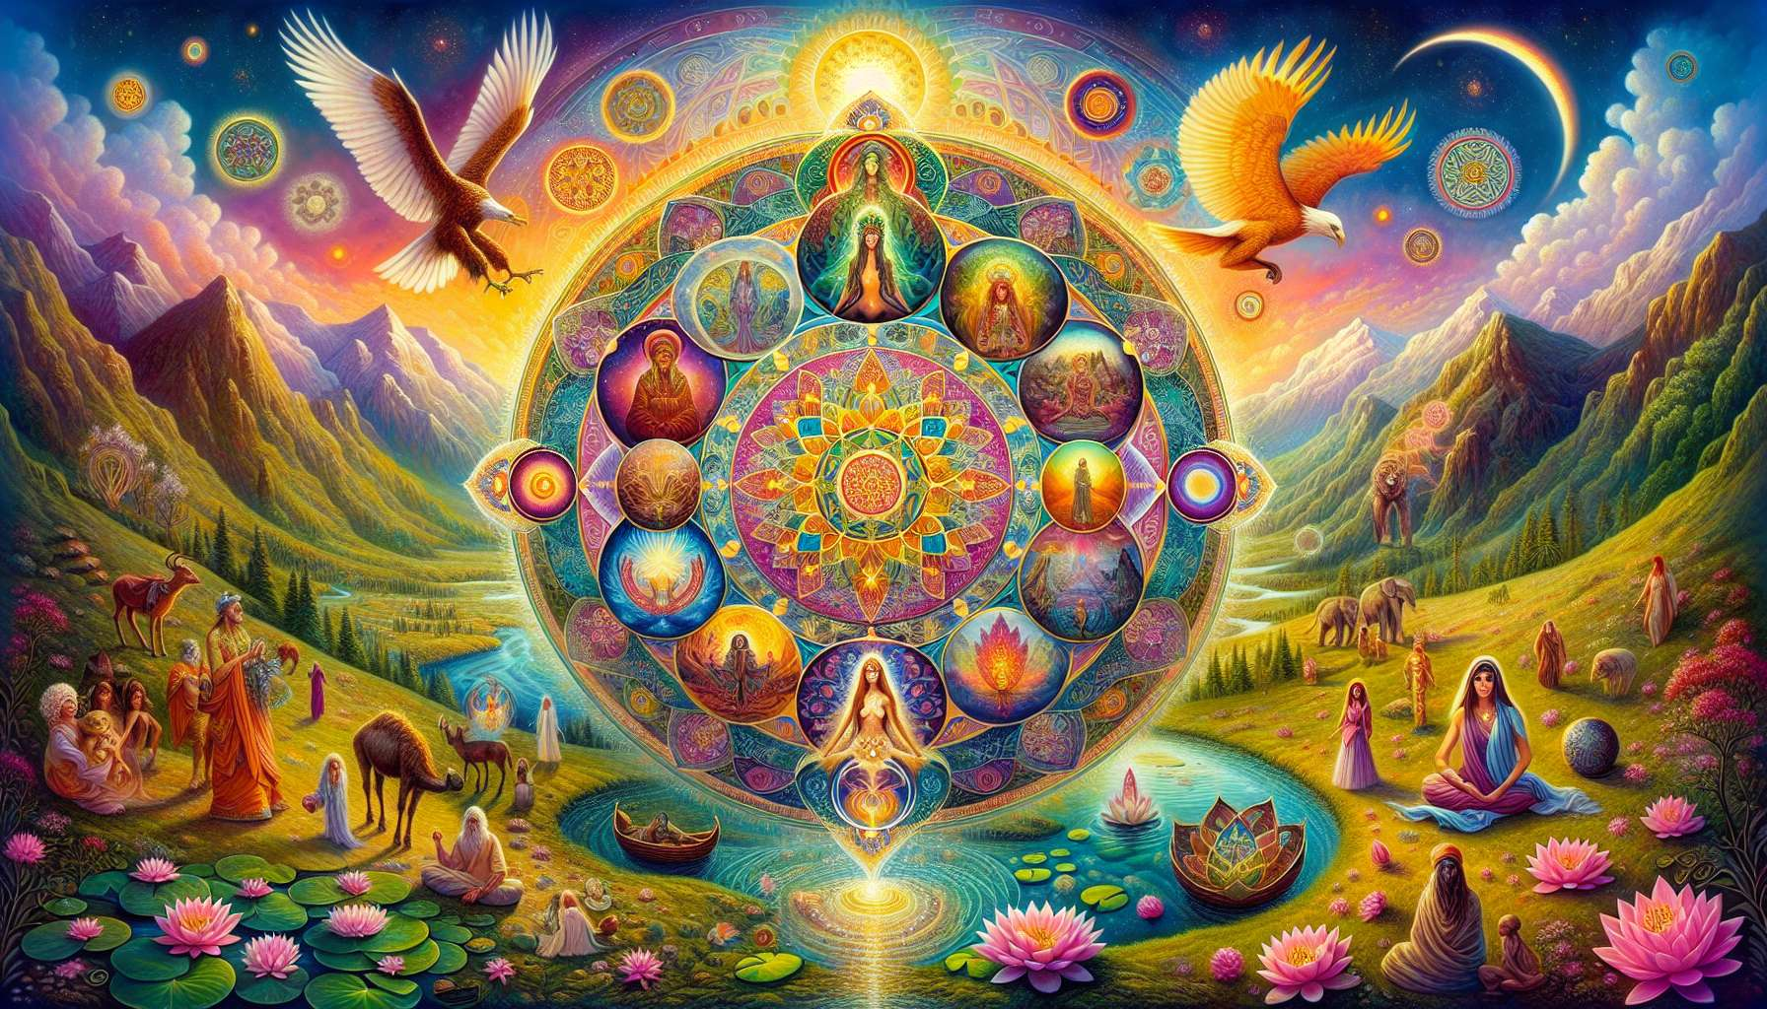
Working with archetypes and symbols is a powerful tool for accessing the wisdom of the collective unconscious and fostering inner transformation. Archetypes are universal patterns of behavior and personality that transcend cultures and eras. They represent fundamental facets of the human psyche, such as the Nurturing Mother, the Courageous Warrior, the Benevolent Sage, or the Inner Child. By connecting with these archetypal energies, we can draw from their specific resources to heal certain aspects of ourselves and unleash our full potential.
Symbols, on the other hand, are visually charged representations that resonate with our unconscious and stimulate our intuition. They can take the form of images, objects, geometric shapes, colors, or even natural elements like animals or plants. Each symbol has a deep and multidimensional meaning, which varies according to individuals and contexts. For example, the lotus symbol evokes spiritual elevation, purity, and beauty emerging from the mud, while the phoenix represents rebirth and resilience in the face of trials.
In order to work with archetypes and symbols in a healing process, one can employ a number of complementary approaches. Creative visualization is a particularly effective technique that involves consciously immersing oneself in the energy of an archetype or symbol by imagining it in a vivid and detailed manner. For instance, one could visualize the figure of the Inner Goddess to cultivate gentleness and self-acceptance or the Just King to strengthen benevolent authority and discernment.
Artistic practices are also wonderful mediums for exploring archetypes and symbols. By drawing, painting, sculpting, or even dancing our inner images, we give them form and life, while releasing the emotions and intuitions they convey. One could create a mandala representing their life path, incorporating symbols that inspire and guide them. Alternatively, one could craft a mask embodying an archetype they wish to integrate, wearing it during a ritual or meditation.
Another powerful approach is dream work, which entails exploring the archetypes and symbols that manifest in our dreams. By keeping a dream journal and analyzing it with the help of archetypal keys, one can access precious messages from our unconscious and engage in a dialogue with various facets of our deepest self. Dreams offer a privileged gateway to our personal mythology, weaved from the threads of our unique history and universal patterns.
As a practitioner in spiritual healing, you can provide your clients with targeted exercises to explore their personal archetypes and symbols. For example, you might suggest they choose an archetypal figure that inspires them and engage in a dialogue with it in their personal journal, asking it questions and listening to its intuitive responses. Alternatively, they could create an altar dedicated to a symbol that strikes a chord with them, placing objects and offerings on it to reinforce its presence in their life.
You could also make use of tools such as oracle cards, initiatory tales, or founding myths to stimulate their archetypal imagination. By drawing a card at random or meditating on a universal story, they can reconnect with unsuspected resources and widen their perspective on their personal situation. Your role is to guide them empathetically in interpreting the messages received while allowing them space for their own discoveries.
Working with archetypes and symbols is a genuine art that requires subtlety, intuition, and broad-mindedness. The goal is not to impose ready-made meanings, but to invite each individual to create their own associations and to let themselves be surprised by the depth of their inner world. By reconnecting with these primordial images, one re-enchants their existence and opens up to the sacred dimension of life.
So, don't hesitate to dive into the fascinating universe of archetypes and symbols, and include them in your healing practice. Let them surprise you, inspire you and transform you, while guiding your clients accurately and creatively on this initiatory journey. And remember that each individual is a unique constellation of archetypes and symbols, waiting to be revealed and celebrated in all its beauty.
Key takeaways:
- Archetypes are universal patterns of behavior and personality that transcend cultures and eras. By connecting with these archetypal energies, one can draw from their resources to heal certain aspects of oneself and unleash full potential.
- Symbols are visually charged representations that resonate with our unconscious. They can take many forms (images, objects, geometric shapes, colors, natural elements) and have a deep, multidimensional interpretation.
- Creative visualization is an effective technique for immersing oneself in the energy of an archetype or symbol by picturing it in a detailed and vivid way.
- Artistic practices (drawing, painting, sculpture, dance) are excellent mediums for exploring archetypes and symbols, providing them with form and liberating associated emotions and intuitions.
- Dream work, through the keeping and analysis of a dream journal, allows for access to precious unconscious messages related to our personal mythology.
- As a practitioner, one can propose targeted exercises to clients to explore their personal archetypes and symbols, utilizing various mediums (inner dialogues, altars, oracle cards, stories, myths).
- The engagement with archetypes and symbols necessitates subtlety, intuition, and open-mindedness. It involves encouraging each individual to generate their own associations and reconnect with the sacred dimension of their inner world.

