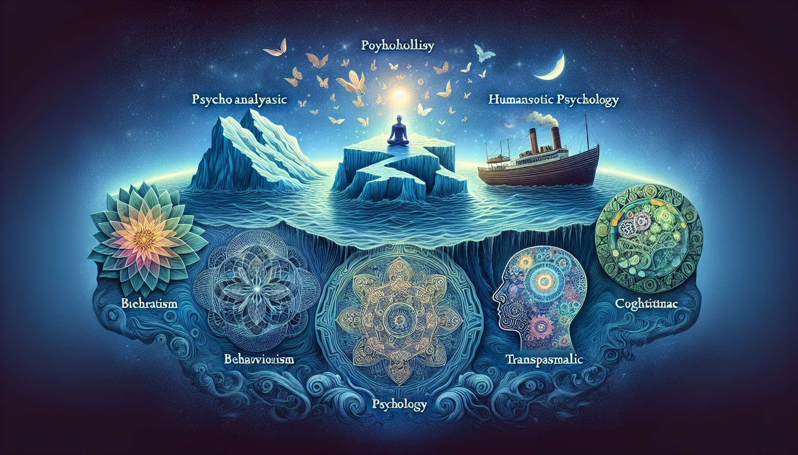

Psychology is a vast and fascinating discipline that explores the intricacies of the human mind. Over the decades, various schools of thought have emerged, each providing a unique insight into our mental, emotional, and behavioral functioning.  
  
Psychoanalysis, founded by Sigmund Freud, emphasizes the importance of the unconscious in our psychic life. According to this approach, our behaviours and emotions are influenced by unconscious drives and conflicts, often rooted in our childhood. Psychoanalysis explores the defense mechanisms we put in place to manage these internal tensions, such as repression, projection, or sublimation. By becoming aware of these unconscious processes, we can better understand our repetitive patterns and work on our emotional wounds, as we will see in sub-module 2.4.  
  
Behaviorism, on the other hand, focuses on the study of observable and measurable behaviors. Behaviorists, like John Watson and B.F. Skinner, believe that our actions are shaped by the conditioning and reinforcements we receive from our environment. Thus, a behaviour followed by a reward tends to be repeated, while a behaviour leading to punishment is gradually abandoned. This approach has been used in behavioural therapies to treat phobias or addictions, helping patients unlearn negative associations and develop new, adaptive behaviors.  
  
The humanist approach, represented by figures like Carl Rogers and Abraham Maslow, places self-fulfillment and self-actualization at the heart of human nature. According to this perspective, each individual has within him the necessary resources to grow and realize his full potential. The role of the therapist is to offer a space of empathetic listening and unconditional support, allowing the person to freely explore his subjective experience and find his own answers. The concepts of authenticity, congruence and unconditional positive regard are at the heart of Carl Rogers' person-centered approach.  
  
Cognitivism is concerned with the mental processes that underlie our thoughts, beliefs and thought patterns. Cognitive therapies, like Beck's cognitive therapy or Ellis's rational-emotive therapy, start from the principle that our emotions and behaviours are influenced by our interpretation of events. By identifying and modifying our automatic thoughts and irrational beliefs, we can improve our emotional and relational well-being. This work on limiting beliefs will be deepened in sub-module 2.5.  
  
Finally, transpersonal psychology is interested in expanded states of consciousness and spiritual experiences. This school explores the dimensions of the psyche that transcend the ego and individual personality, such as meditative states, mystical experiences or psychic phenomena. Transpersonal psychology seeks to integrate ancestral wisdom and contemplative practices into modern psychology, thus offering a holistic view of the human being. It thus complements the principles of spiritual healing discussed in module 1.  
  
These different currents of psychology offer a rich and nuanced understanding of the complexity of the human mind. As a Spiritual Healing Coach, it is essential to immerse oneself in these different perspectives to guide our clients in an integrative and adapted manner to their specific needs. Each approach provides valuable tools to facilitate emotional healing, self-awareness, and personal fulfillment.  
  
Key points to remember:  
  
- Psychology explores the various facets of the human mind through several complementary schools of thought.  
  
- Freud's psychoanalysis emphasizes the importance of the unconscious and defense mechanisms in our psychic life.  
  
- Behaviorism studies observable behaviors and the conditioning that shapes them, used notably in behavioral therapies.  
  
- Roger and Maslow's humanistic approach places self-fulfillment and self-actualization at the heart of human nature, through an empathetic and supportive therapeutic relationship.  
  
- Cognitivism is interested in thoughts, beliefs, and mental schemas that influence our emotions and behaviors. Cognitive therapies aim to modify automatic thoughts and irrational beliefs.  
  
- Transpersonal psychology explores expanded states of consciousness and spiritual experiences, integrating ancestral wisdom into modern psychology.  
  
- As a Spiritual Healing Coach, it is important to immerse oneself in these different approaches to provide integrative and adapted support for the specific needs of each client.