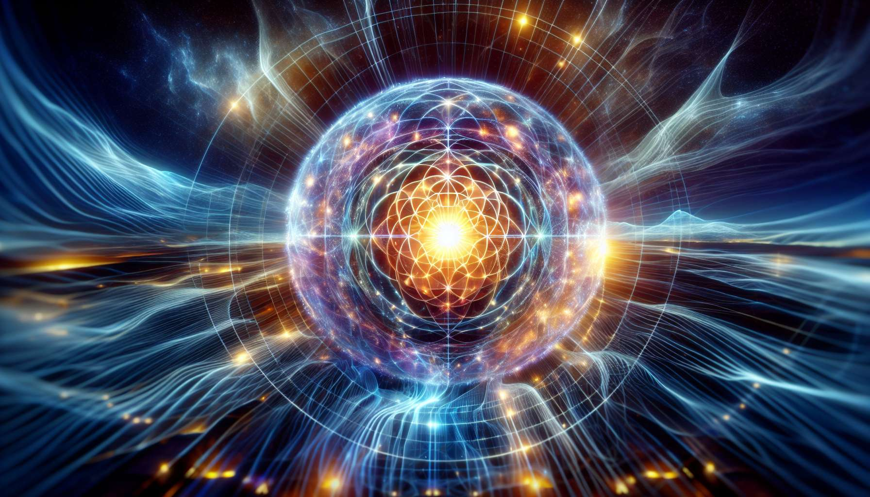

Shamballa Multidimensional Healing is an energy healing technique channeled by John Armitage in the 1990s. According to him, this approach allows access to healing frequencies from the ethereal city of Shamballa, a place of high consciousness described in Buddhist and Hindu traditions. Shamballa Multidimensional Healing aims to activate our spiritual DNA and awaken our full potential as a multidimensional being.  
  
The process of Shamballa Multidimensional Healing relies on the use of sacred symbols that act as vibratory keys to access different dimensions of consciousness. These symbols, revealed to John Armitage during deep meditations, are complex geometric shapes embodying specific qualities such as unconditional love, divine wisdom, or grace. By visualizing and integrating them into the energy field, the practitioner activates these superior healing frequencies.  
  
John Armitage emphasizes the importance of meditation in the practice of Shamballa Multidimensional Healing. Before each session, the practitioner enters a deep meditative state where he connects with his inner guidance and the energies of Shamballa. He visualizes the sacred symbols activating in his own energy field, then projects them into the recipient's aura. This meditative transmission allows for a deep harmonization of the subtle bodies and an elevation of the vibratory frequency.  
  
One of the key symbols of Shamballa Multidimensional Healing is the "Shamballa Crystal", a complex geometric shape representing the union of male and female forces in perfect balance. By meditating on this symbol, the practitioner activates his power of co-creation and manifests abundance, harmony, and joy in his life. He learns to become a crystalline channel for healing energies, like a prism reflecting divine light.  
  
Master Germain, an ascended master channeled by John Armitage, teaches that Shamballa Multidimensional Healing is an advanced spiritual technology that prepares us for ascension to higher dimensions. By activating our 12 strands of DNA and our light bodies, this approach allows us to transcend the limitations of 3D reality and embody our divinity. Many practitioners report experiences of cosmic consciousness, past life vision, and telepathic communication following the initiations.  
  
Shamballa Multidimensional Healing also uses crystals and vibratory elixirs to amplify and stabilize healing frequencies. Crystals act as amplifiers and transmitters of energy, while elixirs, prepared by imbuing water with the sacred symbols, allow to integrate Shamballa frequencies at the cellular level. Their precise use is taught during initiation seminars, allowing practitioners to refine their energetic sensitivity.  
  
As a Spiritual Healing Coach, integrating Shamballa Multidimensional Healing into your practice will allow you to offer your clients an experience of multidimensional awakening. By helping them activate their light bodies and their spiritual DNA, you will accompany them towards a consciousness expansion and a realization of their full potential. Shamballa Multidimensional Healing is particularly indicated for people in search of alignment with their soul mission and connection with spiritual realms.  
  
Drunvalo Melchizedek, a renowned spiritual teacher, sees in Shamballa Multidimensional Healing an expression of the Merkabah, the light vehicle that allows us to travel between dimensions. According to him, by activating our Merkabah through meditation and sacred symbols, we become light ambassadors capable of healing and elevating planetary consciousness. Shamballa Multidimensional Healing thus invites us to embrace our role as divine co-creator and work for the advent of a new paradigm on Earth.  
  
Key Points:  
  
- Shamballa Multidimensional Healing is an energetical healing technique channeled by John Armitage in the 1990s, aiming to access the healing frequencies of the ethereal city of Shamballa.  
  
- This approach uses sacred symbols, such as the "Shamballa Crystal", which act as vibratory keys to activate our spiritual DNA and awaken our multidimensional potential.  
  
- Meditation is essential in the practice of Shamballa Multidimensional Healing, allowing the practitioner to connect to his inner guidance and transmit healing energies.  
  
- According to Master Germain, channeled by John Armitage, this technique is an advanced spiritual technology preparing for ascension to higher dimensions by activating our 12 strands of DNA and our light bodies.  
  
- Crystals and vibratory elixirs are used to amplify and stabilize healing frequencies.  
  
- Integrating Shamballa Multidimensional Healing as a Spiritual Healing Coach allows to offer clients a multidimensional awakening and consciousness expansion experience.  
  
- Drunvalo Melchizedek sees this approach as an expression of the Merkabah, the light vehicle allowing one to travel between dimensions and work for the elevation of planetary consciousness.