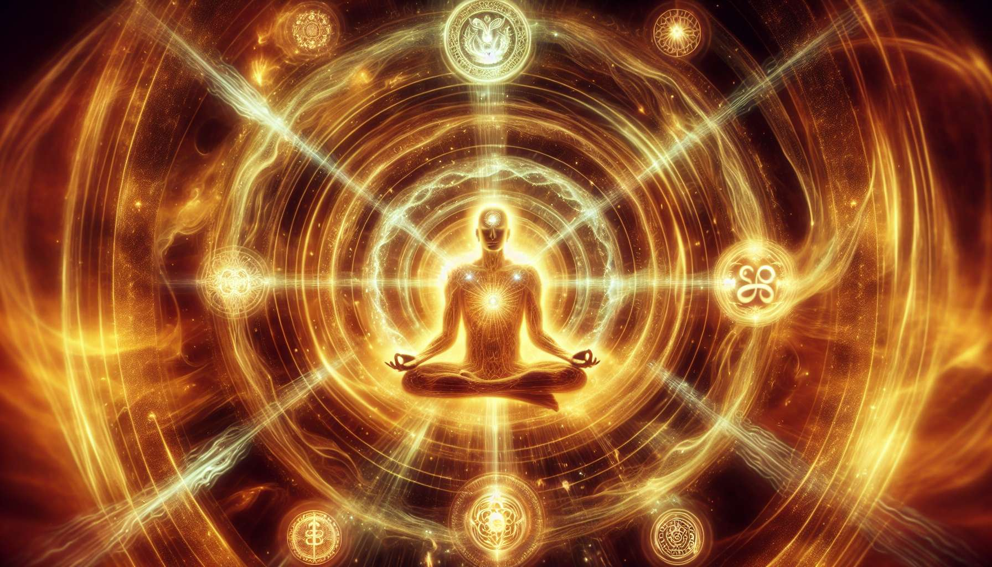

Magnified Healing is an energetic healing technique channeled by Gisèle King in the 1980s. According to her, this approach allows us to access higher healing frequencies emanating from the Divine Source and to anchor them enduringly in our energy field. Thus, Magnified Healing aims at a purification and vibrational elevation of our entire being, reconnecting us to our divine essence and our creative power.  
  
The process of Magnified Healing unfolds in three main phases: preparation, invocation, and integration. During the preparation phase, the practitioner creates a sacred space by purifying the environment and putting her/himself in a state of receptivity and alignment with the Source. They also formulate a clear intention for the session, visualizing the desired outcome.  
  
The invocation phase is the heart of the session. The practitioner calls upon the healing energies of Magnified Healing by reciting a specific prayer that invokes the presence of ascended masters, archangels, and beings of light. They then visualize a vortex of golden light descending from the heart of Creation and entering through the crown chakra, then diffusing throughout the body. This divine energy is directed by the practitioner's intention towards the areas requiring healing or rebalancing.  
  
Gisèle King stresses the importance of anchoring these healing frequencies in the physical body. To do this, the practitioner visualizes the energy of Magnified Healing condensing in each cell and atom, until it becomes an integral part of the being. This anchoring allows for a lasting and profound transformation, acting on both the physical, emotional, mental, and spiritual levels.  
  
Once the energy is anchored, the practitioner moves on to the integration phase. They thank the invoked beings of light and release them, then take a moment of silence to allow the energy to stabilize and fully integrate. It's recommended to drink plenty of water after the session to facilitate the elimination of toxins and the circulation of the new energy.  
  
One of the unique aspects of Magnified Healing is the transmission of energy that takes place from the practitioner to the recipient. Unlike other approaches where the practitioner acts as a simple channel, here there is a real impregnation of their energy field by the invoked frequencies. Thus, even after the session, the practitioner continues to radiate this healing energy, like a beacon of beneficial light for those around them.  
  
Gisèle King teaches that we are all multidimensional beings connected to the Divine Source. By reconnecting to our profound nature through Magnified Healing, we can transcend our limitations and manifest our full potential. Many practitioners report spectacular healings among their clients, as well as positive changes in their own lives such as increased joy, heightened intuition and enhanced synchronicity.  
  
Magnified Healing uses sacred symbols and specific mudras (hand gestures) to amplify and direct the energy. These tools act as vibrational keys that open portals to higher dimensions of consciousness. Their precise use is taught during initiation seminars, allowing practitioners to refine their mastery of this technique.  
  
As a Spiritual Healing Coach, integrating Magnified Healing into your practice will allow you to provide your clients with a profound experience of reconnecting to their divine essence. By assisting them in anchoring these higher healing frequencies into their being, you will accompany them towards a comprehensive purification and regeneration. Magnified Healing is particularly suitable for individuals going through a period of transition or spiritual awakening, as it clarifies the life path and dissolves karmic blockages.  
  
Kryon, a guide channeled by Lee Carroll, sees in Magnified Healing an expression of the New Energy that is unfolding on Earth. According to him, this technique allows us to access higher octaves of light that were previously reserved for spiritual masters. By opening ourselves to these frequencies, we become conscious co-creators of our reality, capable of healing and transforming our lives and the world around us.  
  
Key points to remember:  
  
- Magnified Healing is an energetic healing technique channeled by Gisèle King in the 1980s, aiming at a purification and vibrational elevation of the being.  
  
- The process unfolds in three phases: preparation (creation of a sacred space), invocation (calling upon healing energies), and integration (anchoring of frequencies in the physical body).  
  
- Anchoring allows for a lasting and profound transformation on all levels: physical, emotional, mental, and spiritual.  
  
- The practitioner is impregnated by the invoked frequencies and continues to radiate this beneficial energy after the session.  
  
- Magnified Healing uses sacred symbols and mudras to amplify and direct the energy, opening portals to higher dimensions of consciousness.  
  
- This technique helps reconnect to one's divine essence, transcends limitations, and manifest full potential. It is particularly suitable during a period of transition or spiritual awakening.  
  
- According to Kryon, Magnified Healing is an expression of the New Energy allowing access to elevated light frequencies, making us conscious co-creators capable of healing and transforming our lives and the world.