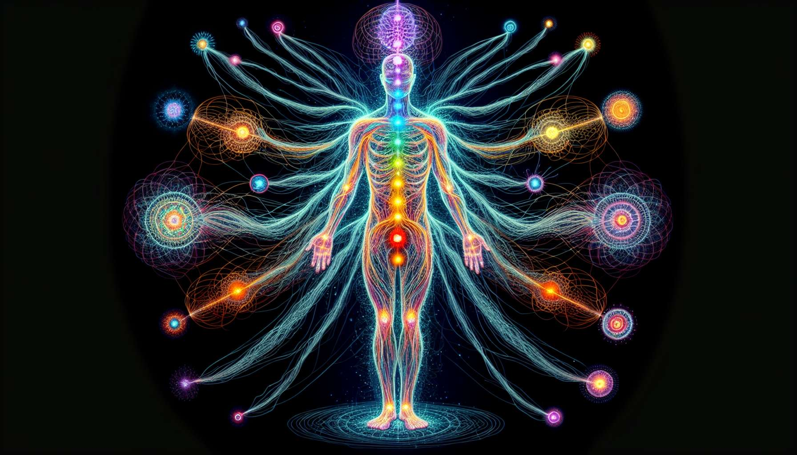

Nadis are subtle channels that allow for the circulation of vital energy, prana, throughout the body. According to yogic tradition, there are 72,000 nadis that irrigate the entire body, in the same way that blood vessels and nerves ensure the distribution of blood and nerve impulses. However, unlike the circulatory and nervous systems which belong to the physical plane, the nadis are located within the energy body or pranico-etheric body.  
  
Of these 72,000 nadis, three are considered as main: sushumna, ida and pingala. The sushumna nadi is the central channel that extends from the base of the spine to the top of the skull. It passes through the center of each of the seven major chakras and represents the path of spiritual awakening, the ascension of the kundalini. When sushumna is activated and energy can freely circulate within it, the person attains higher states of consciousness and experiences unity with the divine.  
  
On either side of sushumna, the nadis ida and pingala wrap themselves, like two intertwined snakes. Ida, of a lunar and feminine nature, transports energies of coolness, soothing, and receptivity. It is associated with the left nostril and governs the parasympathetic nervous system, responsible for rest and regeneration. Pingala, of solar and masculine nature, carries energies of warmth, dynamism and action. It is connected to the right nostril and governs the sympathetic nervous system, involved in activation and energy expenditure.  
  
Balance and harmonization of the ida and pingala nadis is an essential aspect of energy work. When these two channels operate optimally and synchronously, the person benefits from increased vitality, emotional stability, and mental clarity. They are both grounded and inspired, capable of receiving and acting in a just and appropriate manner.   
  
For example, a person in whom the ida nadi is hypo-active and pingala hyper-active would tend to be over-stimulated, impulsive and scattered. Conversely, an individual with a dominant ida and a weakened pingala would likely be apathetic, depressed and lacking stamina. The role of the Spiritual Healing Coach will be to help the person rebalance these two polarities, using techniques such as alternating breathing, color visualization or specific yoga postures.  
  
Beyond the three main nadis, there are many other secondary channels that ensure a fine and precise circulation of energy throughout the body. Each organ, each gland, each part of the body is irrigated by a dense network of nadis that bring the necessary prana for its proper functioning. When these nadis are purified and unblocked, vital energy can circulate smoothly and harmoniously, thus promoting health and wellness at all levels.  
  
For example, the nadis that run through the digestive system are particularly important for assimilating the subtle nutrients contained in food. If these nadis are obstructed by physical or emotional toxins, the person may suffer from digestive disorders, chronic fatigue or deficiencies. The coach's job will then consist of offering protocols for purifying the nadis, such as deep breathing exercises, light visualizations or therapeutic sounds.  
  
It is important to understand that the nadis are intimately linked to other energy structures of the body, such as the chakras and acupuncture meridians. Each chakra is indeed connected to a network of nadis that distributes its specific energy towards the different parts of the body. Similarly, acupuncture points are seen as "entrance gates" through which prana enters the nadis to circulate in the meridians.   
  
Thus, an imbalance in a chakra could lead to a disruption of the energy flow in the associated nadis. For example, a blockage in the heart chakra could result in congestion of the nadis connected to the circulatory and respiratory system, leading to symptoms such as hypertension, shortness of breath or chest tightness.  
  
In the same way, an obstruction on an acupuncture meridian could disrupt the circulation of prana in the corresponding nadis. That's why the Spiritual Healing Coach must have a comprehensive and integrated view of the energy system, taking into account the interactions between chakras, meridians and nadis.  
  
In summary, the nadis form a subtle and complex network that ensures the distribution of vital energy throughout the body. Their purification and balancing is an essential aspect of energy work, which allows to restore health and harmony at all levels of being. By integrating the knowledge of nadis into their practice, the Spiritual Healing Coach has a powerful tool to refine their diagnosis and offer adapted and effective treatment protocols. Whether through breathing, visualization, sound, or posture techniques, the goal is to promote a smooth and harmonious circulation of prana, to support the overall process of healing and awakening of the individual.  
  
Key points to remember:  
  
- Nadis are subtle channels allowing the circulation of vital energy (prana) in the energy body.  
- There are 72,000 nadis, including three main ones: sushumna (central channel for spiritual awakening), ida (lunar energy, left nostril, parasympathetic system) and pingala (solar energy, right nostril, sympathetic system).  
- The balance between ida and pingala is essential for vitality, emotional stability and mental clarity.  
- Every organ and part of the body is irrigated by a network of secondary nadis, whose purification promotes health and well-being.  
- Nadis are connected to chakras (each chakra is connected to a network of nadis) and acupuncture meridians (entry points of prana into the nadis).  
- An imbalance in the chakras or an obstruction of the meridians can disrupt the circulation of prana in the corresponding nadis.  
- The Spiritual Healing Coach uses techniques (breathing, visualization, sound, postures) to purify and balance the nadis, thereby promoting healing and spiritual awakening.