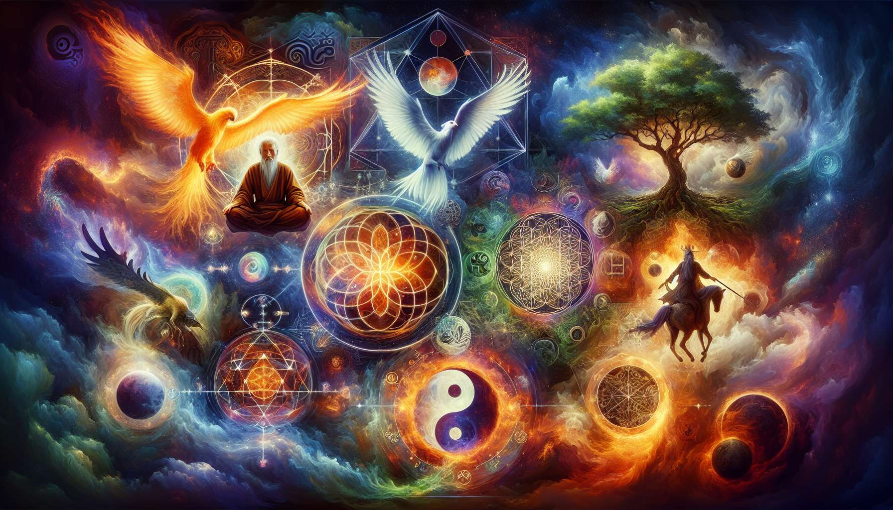

Archetypes and spiritual symbols are fundamental elements of the human psyche and spiritual traditions worldwide. They form a universal language that speaks directly to our subconscious and connects us to profound dimensions of existence. Understanding and working with these archetypes and symbols are a valuable key to inner journeying and the healing of the soul.  
  
Archetypes are original patterns, primal forces that structure our psyche and our life experience. They are present in all cultures and are manifested through mythological figures, tales, dreams. The psychoanalyst Carl Jung extensively explored these archetypes, seeing them as bridges between the personal unconscious and the collective unconscious. Among the main archetypes, we find the Hero, the Wise Man, the Lover, the Rebel, the Innocent, the Creator, the Magician, the Sovereign...  
  
For example, the archetype of the Hero represents the initiatory quest, the courage to face trials to achieve one's full potential. This archetype resonates within each of us when we are called to step out of our comfort zone, to overcome our fears and limitations to fulfill our destiny. The myths of the world are teeming with heroic figures, from Hercules to Joan of Arc and Buddha, who have embodied this archetype and inspire us on our own path.  
  
Each archetype has its strengths, shadows, specific lessons. By becoming aware of the archetypes that animate us, we can better understand our deep-seated motivations, our recurring patterns, our areas of darkness and light. We can also consciously activate certain archetypes to develop qualities we need at certain stages of our life. Working with archetypes is a powerful tool for self-knowledge and inner transformation.  
  
In the Native American tradition, the Medicine Wheel represents the balance and complementarity of the four animal archetypes: the Eagle in the East (vision, spirituality), the Wolf in the South (clan, emotions), the Bear in the West (introspection, healing), the Bison in the North (wisdom, grounding). Each individual is invited to develop these four qualities within them to walk the path of Life in harmony and fulfillment.  
  
Spiritual symbols, on the other hand, are visual representations that condense and transmit profound truths. They act as gateways to states of consciousness, subtle energies, mysteries of existence. They are found in sacred art, mandalas, icons, yantras... Each spiritual tradition has its own symbols, but some are universal, such as the cross, the circle, the spiral, the tree of life, the sun, the moon...  
  
The Yin Yang symbol, in Chinese philosophy, represents the dynamic balance of opposing and complementary forces that govern the universe. Yin, the feminine principle, receptive, dark, and Yang, the masculine principle, active, bright, intertwine in a perpetual dance, each containing a seed of the other. This symbol invites us to embrace the totality of existence, to transcend dualisms to realize the fundamental unity at the heart of Tao.  
  
Meditating on a symbol, contemplating it, internalizing it, allows us to awaken the spiritual qualities it represents within ourselves. Symbols are supports for concentration, springboards for deep meditative states. They also help us connect with spiritual lineages, invoke sacred presences, channel energies of healing or transformation.  
  
The yantras, in the Tantric tradition, are geometric diagrams that represent divinities or cosmic energies. Drawing a yantra, visualizing it internally, reciting its associated mantra, allows us to resonate with the spiritual force it embodies. The Sri Yantra, for example, is one of the most powerful and complex. It represents the entirety of creation emerging from the central point, the bindu, through nine interlaced triangles. Meditating on this yantra opens the door to transcendent states of consciousness, to the experience of unity and bliss.  
  
In the context of spiritual coaching, working with archetypes and symbols can be a valuable tool to help clients connect with their inner wisdom, make sense of their life experiences, mobilize their deep resources. The coach can guide visualizations, meditations, rituals that call upon the power of archetypes and symbols to support the transformation process. The coach can also help the client identify the archetypes that animate them, understand their influences, consciously integrate their qualities.  
  
A woman in career transition could explore the archetype of Death and Rebirth to navigate the grieving of her old identity and fully embrace a new chapter in her life. Guided by her coach, she might visualize the caterpillar entering the cocoon to undergo its metamorphosis into a butterfly, dying to one form to be reborn to another. This universal symbol of transformation would help her let go, trust the process, connect to the life force traversing her.  
  
Thus, archetypes and spiritual symbols are much more than mere intellectual concepts. They are living keys that open us to the depth of our being, to the richness of our unconscious, to the wisdom of traditions. By learning to recognize them, to honor them, to work with them, we connect to forces that transcend us and guide us on the path to self-realization. Spiritual coaching finds inexhaustible resources here to awaken and support the unique potential of every human being.  
  
Key takeaway points:  
  
- Archetypes are original models, primal forces that structure our psyche and life experience. They are present in all cultures through mythological figures, stories, and dreams.  
  
- Each archetype has its strengths, shadows, and specific lessons. Becoming aware of the archetypes that animate us allows us to better understand our deep motivations, recurring patterns, areas of darkness and light.  
  
- Spiritual symbols are visual representations that condense and transmit deep truths. They act as gateways to states of consciousness, subtle energies, and mysteries of existence.  
  
- Meditating on a symbol, contemplating, and internalizing it allows us to awaken the spiritual qualities it represents in ourselves. Symbols are supports for concentration and springboards to deep meditative states.  
  
- In spiritual coaching, working with archetypes and symbols can help clients connect with their inner wisdom, make sense of their life experiences, and mobilize their deep resources.  
  
- Archetypes and spiritual symbols are living keys that open us to the depth of our being and to the wisdom of traditions. By learning to recognize and work with them, we connect to forces that guide us on the path to self-realization.