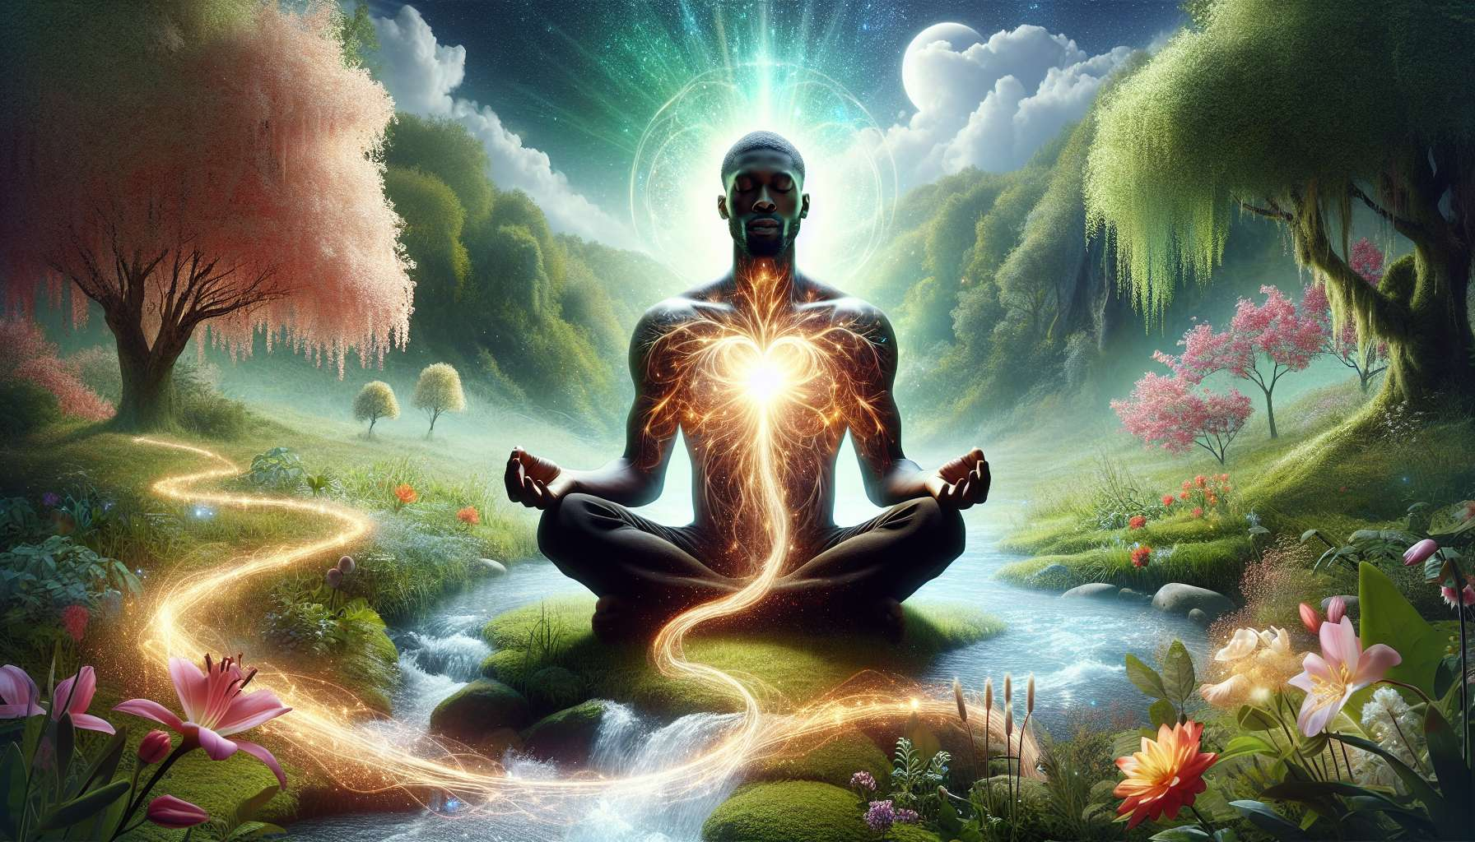

Intuition and self-connection are fundamental pillars of the practice of the Spiritual Healing Coach. Beyond techniques and tools, it is his ability to connect to his own inner wisdom that allows him to offer genuinely transformative coaching.  
  
Intuition can be defined as a form of direct knowledge, which does not pass through the filter of rational mind. It is a subtle perception, an "impression" that spontaneously emerges and guides us towards what is right and aligned for us. Everyone has this intuitive faculty, but it is often stifled by mental noise and conditioning.  
  
For the Spiritual Healing Coach, cultivating his intuition is essential on several levels. First of all, it allows him to be more present and attentive in his coaching. Instead of relying solely on his theoretical knowledge or past experiences, he can be open to what emerges in the moment and receive insights on what the person truly needs. His intuition guides him to ask the right question, propose the appropriate tool, feel what is at play beyond words.  
  
But intuition is also a precious guide for the coach himself, in his own journey. By connecting to this inner voice, he can make more aligned decisions, identify his own areas of shadow and resistance, trust himself in moments of doubt. Intuition becomes a compass that guides him towards ever more authenticity and integrity.  
  
However, for intuition to truly express itself, it requires a deep connection to self. Being connected to self means being present to one's inner experience, to what is lived in the body, the heart, the soul. It means developing an intimacy with oneself, a compassionate listening to one's own needs, desires, aspirations. It means daring to look at one's own shadow and light parts face to face, welcoming all that is there with kindness and compassion.  
  
This connection to self is the basis of any authentic relationship, whether it is with oneself, others or the living. When the coach is deeply rooted in himself, he radiates a stable and reassuring presence that naturally invites the other to reconnect to his own center. He does not seek to "save" or "fix" the other, but simply to be a mirror of his own light.  
  
Concretely, there are many practices to develop one's intuition and connection to self. Meditation is undoubtedly one of the most powerful. Sitting in silence each day, observing the flow of thoughts and sensations without attaching to them, gradually creates a space of inner calm and clarity. This is the space in which intuition can emerge, like a subtle whisper at first, then more and more clearly.  
  
Bodywork is also fundamental. Whether through yoga, dance, qi gong or simply a conscious walk in nature, reconnecting to one's body allows an anchoring in the present moment and a detachment from the mind. The body does not lie, it is the privileged vehicle of our intuition. By refining our sensations, we become more receptive to the subtle messages that pass through us.  
  
Intuitive writing, in the form of a diary or "free writing" practice, is also a precious tool. By letting the pen run on the page without thinking, we allow a more spontaneous and authentic speech to emerge. We can dialogue with our intuition, ask it questions and be surprised by the wisdom of the answers that come forth.  
  
Take the example of Marie, a Spiritual Healing Coach who accompanies Anne, a woman in search of meaning following a professional burnout. During a session, Anne expresses her distress and her feeling of being lost. Instead of giving her advice or reassuring her, Marie relies on her intuition. She feels that there is something deeper that is trying to emerge. Gently, she invites Anne to close her eyes and focus her attention on her bodily sensations. She guides her through a short meditation, inviting her to welcome what is there, without judgment. After a few minutes, Anne begins to cry softly. She becomes aware of a deep-seated sadness, related to an unprocessed grief. Thanks to Marie's intuition and this space of self-connection, Anne can finally let this repressed emotion emerge and begin a healing process.  
  
Throughout her own journey, Marie has learned to trust her intuition and use it as a guide in her coaching. When she senses resistance in a client, rather than insisting, she listens to her intuition and adjusts her approach. When an image or symbol comes to her during a session, she shares it gently, knowing that it may resonate deeply for the person. She understands that her role is not to have all the answers, but to create a space where each person's inner wisdom can emerge.  
  
This connection to self and this intuitive listening, Marie cultivates them daily, in her own practice. Every morning, she takes the time to meditate and write in her journal. She pays attention to her dreams, her synchronicities, the small signs that life sends her. When she feels scattered or stressed, she knows how to return to her anchoring, breathe deeply, reconnect to her center. It is from this rootedness that she can offer a truly supportive presence to those she accompanies.  
  
In the end, intuition and self-connection are the invisible foundations on which the art of the Spiritual Healing Coach rests. More than just a skill to acquire, it is a path of awakening and deepening the relationship with oneself and the living. By cultivating this presence to self and this subtle listening, the coach becomes an increasingly pure channel for healing and transformation. He embodies in his very being what he invites others to: a return to the essence, a connection to the source of life that inhabits us all. From this space of truth and simplicity, blockages are untied, wounds are healed, and life can resume its natural course, in all its beauty and power.  
  
Key Points to Remember:  
  
1. Intuition is a form of direct knowledge, a subtle perception that guides us towards what is right and aligned for us.  
  
2. For the Spiritual Healing Coach, cultivating his intuition is essential for being present and attentive in his coaching, and for orienting himself in his own journey.  
  
3. Intuition requires a deep connection to self, a presence to one's inner experience and a compassionate listening to one's own needs and aspirations.  
  
4. The connection to self is the basis of any authentic relationship and allows the coach to radiate a stable and reassuring presence.  
  
5. Meditation, bodywork, and intuitive writing are powerful practices for developing one's intuition and connection to self.  
  
6. The coach's role is not to have all the answers, but to create a space where each individual's inner wisdom can emerge.  
  
7. By cultivating his own connection to self and intuitive listening on a daily basis, the coach can offer a truly supportive presence to those he accompanies.  
  
8. Intuition and self-connection are the foundations of the art of the Spiritual Healing Coach, a path of awakening and deepening the relationship with oneself and the living.