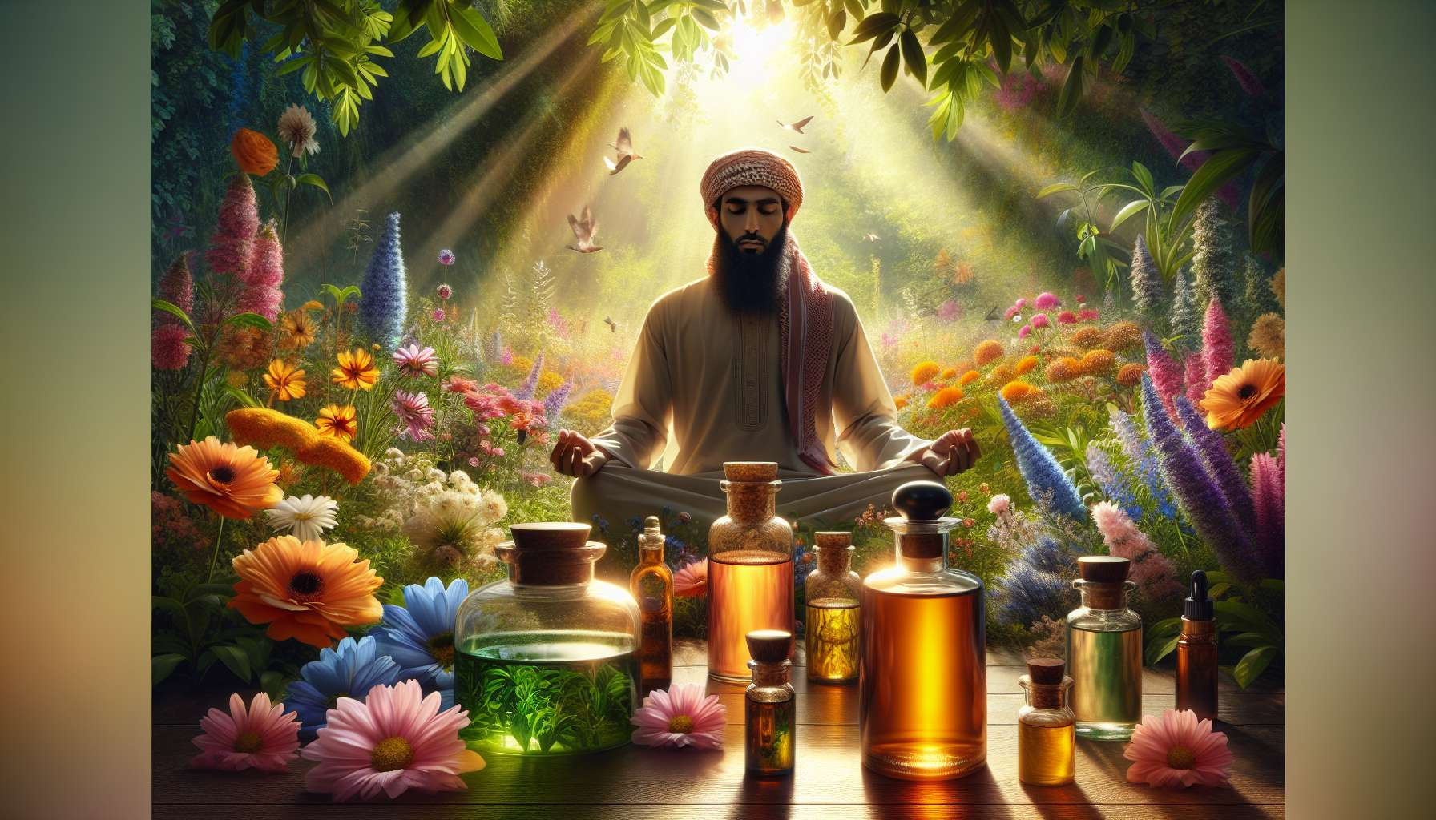

The use of essential oils and floral elixirs is a valuable complement to spiritual healing practices. These natural substances act on both the physical body, emotions, and subtle levels of being, thereby promoting overall rebalancing and deep well-being.  
  
The essential oils are concentrated extracts from aromatic plants, obtained by steam distillation or cold pressing. They contain the active principles and the vital essence of plants, thus offering a unique synergy of therapeutic benefits. Each oil has specific properties, acting, for instance, as an antiseptic, calming, stimulating, or regenerative agent. Beyond their physical indications, essential oils also have a subtle impact on emotions and states of mind. For example, lavender soothes mental agitation and promotes relaxation, while lemon clarifies the mind and boosts motivation.  
  
To use essential oils in a spiritual healing context, it is essential to choose therapeutic quality oils, from organic farming, and preferably complete, that is to say, not rectified or de-terpenated. They can be diffused into the atmosphere to create an ambiance conducive to relaxation and introspection, applied locally on the body's demanded areas, or incorporated into massage blends for a more global action. Some powerful oils such as frankincense or sandalwood are particularly suited to accompany meditative practices and rituals, promoting the connection to the sacred and the raising of consciousness.  
  
The floral elixirs, on the other hand, are liquid preparations obtained by macerating wildflowers in sunlit pure water. They act primarily on the emotional and mental sphere, helping to gently transform negative patterns and to unfold the qualities of the soul. Each elixir carries the vibrational signature of a flower and stimulates a specific process of inner evolution. For instance, the apple elixir promotes mental clarity and the ability to digest life experiences, while the star of Bethlehem brings comfort and gentleness in situations of shock or trauma.  
  
Floral elixirs are typically taken orally, with a few drops under the tongue several times a day. They can be taken on an ad-hoc basis to get through a difficult phase, or follow a longer cure to work on deep patterns. It is also possible to combine them to create synergies suited to individual needs or incorporate them into ambiance sprays or energetic creams. Their subtle action and harmlessness make them precious allies to support therapeutic processes, particularly in sensitive or weakened people.  
  
As a spiritual healing practitioner, it's essential to train seriously in the use of essential oils and floral elixirs before proposing them to your clients. This involves knowing their indications well, their precautions for use, and their potential contraindications. It is also important to take into account the sensitivity and individual reactions of each person, always starting with low dosages and carefully observing the effects produced. Your role is to offer personalized and kind accompaniment, making sure not to impose your own choices but to guide your clients to the most appropriate solutions for them.  
  
Beyond their specific benefits, essential oils and floral elixirs commonly connect us to the intelligence of life and the wisdom of nature. By integrating them into our healing practice, we honor the precious gifts that Earth provides to support our evolution and our fulfillment. We learn to communicate with the plant world and to receive its teachings, while developing our sensitivity and intuition. Each meeting with oil or an elixir, therefore, becomes a unique experience of connection and transformation, inviting us to deploy our potential and radiate our light.   
  
So, do not hesitate to explore the vast universe of essential oils and floral elixirs, and to progressively integrate them into your healer toolbox. Let yourself be guided by your intuition and creativity to create unique and inspiring synergies, gently and powerfully supporting your clients' journey. Always cultivate this wonder and gratitude towards nature's treasures, for it is in this spirit of celebration and connection that the most beautiful healings occur.  
  
Key Takeaways:  
  
- Essential oils and floral elixirs are valuable complements to spiritual healing practices, acting on the physical body, the emotions, and the subtle levels of being.   
  
- Essential oils are concentrated extracts from aromatic plants with specific properties (antiseptic, calming, stimulating, regenerative). They have an impact on the emotions and states of mind.   
  
- It is essential to choose therapeutic quality, organic, and complete essential oils. They can be diffused, applied locally, or incorporated into massages.  
  
- Floral elixirs are liquid preparations obtained by macerating wildflowers. They act on the emotional and mental sphere, helping to transform negative patterns. Each elixir carries the vibrational signature of a flower.  
  
- Floral elixirs are typically taken orally, a few drops under the tongue several times a day. They can be combined or incorporated into ambiance sprays or energetic creams.  
  
- The spiritual healing practitioner must train seriously in the use of essential oils and floral elixirs, knowing their indications, precautions for use, and contraindications. They must offer personalized and kind guidance.  
  
- Essential oils and floral elixirs connect us to the intelligence of life and the wisdom of nature. They support our evolution and fulfillment while developing our sensitivity and intuition.