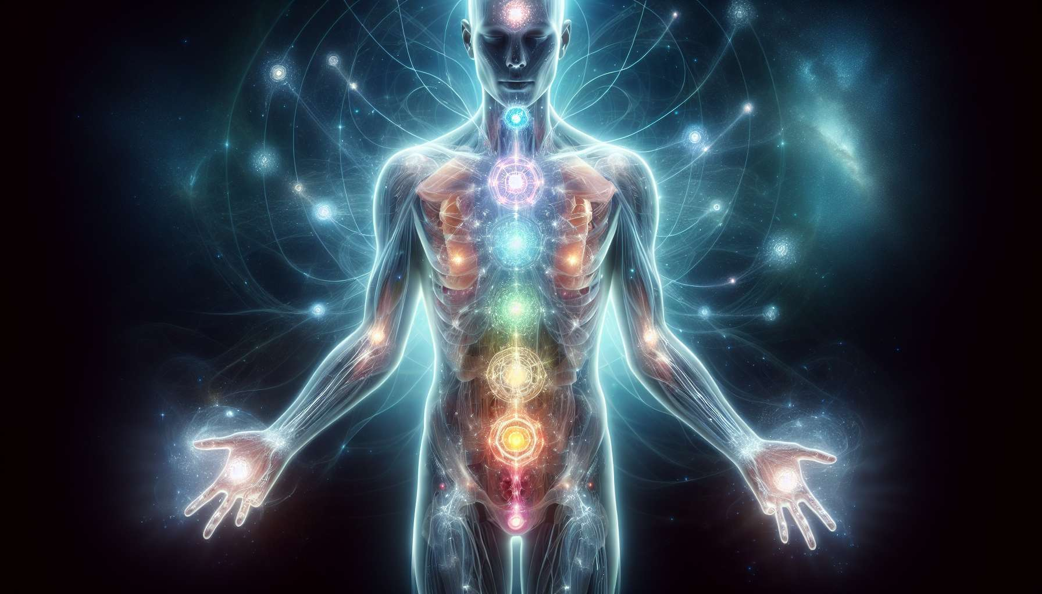

Beyond the seven main chakras, there are many other secondary energy centers scattered throughout the body. These centers play an important role in the fine circulation of vital energy and are connected to specific functions at the physical, emotional, and spiritual levels. Although less known than the major chakras, these secondary centers are nonetheless essential for maintaining the balance and harmony of the entire energy system.   
  
Among the most important secondary centers, we can mention the minor chakras located in the palm of the hands and sole of the feet. These chakras are directly linked to our ability to give and receive energy, whether in a context of care, relationship, or creativity. When they are open and balanced, they allow for a smooth flow of energy between the inside and outside of the body. For example, a therapist with well-developed palmar chakras will be able to transmit healing energy more effectively and intuitively.  
  
Another important secondary center is the thymus chakra, located in the upper part of the sternum. This chakra is associated with the immune system and our ability to protect ourselves from negative or toxic energies. When activated, it acts as a natural energy shield, allowing us to remain centered and intact in the face of external influences. This is especially useful for sensitive or empathic people who tend to easily absorb the emotions and energies of others.  
  
The spleen chakra, located under the left breast, is linked to our vitality and joy of living. It is directly connected to the splenic chakra, which manages our relationship with abundance and prosperity. A balanced spleen chakra translates into a feeling of fullness, trust in life and its possibilities. It is particularly important to take care of this center when going through periods of stress, overwork, or insecurity.  
  
In the back, there are several secondary centers that reflect the frontal chakras. For example, the chakra located between the shoulder blades is linked to the heart chakra and manages our ability to love and accept ourselves as we are. When it is blocked, this can manifest as a feeling of guilt, shame or self-rejection. By working on both the frontal heart chakra and its dorsal reflection, deep healing of emotional wounds and reconciliation with oneself is allowed.  
  
It is interesting to note that some secondary centers are activated during specific spiritual practices. This is the case of the neck chakra, located at the base of the skull, which naturally awakens during deep meditation or the awakening of the kundalini. This chakra is linked to our ability to connect with our inner guidance and spiritual wisdom. When it is open, it promotes expanded states of consciousness, intuition, and connection to our Higher Self.  
  
As a Spiritual Healing Coach, it is essential to take into account these secondary centers in our holistic approach to healing. Indeed, an imbalance at this level can have repercussions on the entire energy system and hinder the overall transformation process.  
  
For example, a person suffering from chronic relationship difficulties can benefit from a rebalancing of the thymus chakra, to strengthen their energy protection and better delineate themselves from others. Similarly, an individual blocked in their creativity or their ability to implement their projects can work on their palmar and plantar chakras, to release the energy flow and take action with confidence.  
  
To harmonize these secondary centers, the coach has many energy tools such as crystals, essential oils, mudras or even therapeutic sounds. For example, they may use a black tourmaline crystal to activate and protect the thymus chakra, or a singing bowl tuned to the note FA to balance the spleen chakra. The important thing is to adapt the treatment protocol to the unique situation of each person, based on a precise and intuitive energy diagnosis.  
  
In summary, secondary energy centers are subtle gateways to our overall balance and fulfillment. By incorporating them into our coaching practice, we refine our understanding of the human energy system and provide ourselves with the means to act in a targeted and effective manner. By taking care of these often overlooked centers, we can truly guide the person towards a deep and lasting healing, which takes into account all dimensions of their being.  
  
Key takeaways :  
  
- Beyond the 7 main chakras, there are numerous secondary energy centers essential to the overall energy balance.  
  
- Minor chakras in hands and feet are linked to the ability to give and receive energy. Their opening allows for better energy circulation.  
  
- The thymus chakra is associated with the immune system and protection against negative energies. It acts as a shield.  
  
- The spleen chakra is linked to vitality, joy of living, and abundance. It is connected to the splenic chakra.  
  
- The dorsal secondary centers reflect the frontal chakras. Working both enables deep healing.  
  
- Some centers are activated during specific spiritual practices, like the neck chakra during meditation.  
  
- Imbalance in secondary centers can impact the entire energy system. Harmonizing them is part of a holistic approach.  
  
- The coach can use different tools (crystals, oils, sounds) in a personalized way to rebalance these centers.  
  
- Incorporating secondary centers into energy coaching allows for refined diagnosis and more targeted, effective action for global and durable healing.