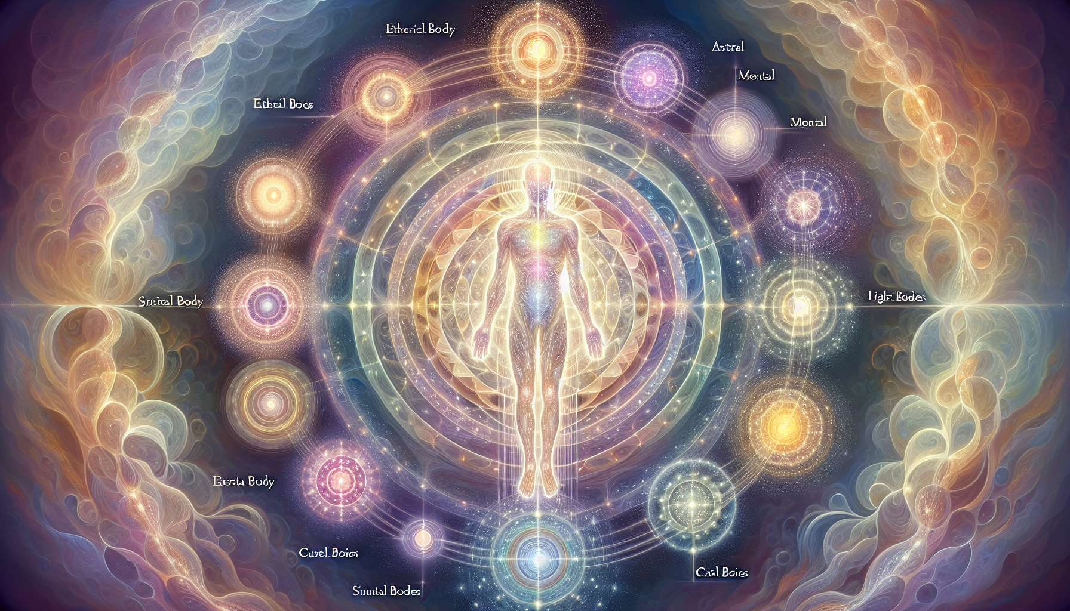

The different subtle bodies that compose human beings are not separate and isolated entities, but form a coherent and interconnected whole. Each body constantly interacts with the others, mutually influencing each other in a constant exchange of information and energy. Understanding these connections is essential for the Spiritual Healing Coach, because it enables them to have a global vision of the person and to act in an integrated way on his entire energy system.  
  
The physical body, which is the densest and most visible, is the material reflection of all other bodies. Each thought, each emotion, each experience lived in the subtle bodies eventually imprints itself in the physical body, creating areas of tension, blockages or, on the contrary, spaces of release and well-being. Thus, an emotional trauma experienced in the astral body can crystallize into muscular knots in the physical body. Similarly, a limiting belief anchored in the mental body can manifest as a slumped posture or functional disorders.  
  
Conversely, the physical body constantly influences the subtle bodies through sensations, perceptions, and movements. Physical pain can generate emotions of fear or anger in the astral body, while an open and confident posture will promote positive thinking in the mental body. This is why bodywork is so important in the healing process: by relieving physical tensions, it allows for a more fluid circulation of energy throughout the system of subtle bodies.  
  
The etheric body, which is the energetic double of the physical body, plays a key role in the communication between the different bodies. It is the one that ensures the transmission of subtle information to dense matter, and vice versa. When the etheric body is healthy and vibrant, it allows for good distribution of vital energy throughout the body, thus promoting health and balance on all levels. On the contrary, a weakened or unbalanced etheric body could cause disturbances in the other bodies, such as a lack of physical vitality, emotional instability, or mental confusion.  
  
The astral body, home to emotions and desires, is closely linked to the mental body that manages thoughts and beliefs. These two bodies often operate in tandem, influencing each other reciprocally in a feedback loop. Thus, fear can trigger anxious thoughts, which in turn amplify the initial fear. Conversely, a positive and confident thought will promote the emergence of pleasant and fulfilling emotions. Working simultaneously on these two bodies, the coach can help the person to permanently transform their limiting emotional and mental patterns.  
  
For example, a person suffering from chronic anxiety can benefit from a protocol integrating emotional release techniques like EFT (Emotional Freedom Technique) to soothe the astral body, and cognitive restructuring exercises like EMDR (Eye Movement Desensitization and Reprocessing) to reprogram the beliefs of the mental body. By acting together on these two levels, deep and lasting healing of anxiety can be achieved.  
  
The causal body, which is the seat of our individual soul and our karmic memory, influences all other bodies through the archetypes, symbols, and life experiences it contains. It holds the blueprint of our destiny and the lessons we have to learn in this incarnation. When we are aligned with our causal body, we have access to our deep wisdom and inner guidance. We can then move through life experiences with more grace, understanding, and serenity, knowing that they all contribute to our spiritual evolution.  
  
A client undergoing a period of profound changes and questioning may thus explore the messages of his causal body, using techniques such as meditation, visualization or art therapy. By connecting to his inner truth and integrating the lessons of his soul, he can give new meaning to his experiences and transform challenges into opportunities for growth.  
  
Finally, the bodies of light and wisdom, which are our most subtle spiritual vehicles, radiate their essence towards all other bodies, bathing them in a light of pure consciousness. When we are connected to these superior bodies, we can transcend the limitations of the ego and access expanded states of consciousness. We then become channels for the divine energies of healing, love, and wisdom, which naturally diffuse throughout our being and radiate around us.  
  
A person engaged in a deep spiritual quest may thus be guided to connect with her light body through practices such as contemplative prayer, devotional chanting, or the meditation of the inner smile. By merging with her divine nature, she can experience deep grace, joy, and peace, and in turn become an agent of transformation for the world.  
  
As a Spiritual Healing Coach, it is essential to always keep in mind this interconnection of the different subtle bodies. Whenever we intervene at one level, whether physical, emotional, mental, or spiritual, we create a resonance effect that reverberates throughout the person's entire energy system. It is by working in an integrated and coherent manner on all levels that we can guide them towards a holistic and lasting healing, which takes into account their entire being.  
  
Points to remember:  
  
- The different subtle bodies of human beings are interconnected and influence each other in a constant exchange of information and energy.  
  
- The physical body is the material reflection of the subtle bodies. Thoughts, emotions, and experiences lived in the subtle bodies imprint themselves in the physical body, creating tensions or areas of well-being.  
  
- The etheric body ensures the transmission of subtle information between the different bodies. A healthy etheric body promotes balance at all levels.  
  
- The astral (emotions) and mental (thoughts, beliefs) bodies operate in tandem and influence each other reciprocally. Working simultaneously on these two bodies allows for a lasting transformation of limiting patterns.  
  
- The causal body contains our karmic memory and the blueprint of our destiny. Aligning with this body helps us navigate life experiences with more grace and serenity.  
  
- The bodies of light and wisdom connect us to our divine nature and enable us to become channels for healing and love energies.  
  
- As a Spiritual Healing Coach, it is essential to work in an integrated manner on all subtle levels, because each intervention creates a resonance effect on the entire energy system of the person.