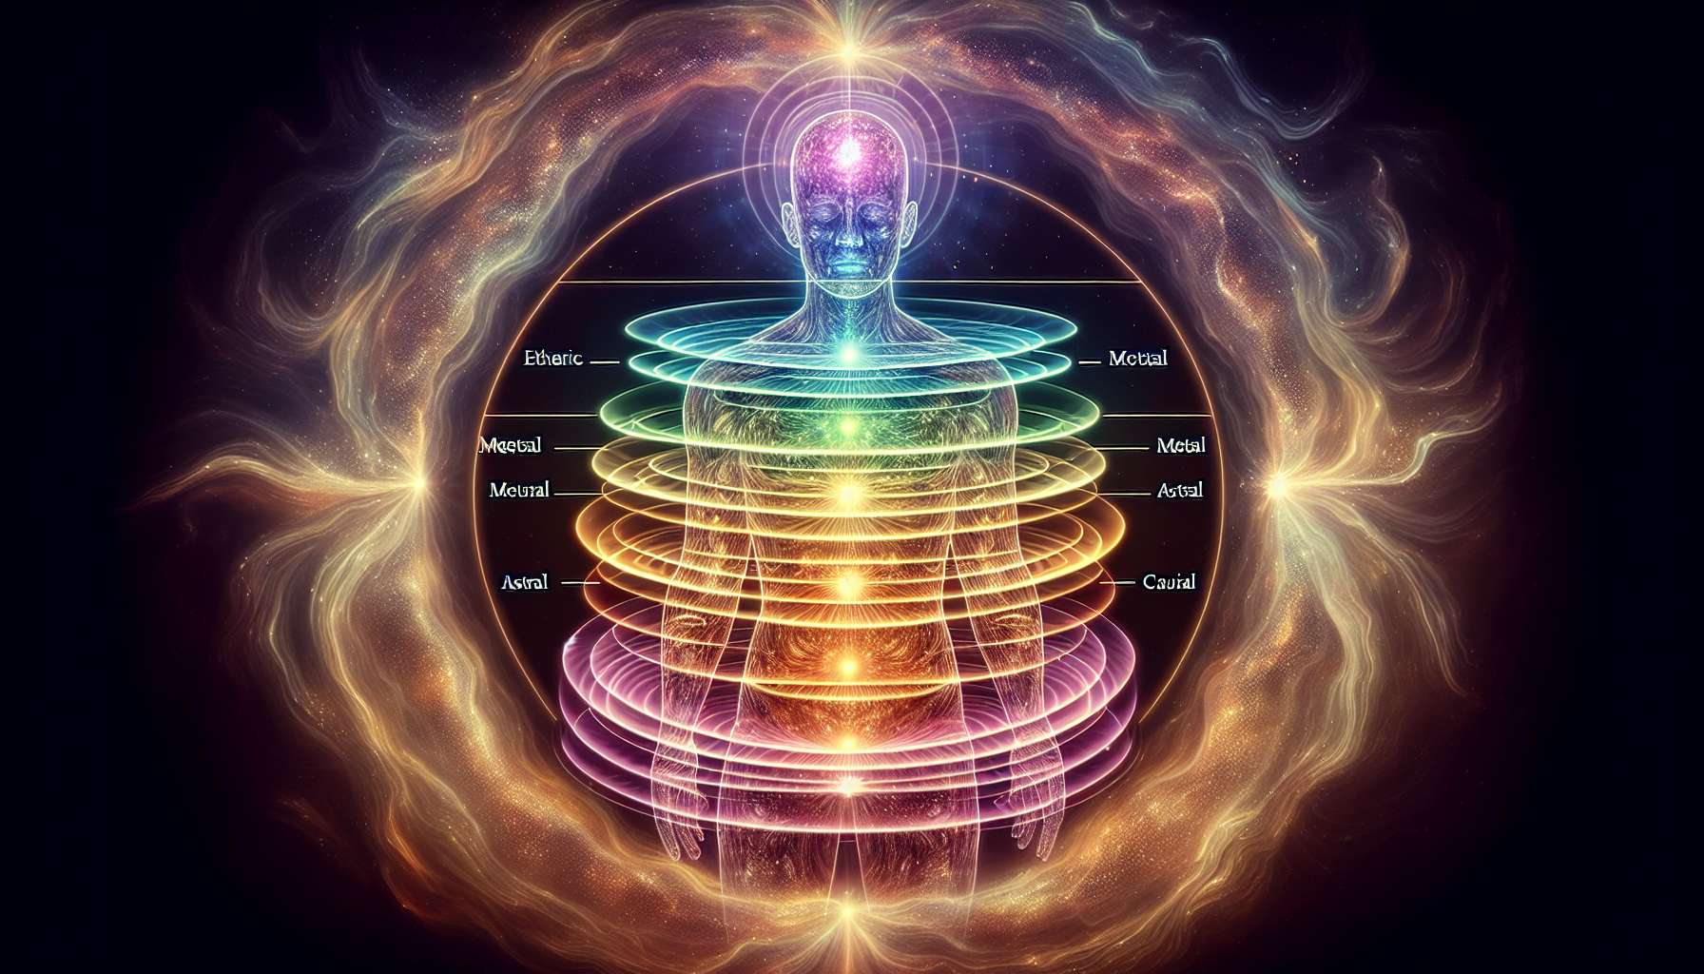

The aura is the subtle energy field that surrounds and penetrates the physical body. It is made up of several vibrational layers that reflect the overall state of the person at the physical, emotional, mental, and spiritual levels. Each layer of the aura has a specific function and constantly interacts with the other dimensions of the being.  
  
The first layer of the aura, called the "etheric body," is the closest to the physical body. It is closely related to the vitality and overall health of the individual. A bright, homogeneous etheric aura indicates good health and a high energy level, while a dull or holey aura may be the sign of chronic fatigue or an ongoing illness.   
  
The second layer, named the "emotional body," reflects the person's emotions and feelings. The colors and shapes that appear in it provide valuable indications about the present emotional state. For example, a dominance of red may indicate anger or irritation, while a shade of gray might suggest sadness or melancholy.   
  
The third layer, the "mental body," is related to thoughts, beliefs, and mental attitudes. A clear and bright mental aura indicates a sharp, positive, and focused mind, while a dark or agitated aura may reflect negative thoughts, ruminations, or a lack of clarity.  
  
The fourth layer, called the "astral body" or "dream body," is the seat of imagination, intuition, and extrasensory perceptions. This is where dreams, visions, and out-of-body experiences manifest. A well-developed astral aura translates into great creativity, sharp intuition, and ease in accessing states of expanded consciousness.  
  
Finally, the fifth layer, called the "causal body" or "spiritual body," represents the most subtle and highest dimension of the being. This is where the divine spark lies, the connection to the universal source. A bright and vibrant causal aura indicates a high level of spiritual realization, great wisdom, and deep compassion.  
  
It is important to understand that these different layers of the aura constantly interact and influence each other. For example, a feeling of fear at the emotional body level can generate anxiety-provoking thoughts in the mental body, which in turn create tensions in the etheric body. Similarly, an intense spiritual experience lived in the causal body can radiate into the other layers, bringing mental clarity, emotional peace, and physical vitality.  
  
The Spiritual Healing Coach uses his or her ability to perceive and interpret the aura to establish an accurate energy diagnosis. For example, if a client complains of chronic fatigue, the coach can observe their etheric aura and detect any potential energy leaks or stagnation areas. Similarly, if someone suffers from anxiety, the coach can identify the colors and shapes associated with this imbalance in their emotional aura.  
  
Beyond the individual aura, the Spiritual Healing Coach must also take into account the collective energy fields in which the person immerses. We are constantly interacting with the energy fields of our environment, be it our family, workplace, city, or even our country. These collective fields can have a considerable influence on our own energy balance.  
  
For example, someone working in a stressful and conflicting professional environment may see their aura impacted by the negative energy field of their company. Similarly, an individual living in a polluted and noisy city will be constantly subjected to the dense and chaotic vibrations of this environment.  
  
The role of the Spiritual Healing Coach is to help the person become aware of these external energy influences and protect themselves if necessary. They may, for instance, suggest grounding and centering techniques to strengthen the individual aura and make it less permeable to toxic energies. They may also suggest environment purification and harmonization practices, such as diffusion of essential oils, use of crystals, or creation of a personal altar.  
  
Beyond protection, the coach can also work with the person on the transmutation and recycling of dense energies. The idea is to learn to welcome these energies consciously, to transform them through the power of intention, and to redirect them towards light. This alchemic practice not only releases from the hold of negative fields but also actively participates in collective vibrational elevation.  
  
In summary, knowledge of the aura and energy fields is a valuable tool for the Spiritual Healing Coach. It allows refining the diagnosis, suggesting appropriate care protocols, and accompanying the person towards a state of overall balance and harmony. By taking into account the different dimensions of being and incorporating the influence of collective fields, the coach offers a holistic and integrative approach to energy healing.  
  
Key points:  
  
- The aura is the subtle energy field that surrounds and penetrates the physical body, reflecting the person's overall state at the physical, emotional, mental, and spiritual levels.  
  
- The aura consists of several vibrational layers each having a specific function: the etheric body (vitality and health), the emotional body (emotions and feelings), the mental body (thoughts and attitudes), the astral body (imagination and intuition), and the causal body (spiritual dimension).  
  
- The different layers of the aura constantly interact and influence each other. An imbalance in one layer can impact the others.  
  
- The Spiritual Healing Coach uses their perception of the aura to establish an accurate energy diagnosis and suggest appropriate care protocols.  
  
- It is vital to consider the collective energy fields (family, work, city, etc.) that can influence individual energy balance.  
  
- The coach can suggest techniques for protection, purification, and harmonization of the aura and environment, as well as practices for the transmutation of dense energies.  
  
- Knowledge of the aura and energy fields allows the Spiritual Healing Coach to offer a holistic and integrative approach to energy healing, taking into account the different dimensions of being and the influence of collective fields.