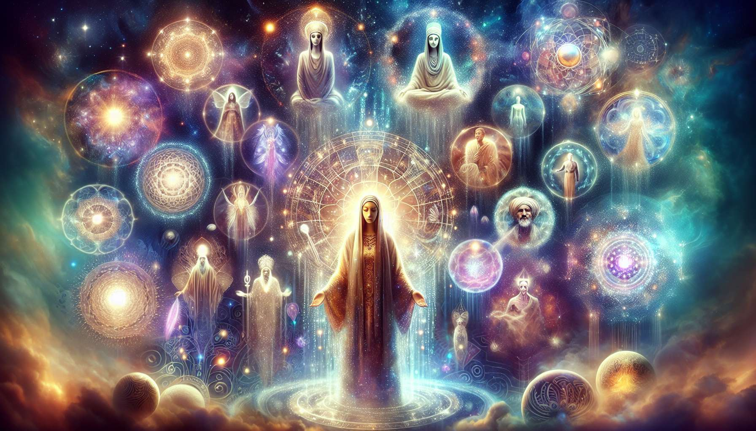

Spiritual guides and beings of light are benevolent presences accompanying us on our path of evolution. Whether referred to as angels, archangels, ascended masters, ancestral guides, or invisible allies, these entities form an integral part of many spiritual traditions worldwide. They represent forces of love, wisdom, and guidance watching over us and assisting on our journey towards fulfilling our full potential.   
  
According to these traditions, each human being is accompanied from birth by one or more spiritual guides. These guides are evolved souls who have chosen to devote themselves to the service of humanity by helping individuals navigate the challenges of earthly existence. They are not there to live our lives for us or make decisions for us, but rather to offer us their support, inspiration, and broadened perspective. They deeply respect our free will and only intervene if we invite them to.  
  
Native Americans speak of "Guardians," these allied spirits that accompany us throughout our lives. They can take the form of totem animals, ancestral guides, or spirits of nature. Each Guardian has its own qualities and specific teachings to transmit to us. During vision quest rituals, young people are invited to meet their Guardians and establish a conscious relationship with them to receive their guidance and protection.  
  
Spiritual guides communicate with us in multiple ways, often subtle and symbolic. They may send us signs through nature, synchronicities, dreams, sudden intuitions. They may also transmit messages through our inner voice, our bodily feeling, or insights that cross our minds. Learning to recognize and decode these messages is a significant part of spiritual progress. It requires refining our sensitivity, cultivating discernment, and trusting our inner wisdom.  
  
Many mystics and saints, such as Joan of Arc or Saint Teresa of Avila, have reported direct communications with angels and divine beings. These experiences radically transformed their lives and gave them the strength and clarity to accomplish their mission. They bear witness to the reality of these spiritual presences and their profound impact on the course of an individual and collective destiny.  
  
Beyond our personal guides, there are also beings of light working for the good of humanity and the planet as a whole. Archangels, for example, are often associated with specific functions: Michael for protection and courage, Raphael for healing and knowledge, Gabriel for communication and creativity, Uriel for peace and transmutation... Invoking these archangels, connecting to their energy, can bring us invaluable support in key moments of our lives.  
  
In the Jewish tradition of Kabbalah, the Tree of Life represents the structure of creation, with its different worlds and hierarchies of spiritual beings. Each sephira, each level of manifestation, is associated with specific angelic orders, from Cherubim to Seraphim through the Thrones and Dominations. Meditating on the Tree of Life, invoking these beings of light, allows us to align with cosmic forces and receive their sacred influx.  
  
The ascended masters are another category of beings of light who arouse keen interest in contemporary spiritual movements. These are individuals who have reached a high degree of spiritual evolution during their earthly incarnations and who have chosen, after their ascension, to continue to guide humanity from the subtle planes. Figures like Jesus, Buddha, Mary, Kuthumi, Saint Germain are often considered ascended masters who continue to inspire and educate those who turn to them.   
  
Count of Saint Germain, the enigmatic figure of the 18th century renowned for his wisdom and mysterious powers, is considered in several esoteric movements as an ascended master. He is credited with the ability to appear in different forms, to transmit advanced spiritual teachings, and to influence the course of global events towards more peace and unity.  
  
Entering into a conscious relationship with our spiritual guides and beings of light can bring a valuable dimension to our journey. Their loving presence reminds us that we are never alone, that we are always surrounded by invisible supports. Their messages and inspirations can shed light in our moments of doubt, comfort us in our trials, encourage us to unfold our unique potential. Cultivating a relationship of trust and reciprocity with them means opening up to the sacred dimension of existence and connecting to something greater than ourselves.  
  
Many creatives, artists, inventors testify to the influence of their guides in their creative process. Composer Tchaikovsky claimed to receive his music from a divine source beyond him. Inventor Nikola Tesla said he communicated with beings of light who transmitted to him revolutionary scientific knowledge. These examples illustrate how the connection with guides can catalyze the expression of our singular genius.  
  
However, it is important to keep in mind that contact with spiritual guides and beings of light requires discernment and a solid grounding in our center. Not all entities that present themselves to us are necessarily benevolent or evolved. Some may seek to influence us or destabilize us to serve their own interests. That's why it's essential to always filter these contacts through our heart, our inner wisdom, and never give our power to an outside force, no matter how impressive it may be.  
  
In his book "The Indigo Children," Lee Carroll warns against the risks of fascination and dependence on disembodied entities. He emphasizes the importance of developing our direct connection with the divine, honoring our inner authority, and not passively waiting for guides to solve our problems for us. Our true power lies in alignment with our soul, and the guides are there to assist us in this process, not replacement.  
  
In the context of spiritual coaching, exploring the relationship with guides and beings of light can be a fruitful path to support clients' progress. The coach can invite them to clarify their intention, to take an open and receptive stance, to learn to discern authentic messages. He can guide them in meditations or visualizations to meet their invisible allies, dialogue with them, invoke their support. He can also help them to integrate this guidance into their concrete life, to take action aligned with their inner wisdom.  
  
A woman mourning a loved one might thus be invited by her coach to connect to the soul of the deceased, express what is in her heart, imagine it surrounded by light and peace. This spiritual connection could help her find the strength to get through her grief, feel the loving presence that endures beyond death, find new meaning in life. The coach would accompany her in this delicate process with respect, kindness, and discernment.  
  
Thus, spiritual guides and beings of light are precious allies on the path of awakening and self-realization. Learning to recognize them, communicate with them, open up to their guidance, is a vital part of spiritual progress. Not to delegate our responsibility to them, but to co-create with them, to benefit from their expanded view and unconditional love. By cultivating this relationship of reciprocity and partnership, we connect to the sacred dimension of existence and allow ourselves to be guided towards the full expression of who we are.  
  
Here is a summary of the key points to remember from this text on spiritual guides and beings of light:  
  
Key Points:  
  
- Spiritual guides and beings of light are benevolent presences that accompany us on our path of evolution. They are found in many spiritual traditions.  
  
- Each human being is accompanied from birth by one or more guides who are evolved souls serving humanity. They offer us support, inspiration, and guidance, respecting our free will.  
  
- Guides communicate through subtle and symbolic channels: signs, synchronicities, dreams, intuitions, feelings... Learning to recognize their messages requires refining sensitivity and discernment.  
  
- Beyond personal guides, there are beings of light working for the good of humanity: archangels, ascended masters... Invoking their presence and connecting to their energy can provide valuable support.  
  
- Consciously relating to one's guides develops trust, comforts in trials, encourages unfolding of potential. It's opening to the sacred and connecting to the greater.  
  
- Contact with guides requires discernment. Not all entities are benevolent. It is essential to filter contacts with the heart, honor one's inner authority.  
  
- In spiritual coaching, exploring the relationship with guides can support progression by clarifying intention, guiding meditations to dialogue with them, helping to integrate their messages into practical life.  
  
- Learning to communicate with guides allows co-creation with them, benefiting from their expanded view and love, awakening to full self-expression.