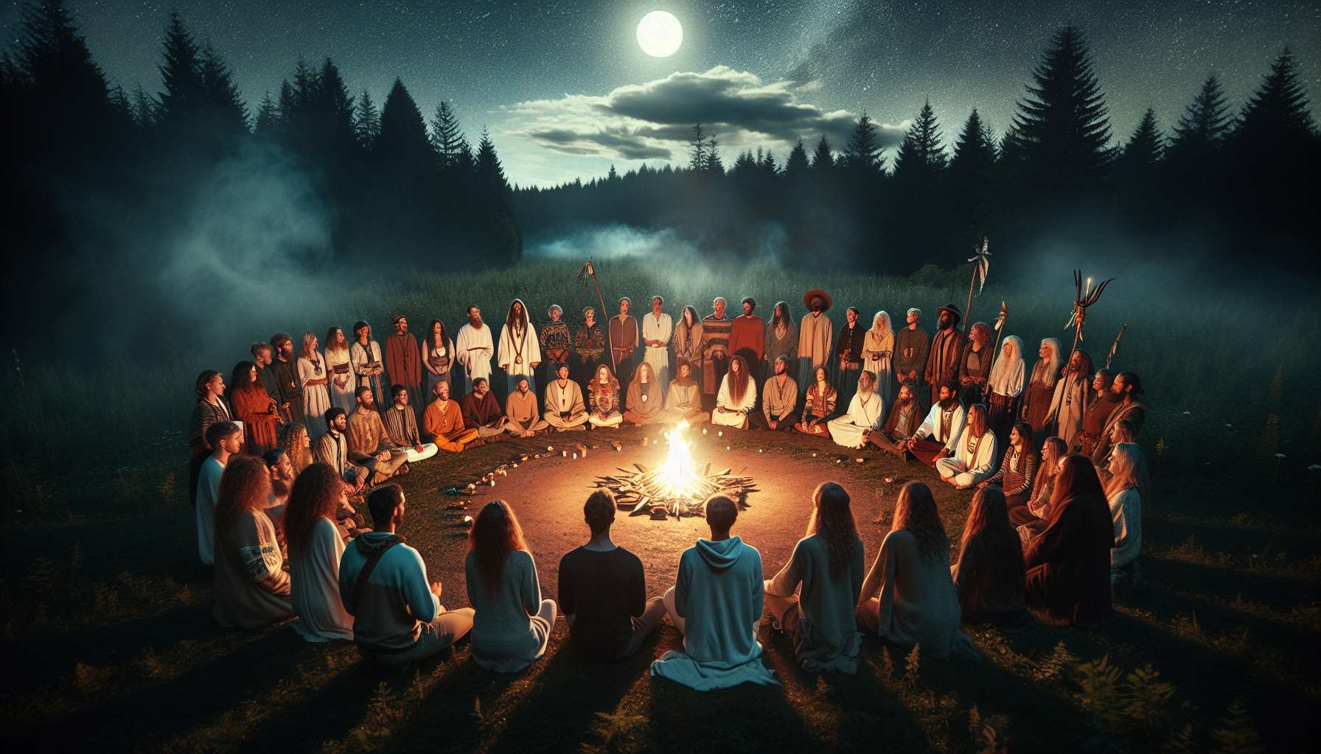

Rituals and sacred ceremonies are spiritual practices present in all traditions of the world. They create a particular space-time where one connects with the divine, where one honors the forces of life and where one celebrates the important passages of existence. More than just a repetition of gestures and formulas, rituals are powerful symbolic acts that allow us to align ourselves with the cycles of nature, to mark the stages of our inner journey, and to connect to something greater than ourselves.  
  
At the heart of every ritual, there is an intention, a clear objective that gives meaning and direction to the whole process. Whether it be to purify and consecrate a space, to invoke healing energies, to mark a commitment, or to celebrate an achievement, the intention is the thread that connects all the elements of the ritual. It is formulated from the outset, often through a prayer or an affirmation, and is maintained throughout the ceremony by the concentration and presence of the participants.  
  
Passage rituals, such as weddings, baptisms, or funerals, are present in all cultures. They mark the major transitions of life - birth, entry into adulthood, union, death - and allow the individual and the community to cross them with awareness and support. These rituals connect us to past and future generations, inscribing our personal history in a larger web.  
  
Another key element of rituals is the use of symbols - objects, substances, gestures, words - which condense and convey deep meanings. Each tradition has its own symbols, but there are universal archetypes such as purifying fire, lustral water, protective circle, offerings of food, or flowers. These symbols act as bridges between the visible and the invisible, the ordinary and the sacred. They speak directly to our unconscious and awaken in us subtle resonances.  
  
In the Hindu tradition, the puja ritual is an offering to the deity that involves all the senses. Colorful flowers, fruits, incense, a flame, devotional songs are presented with love and veneration on an altar. Each offering has a symbolic meaning and allows the devotee to express their gratitude, devotion, and aspiration for spiritual realization.  
  
The repetition is another essential characteristic of rituals. Whether it be mantras recited 108 times, circumambulations around a holy place, or precise repeated gestures, repetition induces a specific state of consciousness, both focused and receptive. By syncing with a rhythm, a cadence, we quieten the mind and open a space where the experience of the sacred can unfold. Repetition also inscribes the ritual in our body and memory, giving it a strength of anchoring and transformation.  
  
Sufi rituals of dhikr involve the repetition of divine names, often accompanied by body movements and breathing. This intense practice allows the devotee to empty themselves of thoughts and concerns to merge into the divine presence. As the repetition progresses, the heart opens, the senses refine, and a subtle joy permeates the whole being.  
  
Finally, rituals have an essential collective dimension. Even when practiced alone, they connect us to a community, visible and invisible, to all those who have performed these same gestures before us and who will perform them after us. Collective ceremonies, where everyone has a role and a place, strengthen ties, allow an exchange of energy and fervor. They bring us to our sense of belonging to a whole that surpasses and includes us.  
  
The Sweat Lodge ceremonies, or sweating huts, are practiced by many native peoples of North America. They bring the community together around a project of purification, healing, and prayer. In the darkness and intense heat of the hut, to the rhythm of songs and drums, the participants experience a symbolic death and rebirth. They come out of the lodge purified, regenerated, connected with each other, and with the vast web of life.  
  
Thus, rituals and sacred ceremonies are powerful tools for spiritual transformation. By reconnecting us with the subtle dimensions of existence, by giving shape to our highest aspirations, they allow us to harmonize our inner being and to embody our deepest potential. Whether we follow ancestral rituals or create our own ceremonies, the essential thing is to engage all our heart and being. For it is in this total engagement that the ritual unfolds its magic and opens the doors to the sacred.  
  
The Japanese ritual of Misogi is a practice of purification by cold water, often practiced at sunrise in sacred rivers or waterfalls. By fully immersing in the living water, by uniting through breathing and prayer to the current of life, the practitioner experiences a symbolic rebirth. They emerge from the water purified, revitalized, ready to begin a new stage of their journey.  
  
In the context of spiritual coaching, rituals can be valuable tools to accompany the transformation processes of clients. By creating personalized rituals that reflect their intention and sensitivity, the coach can help their clients to mark important stages, to let go of limiting patterns, to anchor new resources. They can also guide them in creating their own daily rituals, to nourish their inner life and maintain their alignment. By integrating the power of symbols, repetition, and heart commitment, these rituals become allies on the path to self-realization.  
  
Points to remember:  
  
- Rituals and sacred ceremonies are universal spiritual practices that create a specific space-time to connect with the divine, honor life forces, and celebrate the important passages of existence.  
  
- Intention is at the heart of every ritual, giving meaning and direction to the whole process. It is formulated from the start and maintained throughout the ceremony.  
  
- Passage rituals mark the major transitions of life and connect the individual to the community and to past and future generations.  
  
- Symbols are key elements of rituals acting as bridges between the visible and the invisible, the ordinary and the sacred. They evoke universal archetypes and speak to our unconscious.  
  
- The repetition of mantras, gestures, or circumambulations induces a specific state of consciousness, both focused and receptive, conducive to the experience of the sacred.  
  
- The collective dimension of rituals strengthens community ties and energy sharing, connecting us to a whole that surpasses and includes us.  
  
- In spiritual coaching, personalized rituals can accompany the transformation processes of clients, helping them mark stages, let go of limiting patterns, and anchor new resources.  
  
- Integration of symbols, repetitions, and heart commitment makes rituals powerful and makes them precious allies on the path to self-realization.