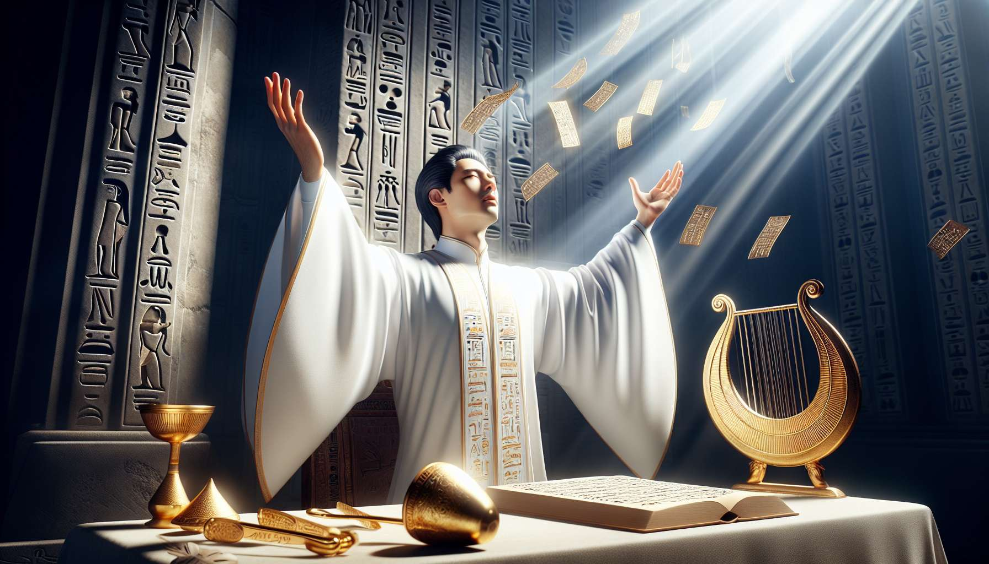

The hymns, prayers, chants, and intonations are the words of power that bring life to the rituals of Ancient Egyptian Shamanism. They allow the invocation of deities, the expression of sacred intentions, and the channeling of subtle energies for healing and transformation. Far from being mere recitations, these formulas are sound vibrations that resonate with cosmic forces and open the doors to higher consciousness.  
  
Hymns are poetic praises addressed to the deities to celebrate their essence and benefits. Each god and goddess has their own hymns, passed down for millennia and adapted to different ritual occasions. The hymns to Ra celebrate his life-giving light that is reborn every morning, while those dedicated to Osiris evoke his mystery of death and resurrection. Chanting these sacred texts with zeal and devotion allows one to resonate with divine qualities and anchor them in their own consciousness.  
  
Prayers are more personal invocations that express the requests and gratitude of the officiants and participants. They can take the form of supplications for healing from an ailment, thanksgivings for received blessings, or requests for guidance to navigate a trial. Prayers are often spontaneously improvised according to the needs of the moment, while respecting the codes and formulas consecrated by tradition. They create an intimate bond between the supplicant and the invoked deity.  
  
Chants are melodic compositions that combine sacred words and music to create an intense vibrational experience. They can be sung a cappella or accompanied by instruments such as the harp, the sistrum, or the drum. The melodies often draw inspiration from the sounds of nature, such as the singing of birds or the rustling of the wind through the papyrus. Singing in unison allows for the synchronization of the energies of the group and creates a profound communion with the invoked divine forces.  
  
Intonations are specific vocal techniques that use the creative power of sound to activate subtle energies. They include prolonged vowel sounds, rhythmic mantras, glossolalia, and guttural vibrations. Each sound corresponds to a vibrational frequency that resonates with a center of energy or a specific divine quality. Mastering the art of intonations allows one to modulate states of consciousness and direct energy flows precisely for healing and transformation.  
  
The power of hymns, prayers, chants, and intonations lies in their accuracy and sincerity. More than the words themselves, it is the intention and presence of the officiant that brings them to life. A simple whisper uttered with a pure heart can have a greater impact than a long litany recited mechanically. The great priests of ancient Egypt were masters in the art of sacred speech. They knew how to modulate their voice to awaken divine forces and perform true wonders.  
  
Sacred texts such as the Pyramid Texts, the Coffin Texts, and the Book of the Dead are rich with formulas of unmatched power. Their mere recitation in tombs and temples could activate the energies of the beyond and guide the soul of the deceased toward rebirth. Similarly, the hymns to Aton composed by Akhenaten testify to the transformative power of inspired speech. By celebrating the unity of all life in divine light, they paved the way for a universal spirituality that resonates even today.  
  
For the practitioner of Ancient Egyptian Shamanism, mastering hymns, prayers, chants, and intonations is a crucial key. By learning to feel the power of words beyond their simple meaning, one can invoke divine forces with precision and efficacy. One can create their own inspired compositions, tailored to the specific needs of their practice. By harmonizing their voice with subtle energies, they become a living channel for healing and revelation.  
  
The art of sacred speech is also a powerful tool for personal development. By regularly chanting hymns and prayers, the practitioner clarifies their mind, opens their heart, and sharpens their connection to the divine. They learn to master their breath and to anchor their presence in the moment. Each recitation becomes an active meditation that nurtures their soul and strengthens their bond with the Source.  
  
By perpetuating the millennia-old tradition of hymns, prayers, chants, and intonations, the Egyptian shaman reactivates the magic of the Word that shaped the world since the dawn of time. They are part of the lineage of priest-magicians who knew how to speak to the gods and awaken the forces of nature. Every word uttered with love and truth becomes a sacred offering, a vibrant praise that celebrates and renews the great mystery of divine Life in all things.