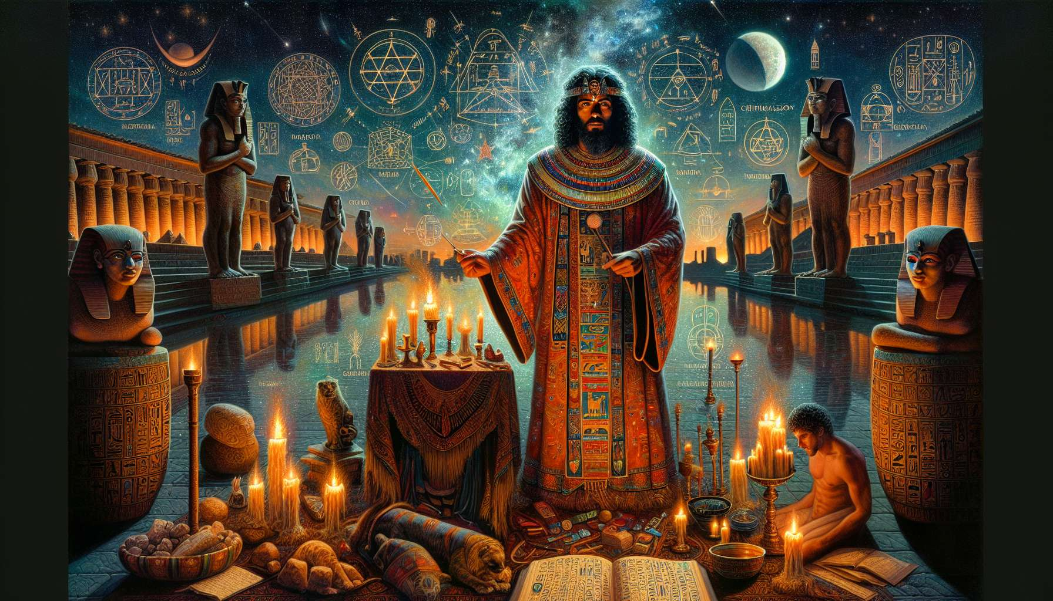

The celebrations of life cycles - birth, circumcision, marriage, death - are at the heart of Ancient Egyptian Shamanism. These rites of passage allow for the honoring of the great stages of human existence by linking them to the cyclical mysteries of divine life. They provide a sacred framework to welcome major transitions, integrate them harmoniously, and reveal their initiatory dimension. By guiding his contemporaries through these celebrations, the Egyptian shaman helps them to make sense of their personal stories and consciously place themselves within the great cycle of life.  
  
Birth is celebrated as a true divine epiphany. The newborn is welcomed as a gift from the gods, bearer of a sacred spark destined to flourish. Specific rituals are performed to connect the child to cosmic forces and ensure their protection. The child's secret name, which captures their divine essence, is revealed by the oracles and inscribed on an amulet that will accompany them throughout their life. Offerings are made to the protective deities of childhood, such as Bes and Taweret, to attract their blessings. The midwife, initiated into the mysteries of birth, ensures the proper integration of the ka, the energetic double, into the body of the infant.  
  
Circumcision, practiced since the earliest antiquity in Egypt, marks the entry into adulthood and access to sacred mysteries. Beyond its physical aspect, it is experienced as a true spiritual rebirth. The foreskin, symbolically associated with chaos and ignorance, is cut away to allow the new being to emerge, aligned with the divine plan. Intense purificatory rituals prepare the neophyte for this radical transformation. The pain of the procedure is transcended through trance techniques that open to initiatory visions. The circumcised thus reborn to himself, ready to assume his sacred role within the community.  
  
Marriage, the union of masculine and feminine polarities, is celebrated as a microcosmic reflection of the creation of the world. The spouses are likened to divine couples - Osiris and Isis, Geb and Nut... - whose loving union engenders the universe. Everything is done to attract the energies of harmony and fecundity: sensual dances, love songs, aphrodisiac offerings... The wedding bands, often engraved with hieroglyphic formulas, seal the sacred bond between the lovers. The nuptial bed is consecrated with libations and fumigations to promote the magical conception of awakened children. Oracles are consulted to guide the spouses in their new life and together embody the divine complementarity.  
  
Death, the passage to the beyond, is prepared throughout life through profound spiritual work. Far from being an end, it is experienced as a sacred metamorphosis, a birth to another level of consciousness. Funerary rituals aim to accompany the soul in its transition to the divine world and to preserve the body as a vehicle for rebirth. The mummification techniques, inherited from the priests of Anubis, allow for the transmutation of perishable matter into a receptacle of eternity. The sacred formulas from the Book of the Dead, recited during the ritual, activate the initiatory transformation of the deceased. They serve as a guide in the territories of the beyond to face the judgment of Osiris, lord of eternity. Each step of the funerals is an initiation into eternal life culminating in the weighing of the heart, the ultimate test of truth where only love prevails. Thus prepared, the deceased can reborn as Osiris and guide his loved ones from the subtle worlds.  
  
For the Egyptian shaman, the art of celebrating the cycles of life is the culmination of his practice. He learns to create powerful and personalized rituals that respond to the unique needs of each stage. He knows how to invoke the archetypal forces that underlie each passage and harness them for individual and collective transformation. By reviving the initiatory mysteries at the heart of these celebrations, he offers his contemporaries a direct path to their deep nature and the sacred meaning of their existence.  
  
Integrating the awareness of cycles into one’s personal life is also a powerful development tool for the practitioner. By honoring each step of his own story as a divine initiation, he learns to surf the waves of change with grace and confidence. Each birth, each symbolic death reveals to him a new face of his being and deepens his relationship with mystery. His life itself becomes a great celebration of cycles, a perpetual dance with the gods to the rhythm of the seasons of the soul.  
  
Thus, by reactivating the ancestral art of rites of passage, the Egyptian shaman re-enchants our relationship with time and its divisions. He invites us to embrace the cyclical nature of existence and to recognize the sacred dimension of our metamorphoses. Each celebration of the cycles of life becomes an anthem to the beauty of becoming, an ode to eternal life that is constantly renewed within us and around us. To be born, to grow, to unite, to die, and to be reborn: all are opportunities to awaken ever more to our true nature and to fully participate in the great breath of the cosmos.