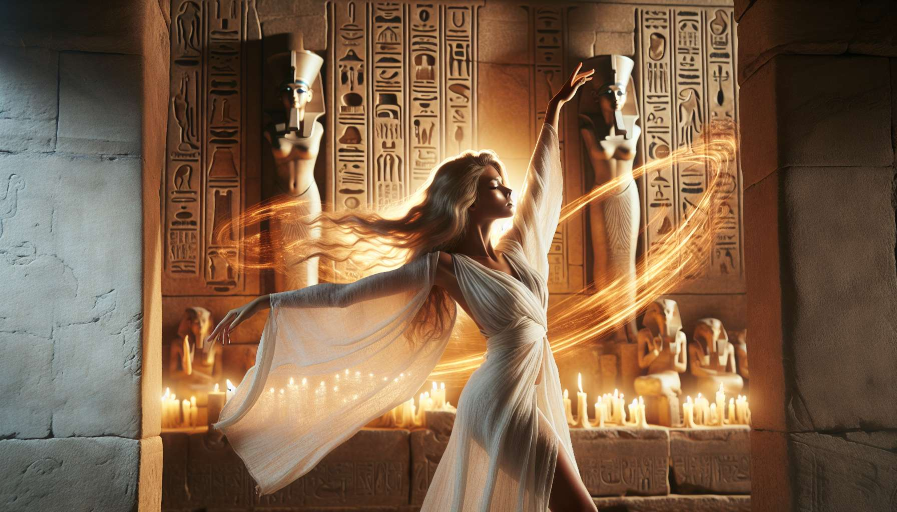

Sacred dances and hieratic postures are essential physical practices in the rituals of Ancient Egyptian Shamanism. They allow individuals to embody divine mysteries and channel cosmic energies through movement and gesture. Far from being mere choreographies, these practices are true danced prayers that align the body, soul, and spirit with the sacred forces of the universe.  
  
The sacred dances draw inspiration from the archetypal movements of the deities as depicted in temple iconography. The dance of joy by Hathor, where the goddess shakes sistrums and moves sensually, celebrates the vital power of femininity. The warrior dance of Sekhmet, punctuated by jumps and cries, evokes the destructive and purifying force of the lioness goddess. The cosmic dance of Nut, where the goddess arches to represent the celestial vault, honors the mystery of the eternal cycle of life, death, and rebirth.  
  
By reproducing these sacred movements, the dancer resonates with divine qualities and embodies their essence. They become a living vessel for the archetypal energies that unfold through them. The dance enables a direct connection between the divine macrocosm and the human microcosm, making the body a sacred vehicle for the manifestation of cosmic forces.  
  
Hieratic postures are codified positions that symbolically express divine mysteries. They are omnipresent in Egyptian art, from statues to bas-reliefs to wall paintings. Each posture has a specific meaning related to an archetype or cosmic principle. The posture of Osiris, with arms crossed over the chest, evokes initiation death and the promise of rebirth. The posture of Horus, with one foot forward and the arm raised, symbolizes the victorious march and the affirmation of divine will.  
  
By adopting these sacred postures, the practitioner aligns their energetic body with the subtle currents that traverse the universe. They activate specific power points that promote the awakening of consciousness and the opening of spiritual channels. The postures act as mudras, energetic seals that imbue the aura with divine vibrations and connect the practitioner to their deeper nature.  
  
The combination of sacred dances and hieratic postures creates a powerful synergy. The fluid movements of the dance circulate the energies awakened by the static postures. The postures anchor and stabilize the dynamic forces released by the dance. Together, they allow for a complete integration of divine mysteries into the different planes of being.  
  
In the temples of ancient Egypt, priests and priestesses were trained from a young age in the mastery of these sacred arts. The movements and postures were transmitted from master to disciple through progressive initiations. Their daily practice helped to maintain alignment with divine forces and cultivate the necessary qualities for sacred service.  
  
Great religious festivals were occasions for spectacular ritual dances that revived cosmic mysteries. During the Mysteries of Osiris, priestesses embodied Isis and Nephthys, executing funeral dances around the god's sarcophagus. Their movements of lamentation and invocation facilitated the process of regeneration and divine resurrection. Likewise, during the New Year celebrations, triumphant dances celebrated the victory of order over chaos and the renewal of the cosmic cycle.  
  
For the practitioner of Ancient Egyptian Shamanism, mastering sacred dances and hieratic postures is a subtle art. They learn to listen to their body as an instrument of divine revelation. By refining their kinesthetic sensitivity, they can capture the energy currents flowing through their being and direct them consciously for healing and transformation. They develop an embodied presence that allows them to radiate the power of archetypes in the ritual space.  
  
Integrating dances and postures into their personal practice enables the shaman to cultivate divine qualities at the heart of their everyday life. By dancing the joy of Hathor, they anchor gratitude and celebration in each of their gestures. By adopting the posture of Osiris, they honor the mystery of death and rebirth at every moment. Their physical practice becomes a continuous prayer, an offering of each movement to the glory of the Divine.  
  
By transmitting this sacred art to their students, the Egyptian shaman offers them a precious key to embody their inner divinity. Through the grace of movement and the power of postures, they can awaken the ancestral memories inscribed in their cells and connect with the primordial source of their being. Every dance, every posture becomes a vibrant celebration of the divine Life that animates all creation.  
  
By perpetuating the millennia-old tradition of sacred dances and hieratic postures, the practitioner of Ancient Egyptian Shamanism reactivates the mysteries of the temple body. They honor their embodied divine nature and become a living vessel for cosmic energies. Each movement, each position becomes a sacred offering, a silent praise that unites the visible and the invisible in the ecstasy of the divine Presence.