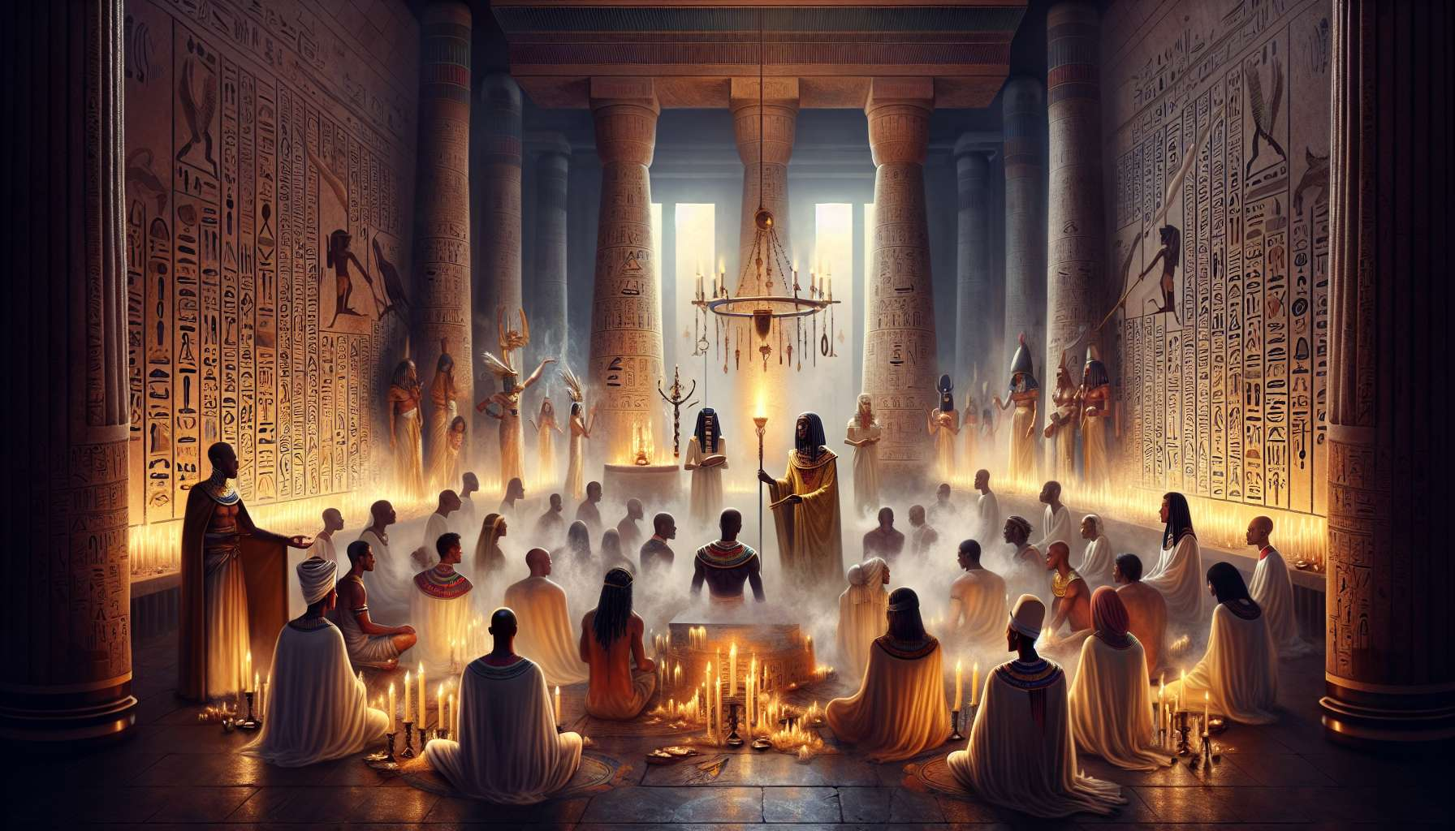

Ritual dramas and initiatory mysteries are complex ceremonial practices aimed at revitalizing the great foundational myths of ancient Egypt. Far more than mere theatrical representations, these rituals are true initiatory processes that allow participants to experience the divine mysteries from within and to transform through their engagement. They lie at the heart of the tradition of Ancient Egyptian Shamanism and represent the culmination of the entire ritual process.  
  
The most famous ritual dramas are those that enact the Osirian myth, the true keystone of Egyptian spirituality. Each year, during the Mysteries of Abydos, the murder of Osiris by his brother Seth, Isis's quest to gather the scattered pieces of the dismembered body, and the resurrection of the god through the magic of love are reenacted by priests in a series of vivid tableaux of great dramatic intensity. Participants, by identifying with the various protagonists of the myth, can revive from within the crucial stages of the initiatory process: the death of the self, the dismemberment of illusions, and the rebirth to a higher level of consciousness.  
  
Other famous ritual dramas include the Mysteries of Ra, where the journey of the solar god through the sky and his nocturnal trek in the Duat are staged to reveal the secrets of inner transformation and spiritual illumination. The Mysteries of Isis invite the initiates to relive the goddess's trials to awaken in them the healing powers of love and compassion. Each major deity has its own mysteries, which explore a specific facet of the human psyche and cosmic reality.  
  
The preparation for these ritual dramas is a long and demanding process that mobilizes all the resources of tradition. The most experienced priests are responsible for the spiritual direction of the ritual, ensuring that every detail aligns with ancestral prescriptions. Sacred scribes adapt mythological texts into ceremonial scripts, while artisans create masks, costumes, and sets to foster an atmosphere conducive to the awakening of archetypes. Dancers, musicians, and storytellers rehearse for long weeks to incorporate divine qualities and become pure channels for archetypal energies.  
  
The location of the ritual, often a temple or necropolis, is carefully consecrated through purifications and offerings, becoming a liminal space between the world of humans and that of the gods. Initiatory pathways are arranged, punctuated by symbolic challenges and death-rebirth experiences, allowing participants to traverse their own shadows and access higher levels of consciousness. Everything is put in place to create a total immersion in the living myth.  
  
When the ritual begins, initiates are guided through a series of trials and revelations that allow them to experience the myth from the inside. By completely identifying with the deities and playing their role to the point of self-forgetfulness, they can transcend the limits of their ordinary personality and directly experience the mysteries. The challenges encountered in the ritual reflect their own inner obstacles, and symbolically overcoming them gives them the strength to surpass those challenges in their lives. Thus, reviving the death of Osiris teaches them to mourn their ego and to rebirth to their divine nature. Searching for the scattered limbs of the god invites them to reconnect the fragmented facets of their being to rediscover their deep unity. Each step is an initiation into a new mystery that brings them closer to the Source.  
  
At the heart of the initiatory experience often lies a central revelation, a profound insight that shatters the illusions of ordinary consciousness. For the Mysteries of Osiris, this is the discovery of the divine within oneself, that immortal spark that survives all death and connects to eternity. This revelation is often experienced as a mystical ecstasy, a dissolution of boundaries between the self and the All that radically transforms one’s perception of reality. The initiate dies to their former identity to be reborn to their true nature, infinitely vast and luminous.  
  
This initiatory death-rebirth is the core of the shamanic transformation process. By symbolically living the dismemberment and recomposition of their being, the initiate can transmute their blocked energies, untangle their limiting beliefs, and realign their soul with the divine plan. They rebirth to themselves like Osiris resurrected, fully aware of their unity with the Source and their mission of awakening at the heart of the world. Each participant thus emerges profoundly transformed from the initiatory experience, carrying a new consciousness and renewed life energy.  
  
For the practitioner of Ancient Egyptian Shamanism, mastery of ritual dramas and initiatory mysteries is the fulfillment of their art. By guiding participants through symbolic trials and facilitating their inner revelations, they become a midwife of souls, a passer between worlds who helps each individual realize their divine potential. They learn to create powerful ritual spaces where myth can come to life and unleash its transformative power. They refine their ability to channel archetypal energies and use them for healing and awakening.  
  
Integrating the mysteries into their personal practice is also a means for the shaman to continue their own growth. By regularly reenacting the great initiatory myths, they can deepen their connection to divine forces and explore further into the territories of the psyche. Each new initiatory cycle reveals to them new facets of themselves and allows them to embody more fully the qualities of the neteru. Their life itself becomes a great initiatory ritual constantly renewed, a sacred dance with the gods for the awakening of all beings.  
  
Thus, by perpetuating the millennia-old tradition of ritual dramas and initiatory mysteries, the practitioner of Ancient Egyptian Shamanism reactivates the transformative power of myths. They offer their contemporaries a direct path to the mysteries of life, death, and rebirth. Through the magic of ritual, they create bridges between worlds so that each person can reconnect with their divine nature and fully participate in the great adventure of consciousness. Each ritual drama, each initiatory journey thus becomes a catalyst for awakening, an invitation to embrace the mystery and to become a living myth in service of human and cosmic evolution.