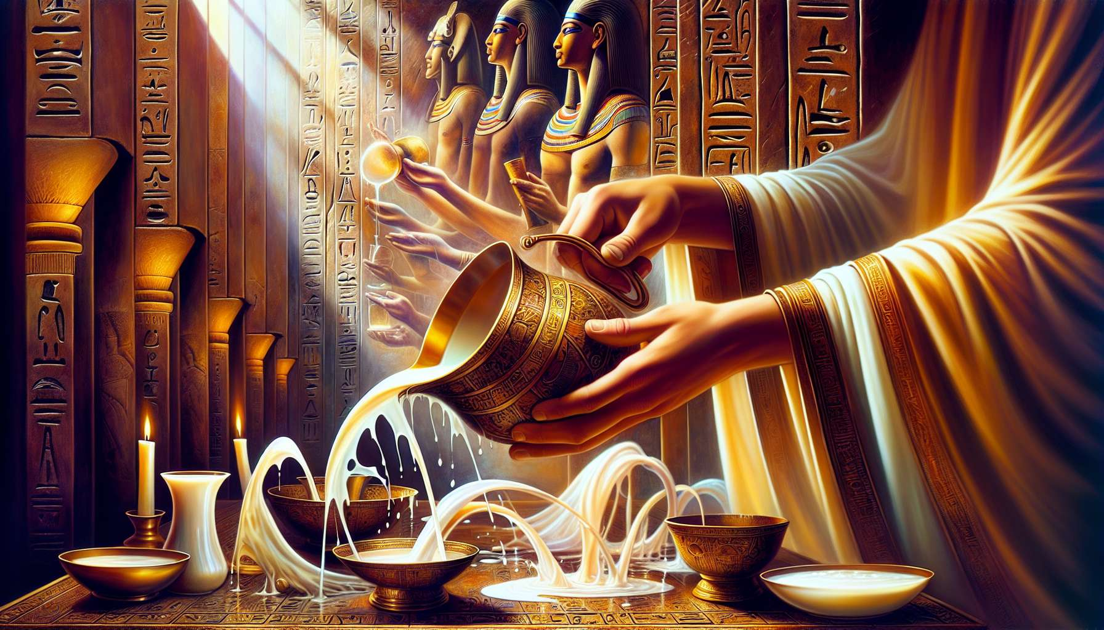
Liquid libations of milk, wine, beer, and water are fundamental liquid offerings in the rituals of Ancient Egyptian Shamanism. They serve to honor the deities by providing them with sacred drinks that symbolize the vital fluids of creation. Each liquid carries a profound meaning and specific properties, making it a preferred vector for communication with the divine.
Milk, with its immaculate color and sweetness, is associated with purity and rebirth. It is the quintessential offering to the goddess Hathor, the Celestial Cow who bestows love and fertility. Pouring milk on altars or divine effigies is to nourish the gods with the very essence of life, the essence that soothes and regenerates. Milk libations are particularly indicated during healing and purification rituals, to soften suffering and restore inner harmony.
Wine, the elixir of joy and sacred intoxication, is the blood of the vine that connects heaven and earth. It is the privileged offering to Osiris, the god who experienced death and resurrection. Spilling wine on the ground or altars is to celebrate the mystery of transformation and eternal rebirth. Wine libations are often performed during funeral rituals and the Osirian Mysteries, to accompany the soul of the deceased on its journey to the afterlife and promote its regeneration.
Beer, the drink of festivities and conviviality, is the golden nectar derived from the fermentation of barley, the sacred grain of Osiris. It is the joyful offering par excellence, which delights the hearts of gods and men alike. Pouring beer on altars is to share in divine joy and invite celestial powers to join earthly celebrations. Beer libations are particularly fitting during religious feasts and community celebrations, to strengthen the bonds between the visible and invisible worlds.
Water, the source of all life, is the primordial offering that links all others. The water of the Nile, springing from the depths of Osiris, is considered a divine substance that irrigates and fertilizes the land of Egypt. Pouring pure water on altars is to honor the mystery of creation and invoke the forces of regeneration. Water libations are present in all rituals, from simple daily purification to grand initiatory ceremonies, to refresh and revitalize the energies at play.
The preparation of libations follows precise protocols passed down for millennia. The water used is carefully purified through sacred formulas and ritual gestures. The milk comes from selected cows known for their purity and gentle nature. Wine and beer are brewed according to ancestral recipes, transforming them into true initiatory drinks. Specific prayers are recited over each liquid to imbue it with divine essence and render it worthy to be offered to the gods.
The timing and manner of pouring the libations are codified by the tradition unique to each temple. Generally, the priest approaches the altar carrying the sacred vessels, lifting them to the heavens while reciting invocation hymns. Then he slowly pours the liquid over the divine effigy, the offerings, or directly onto the ground, tracing sacred signs that activate the energies present. Consecration and gratitude formulas accompany each gesture, sealing the bond between the offering and the deity.
For the practitioner of Ancient Egyptian Shamanism, mastering the art of libations opens numerous possibilities. By choosing the appropriate liquid based on the ritual intention, one can invoke specific energies and subtly modulate the atmosphere of the temenos, the sacred space. One can create synergies among the various libations to balance the forces present and facilitate transformation processes. By consecrating the drinks through prayer before offering them, one transforms them into true “initiatory elixirs” that convey divine essence.
The art of libations also serves as a powerful aid for meditation and visualization. By contemplating the flowing liquid, the practitioner can internally follow the flow of energy connecting earth to sky, matter to spirit. They can identify with the deities receiving the offering and feel their living presence at the heart of the ritual. Each libation thus becomes an opportunity to connect to the Source and quench one’s thirst from the living water of divine consciousness.
By perpetuating the millennia-old tradition of libations, the Egyptian shaman is part of the lineage of priests who, each day, honored the gods and maintained Ma’at, cosmic harmony. They revive the memory of sacred gestures that link humanity to the vital forces of creation. Each drop of milk, wine, beer, or water poured becomes a liquid prayer, a vibrational offering that celebrates and regenerates the great cycle of divine life within all things.

